AutoISF Fork —Summary Operations Manual

AIM of the program. [a personal use example of ideas]

The aim is to make the requirement for intervention very minimal, given still the expectation of at least intermittent bolus calculation. This represents a lesser goal than the “boost” Variant aAPS programme, which I think really aims at no bolus.

Although the internal code automations do switch profiles and set temp targets these can be set individually as well if necessary and particularly if there is a concern about overall excess strength causing hypoglycemia or various conditions [such as steroids, hormones and so on] interfering in the last few days or weeks,

It is simple enough to switch the “high and low” profiles used by the program. Also, setting “MJ” types from List1 [or States] sets either 3, 2 , or 1 day of more gentle criteria for changing profiles, setting Steroid profiles [first set Kotlin MJ and Steroid buttons] from List1 sets more aggressive changes during the day.

Introduction: Most significant new features [↑ TOC]
This is the plain-language companion to the full AutoISF Operations Manual -- same section numbering, same headings, same settings/reference tables, but each subsection here is one short paragraph explaining what it does and why it matters, instead of the full technical detail. Use this to get oriented quickly; use the full manual when you need the actual mechanism, thresholds, or code references.

Screenshots
Real device screenshots (Virtual, 24 Aug 2026). Small thumbnails floated beside the relevant Introduction paragraphs link here -- click one to jump to its full-size copy, or just scroll through them below in one place.

GUI display changes.img_overview_stacked
This graph is always the primary time-aligned display Also reachable via a direct TT-code Secondary graphs (graphs 1-4). Graph 5 is a dedicated main-sized comparison panel Gesture and remote triggers. A basal-area long-press cycles the main graph's display preset and controls the quick visibility of empirical carb line 1. An IOB-area long-press toggles SMB labels, resets the basal display preset to normal [↑ TOC]

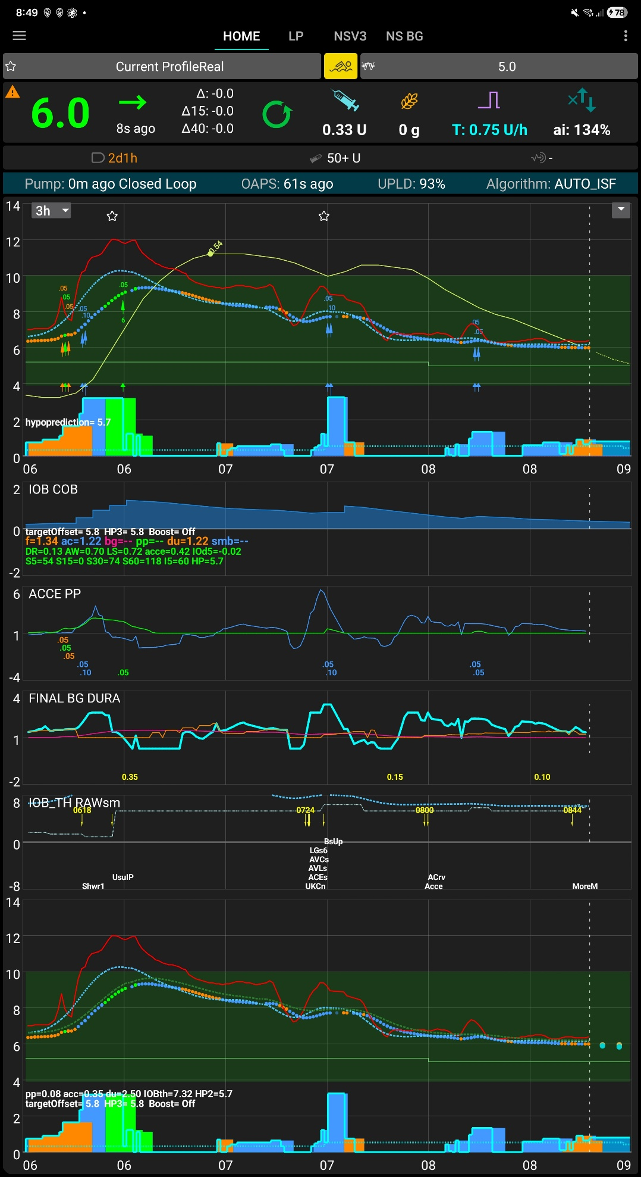
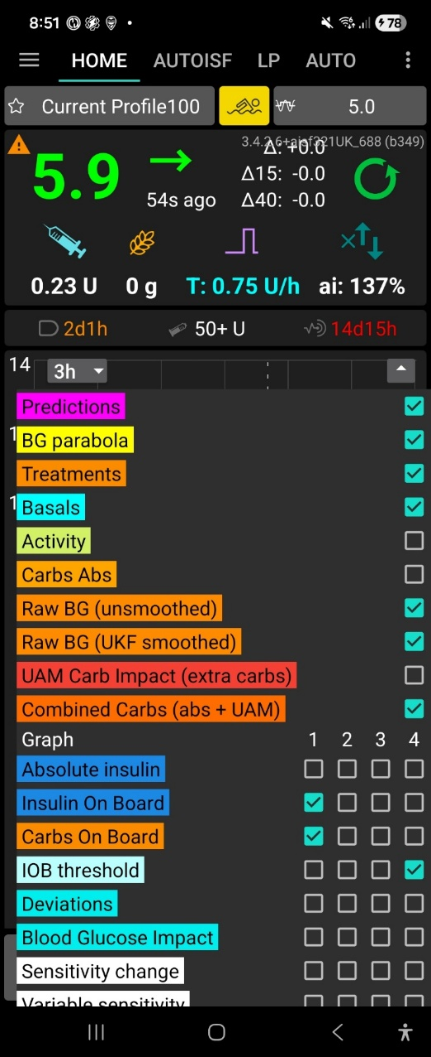
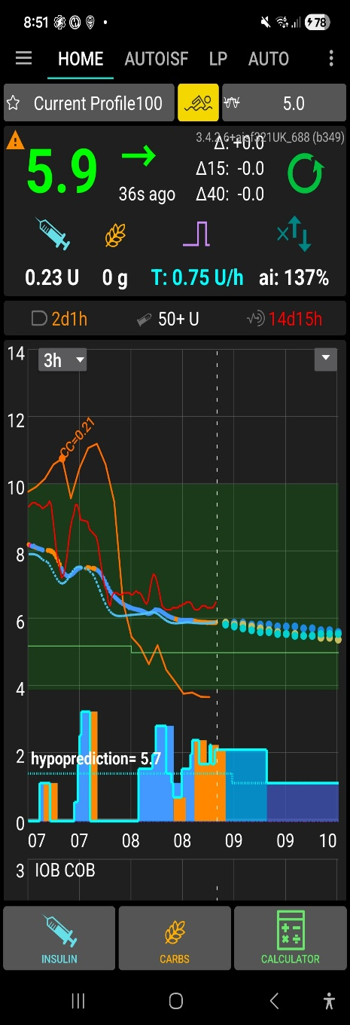
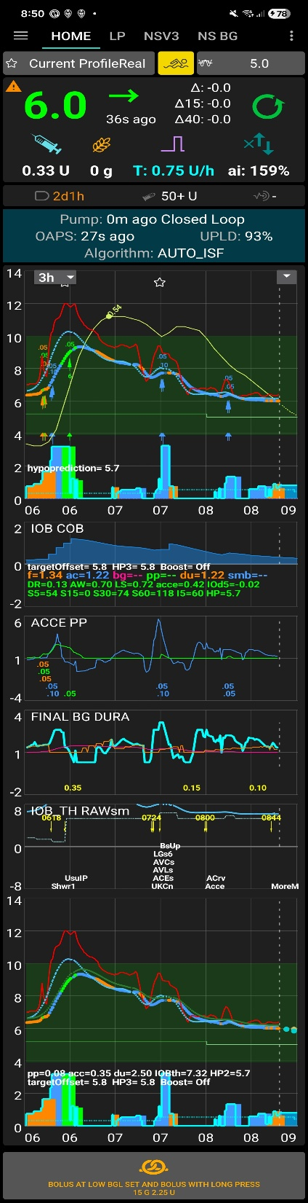
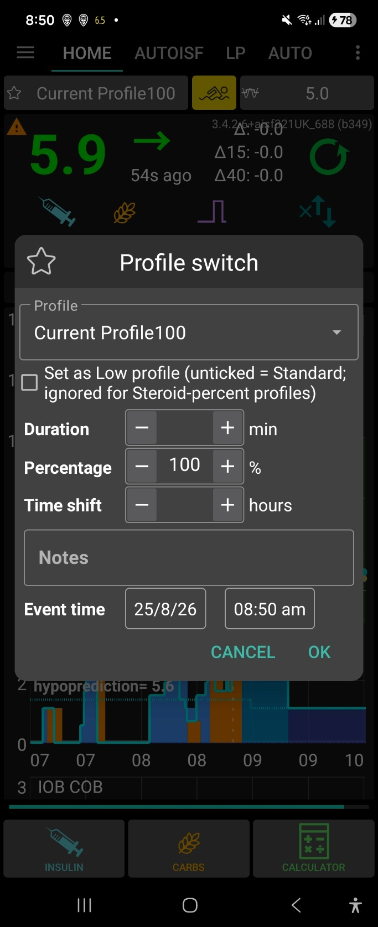
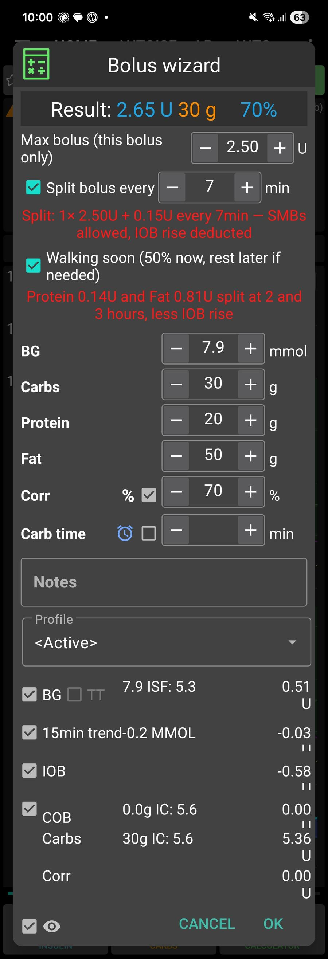

Bolus wizard: split-bolus + Walking soon [↑ TOC]

- Full description of the bolus calculator changes; split and delayed bolus, safer calculation;
Changes to bolus calculator with addition,s modificationeg
Initial screen and live calculation., carbs, protein, fat . Protein and fat are not included in the immediate total
Manual split-bolus if bolus over maximum bolus, remainder split

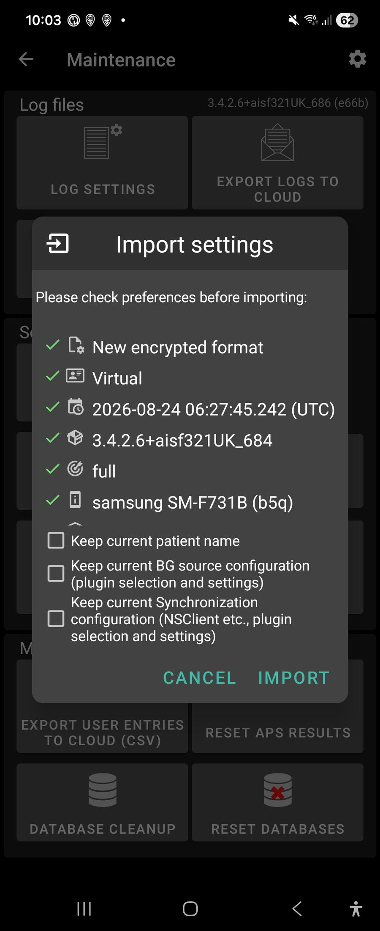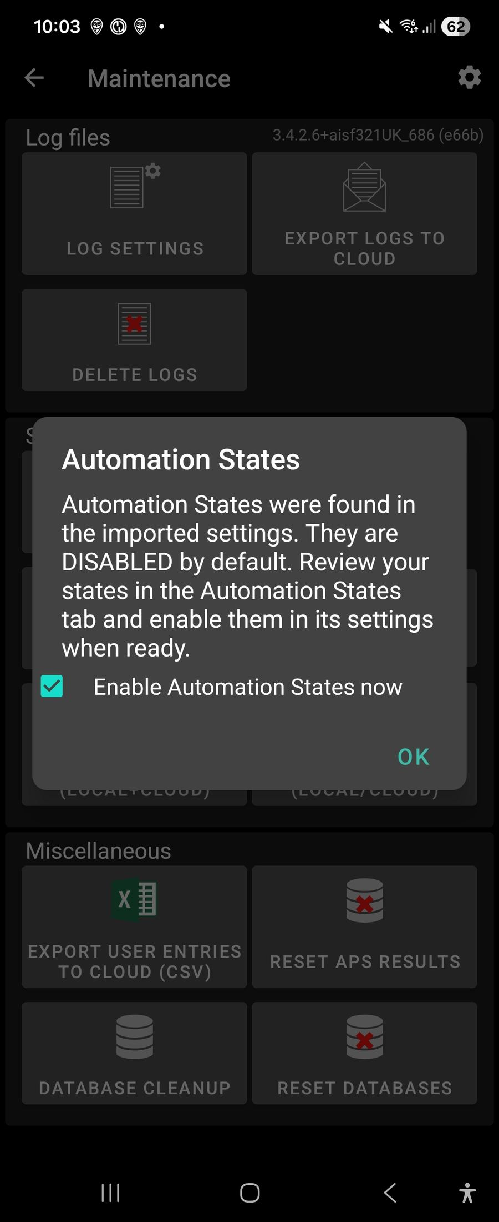

Import settings, with Keep-current checkboxes [↑ TOC]

- Settings Import Features — Especially With States.
Four “Keep current…” checkboxes not present in stock AAPS
Automation States are force-disabled after every import, requiring confirm
Import restores states wholesale — where “states I never made myself” can come from

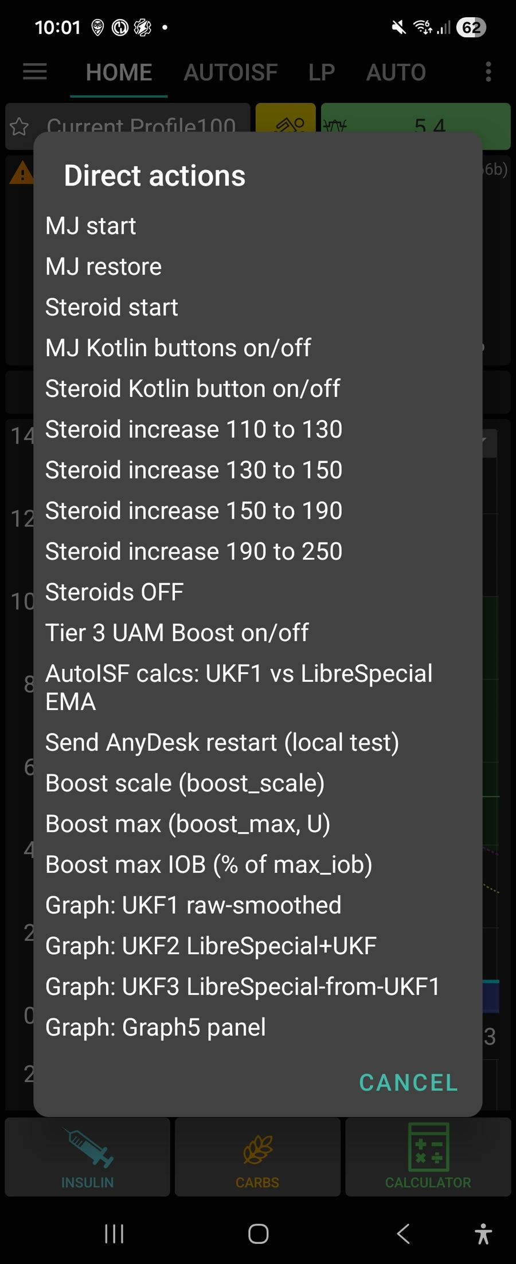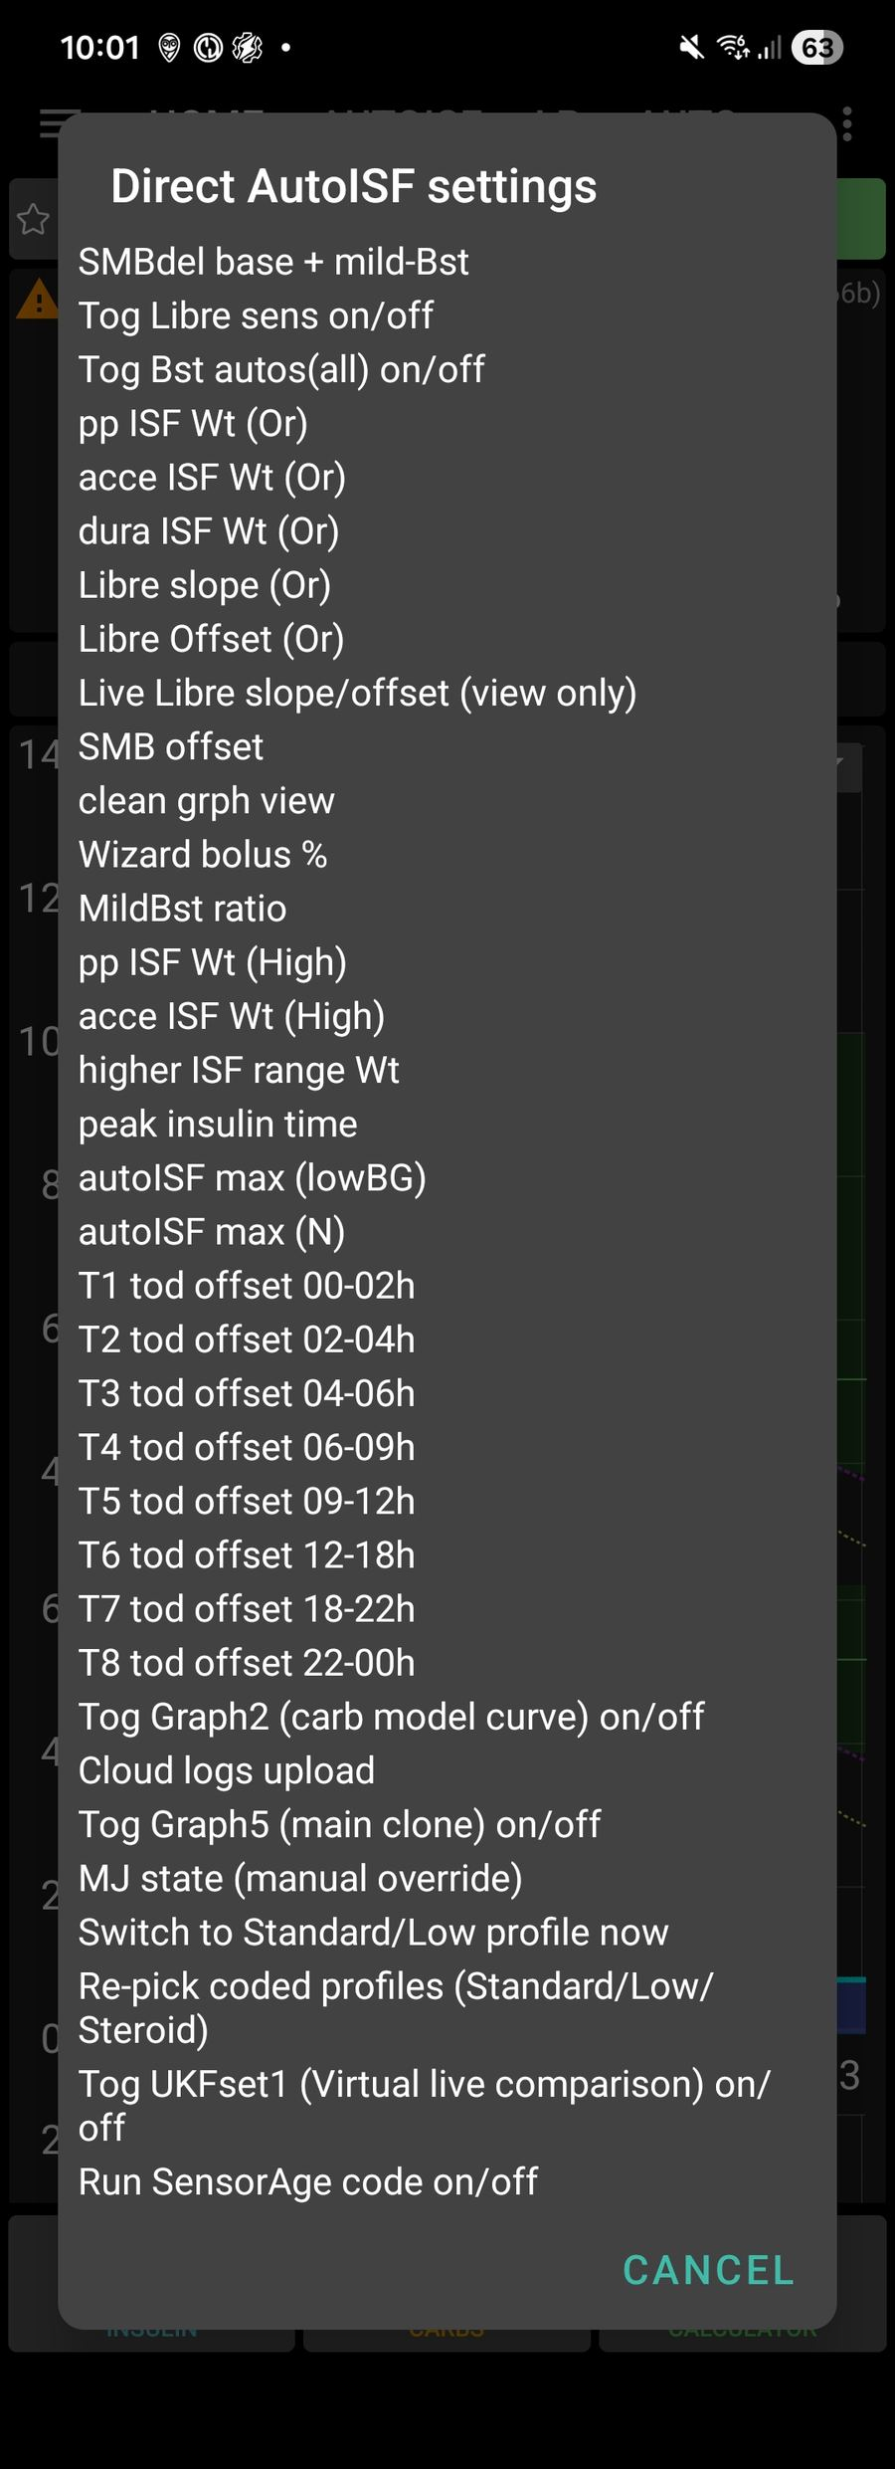
List 1 -- Direct AutoISF settings [↑ TOC]


- Lists 1 and 2: full descriptions; rapid access to settings
Double-tap the IOB area to open List 1. Double-tap the basal-rate area to open List 2
The outer list shows setting names ; for setting preferences and some functions, with confirmation.
On AAPSClient preferences are not changed locally, so confirmation creates the matching five-minute custom temporary-target code for the pump to receive, apply and cancel.

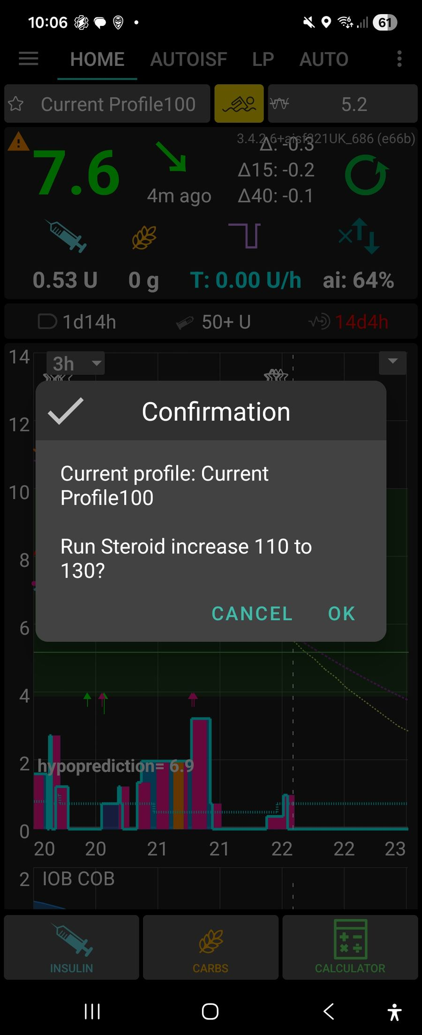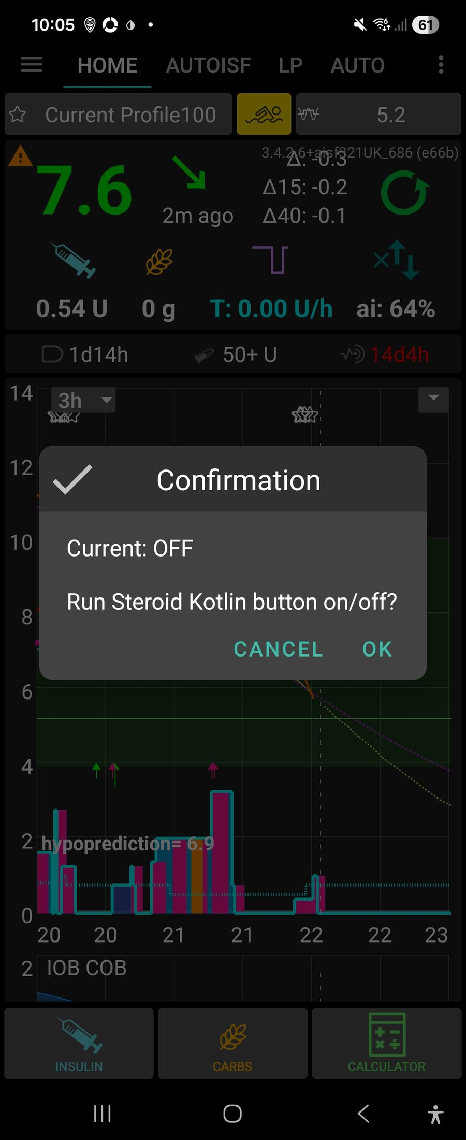
Steroid Kotlin button on/off confirmation [↑ TOC]
MJ Kotlin buttons on/off confirmation [↑ TOC]
List 2 -- Direct actions [↑ TOC]

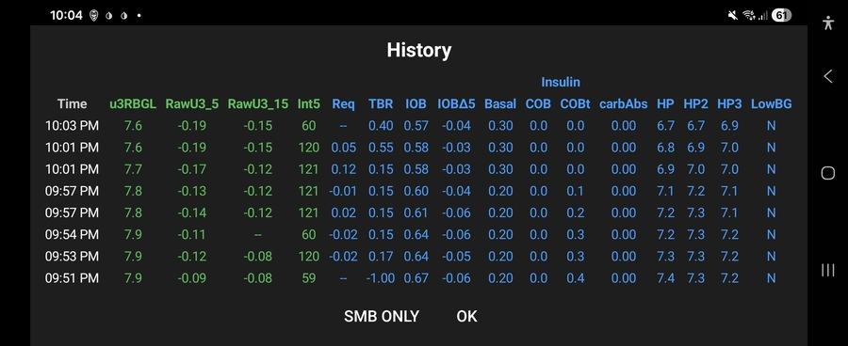
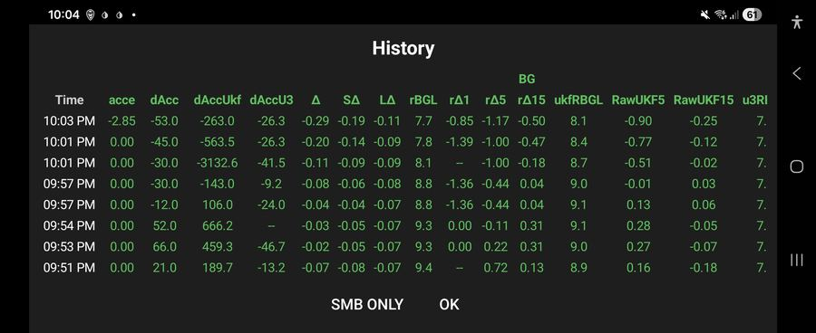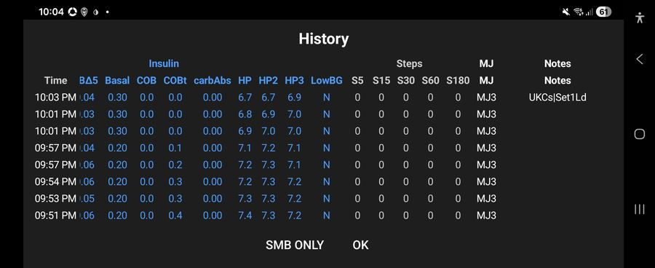
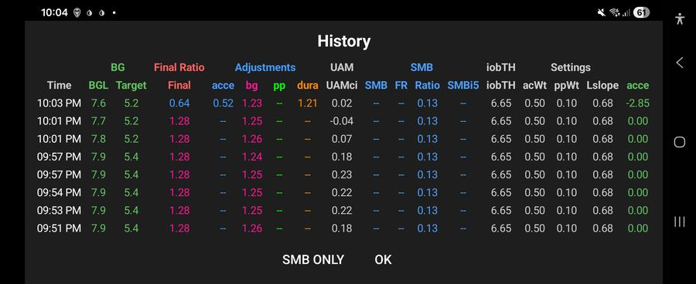


- AIV table popup, automatic backup with logs and settings immediately and 6 hourly
Long-pressing the ISF/history control opens the AIV history popupEach row presents grouped glucose/raw-delta, ISF-factor, insulin/carb/HP, request/delivery and activity/status fields
Each row joins the nearest available context to an AIV timestamp and presents grouped glucose/raw-delta, ISF-factor, insulin/carb/HP, request/delivery and activity/status fields Manual/on-open and Automatic /export ; all export AIV csv, text, setting txt, userentries.csv, logarithmic zip End [↑ TOC]

Introduction: Most significant new features [↑ TOC]
This is the plain-language companion to the full AutoISF Operations Manual -- same section numbering, same headings, same settings/reference tables, but each subsection here is one short paragraph explaining what it does and why it matters, instead of the full technical detail. Use this to get oriented quickly; use the full manual [or Plain Language manual] when you need the actual mechanism, thresholds, or code references.
This manual concentrates on the operational changes that most distinguish this AutoISF fork from stock AAPS and that are most likely to affect daily use:

- Full description of the bolus calculator changes; split and delayed bolus, safer calculation;
Changes to bolus calculator with addition,s modificationeg
Initial screen and live calculation., carbs, protein, fat . Protein and fat are not included in the immediate total
Manual split-bolus if bolus over maximum bolus, remainder split
Automatic delayed bolus at 50% or recent-50. This is distinct from the manual split.


- Lists 1 and 2: full descriptions; rapid access to settings
Double-tap the IOB area to open List 1. Double-tap the basal-rate area to open List 2
The outer list shows setting names ; for setting preferences and some functions, with confirmation.
On AAPSClient preferences are not changed locally, so confirmation creates the matching five-minute custom temporary-target code for the pump to receive, apply and cancel.


- Settings Import Features — Especially With States.
Four “Keep current…” checkboxes not present in stock AAPS
Automation States are force-disabled after every import, requiring confirm
Import restores states wholesale — where “states I never made myself” can come from


- AIV table popup, automatic backup with logs and settings immediately and 6 hourly
Long-pressing the ISF/history control opens the AIV history popupEach row presents grouped glucose/raw-delta, ISF-factor, insulin/carb/HP, request/delivery and activity/status fields
Each row joins the nearest available context to an AIV timestamp and presents grouped glucose/raw-delta, ISF-factor, insulin/carb/HP, request/delivery and activity/status fields
Manual/on-open and Automatic /export ; all export AIV csv, text, setting txt, userentries.csv, logarithmic zip
- Mechanism For Ignoring Or Invoking Native Automations; new ones now self-healing for the coded automations' own states.
his fork re-implements roughly 100+ of what used to be native AAPS Automation-tab triggers/actions directly as hand-coded Kotlin blocks
each native Automation-tab event's title against that registry every time it decides whether to actually run a native event
cf explanation of automation toggles gor MJ, Steroid buttons, installation check of cose tuned on for aISF running

- Tier 3 UAM Boost criteria, output limits and duration.
This is not active and only runs on virtual pump at the moment.
Tier3 from Boost variant program with different protection; testing only
- BolusGiven strong-boost effects.
BolusGiven strong boost. This is separate from Tier 3. sets SMB delivery ratio to Mild Boost base + 0.03 It uses delivery change
- BolusGivenMild and Mild Failsafe behavior.
Mild Failsafe applies similar effects BolusGiven/Mild automations run first and can change smb_delivery_ratio, profile percentage, target and weights. AutoISF weighs BG acceleration, post-meal rise, and how long BG has been stable differently depending on the situation -- each has a normal (“resting”) weight and a stronger (“boosted”) one that kicks in when conditions call for extra correction.

- Steroid-management initiation and escalation.
Steroids (e.g. prednisone) sharply and progressively raise insulin resistance for as long as they're active. • GUI: “Steroid Kotlin button” setting Also reachable via a direct TT-code Each step requires the previous step's Automation State + profile match to still hold [or set directly from List1

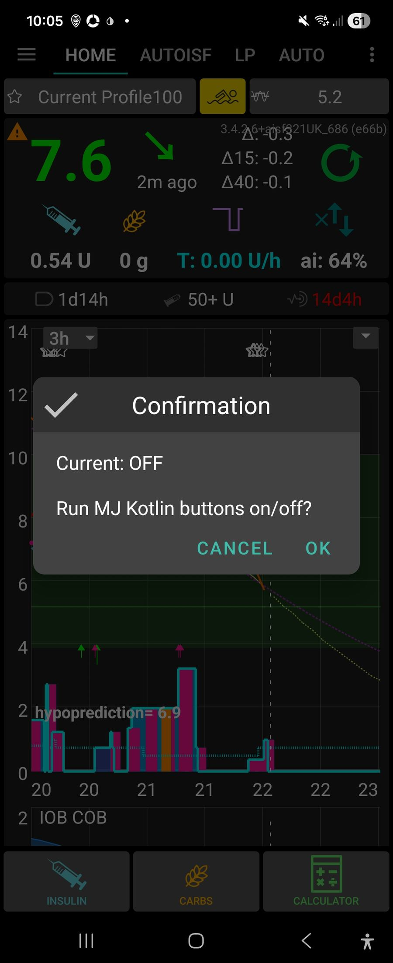
- The Mounjaro three-day reduced-insulin cycle.
MJ means Mounjaro in this fork The MJ controls implement a reduced-insulin state cycle for the period after a Mounjaro dose, when insulin requirements may be lower and hypoglycaemia risk may be greater Also reachable via a direct TT-code The start button is offered when Automation State MJ is NOMJremains as the configured Low Profile


- Hypoglycaemia warnings and protective overrides.
Hypoglycaemia warning causes and outcomes.
Hypoglycaemia warnings do not automatically mean “cancel MJ and restore 100%”. GentleHypoRisk, AlarmHypo1, AlarmHypo2, the 50% profile machinery, and related HP/HP2 checks can lower acceleration weighting. SMS may also be sent
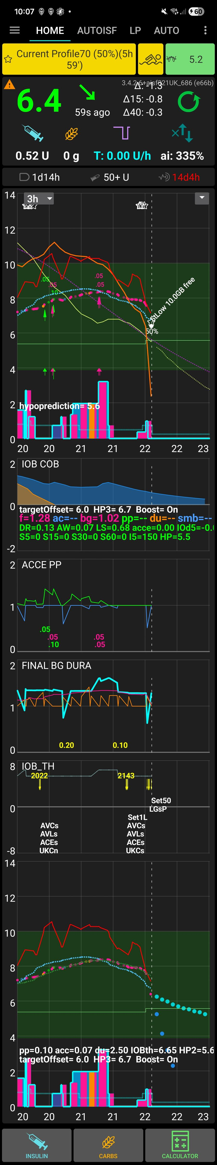
- GUI display changes.
This graph is always the primary time-aligned display Also reachable via a direct TT-code Secondary graphs (graphs 1-4). Graph 5 is a dedicated main-sized comparison panel Gesture and remote triggers. A basal-area long-press cycles the main graph's display preset and controls the quick visibility of empirical carb line 1. An IOB-area long-press toggles SMB labels, resets the basal display preset to normal

- VirtualPseudoWizard: background real-bolus correction (Virtual Pump, testing only).
It places an actual BS.Type.NORMAL bolus, computed by running the same constrained BolusWizard used by the manual calculator, but entirely in the background — no calculator screen is ever shown This graph is always the primary time-aligned display


- Automation States in use: which states this fork’s coded automations read/write and why.
Appendix F — Automation States In Use ; A reference for every named state this fork’s coded automations


- Fast-rise SMB tapering: the tiered cascade, the separate late taper, and what the AIV export actually shows.
a set of checks for excess insulin SMB size, scaling them down

Contents [↑ TOC]
Introduction: Most significant new features
1. Requirements for “Automation States”
a. It has a master on/off switch, and things silently do nothing when it's off
b. Fixed 2026-08-19: this is now self-healing for the coded automations' own states
c. A second, related gap: declaring the value list still isn't the same as the state having a value
2. Settings Import Features — Especially With States
a. Automation States are force-disabled after every import — by design, not a bug
b. Import restores states wholesale — where “states I never made myself” can come from
c. Four “Keep current…” checkboxes not present in stock AAPS
3. Settings That Materially Affect Day-to-Day Function
a. The SMB delivery brake
b. Tier 3 UAM Boost: criteria, output, and duration
c. The weight system's Resting/Boosted pairs
d. Duration (dura) modifications to the AutoISF algorithm
e. TDD factor / sensitivity toggles
f. The overnight safety-guard architecture
4. Setting: If Steroids Are Needed
a. Turning it on
b. The escalation ladder
5. Mounjaro (MJ): three-day reduced-insulin cycle
a. Starting the cycle
b. Day-by-day state progression
c. What changes while MJ remains active
d. Hypoglycaemia warnings and protective overrides
e. Automatic exit and manual restoration
6. Mechanism For Ignoring Or Invoking Native Automations
a. The reconciliation mechanism
b. The suppression only applies while AutoISF is actually the active algorithm
7. Other Idiosyncrasies Worth Knowing
a. CarePortal note codes as a compact diagnostic language
b. MJ as the fork's other major state machine
c. The AIV/UKFcheck export pipeline has more moving parts than it looks
d. A concrete regression pattern worth remembering
8. Manual controls and AIV history
a. Bolus calculator: screen, calculation and follow-up dosing
b. Lists 1 and 2: mechanism, current status and confirmation
c. AIV table: popup population and backup/export behavior
d. Coded profile roles (Standard/Low): assignment, re-picking, and why it matters
e. Steroid escalation as a third coded role (added 2026-08-23)
9. GUI display changes
a. Graph types and the triggers for each
b. Colour changes driven by AutoISF input
c. Information shown on each graph
d. What the different carbohydrate graphs mean
10. Factors affecting progress and hypoglycaemia outcomes
a. Pod age and pump-type qualification
b. Projected HP at bolus-calculator initiation
c. Effects of 50recent, a 50% profile and a hypo temporary target on progress
d. Hypoglycaemia warning causes and outcomes
11. UKF: formulas, roles and initial comparison assessment
a. The UKF variants and where each is used
b. Formula and full explanation of each
c. Progress of the initial UKF-check assessment and earliest-change question
d. UKF1 for live AutoISF dosing (toggle, added 2026-08-23)
12. Battery 1% automation and profile recovery
a. Battery1pc: action at 1% or below
b. BatteryOver1pc: restoration after recovery
13. SensorAge: aging/new-sensor Libre calibration compensation
a. What it compensates for and how the tiers are built
b. The six age tiers and their symmetry
c. Two independent enable switches
d. Entry/exit gating and interaction with LowRaw24Cal
e. Related sensor/pod-age reminders (notification-only)
14. VirtualPseudoWizard: background real-bolus correction (Virtual Pump, testing only)
a. Why it is not a real carb treatment
b. Entry gating
c. Calculation and delivery mechanics
d. Outcome reporting
15. Fast-Rise SMB Tapering: the Tiered Cascade and the Separate Late Taper
a. Where this sits, and the entry gate
b. The tier ladder: Delta/SDelta bands, BG sub-branches, and multipliers
c. Other branches inside FAST RISE HANDLING: Higher BG, early-morning guard, twilight hours
d. The preceding sibling branches, including Sensor Glitch3
e. The separate late taper and cumulative SMB caps
f. What actually reaches the AIV "FastRise" column
g. Libre-calibration slope compensation (added 2026-08-22)
Appendix C — Contents
a. List 1 and List 2 command/temporary-target reference
b. AutoISF Coded Automations - Current Code Registry
Appendix A — Installation and explanatory information
a. Version tag & build identification
b. Per-device backup/export folder naming
Appendix B — Changelog
Appendix D — Alphabetical CarePortal Note Code Reference
Appendix E — List 1 and List 2 Temporary-Target Command Catalogue
Appendix F — Automation States In Use
a. MJ
b. Steroids
c. LowBG
d. Steps
e. Profile
f. Sleeping
g. Removed 2026-08-22
Appendix G — Current Live Settings Snapshot

1. Requirements for “Automation States” [↑ TOC]
“Automation States” is a generic named state-machine store (its own plugin, its own “States” tab in the UI) shared between native Automation-tab triggers/actions and this fork's own coded automations in Kotlin. Two things make it easy to trip over:

a. It has a master on/off switch, and things silently do nothing when it's off [↑ TOC]
Automation States are a shared memory the coded automations use to track things like whether steroids are active or a low just happened. There's one master switch for the whole system -- if it's off, every automation that depends on a state just quietly does nothing, rather than erroring.

b. Fixed 2026-08-19: this is now self-healing for the coded automations' own states [↑ TOC]
If the app needs a state value that was never registered (say, after an update added a new one), it used to be able to crash. Now it automatically registers anything missing the first time it starts, so this fixes itself instead of needing a manual settings edit.

c. A second, related gap: declaring the value list still isn't the same as the state having a value [↑ TOC]
Declaring which values a state is allowed to hold isn't the same as that state actually holding one yet -- a freshly registered state can still be genuinely empty until something writes to it for the first time.
Also fixed 2026-08-19, same day: the bootstrap now also assigns a safe default CURRENT value, but only for the 5 states where there's real evidence of what “neutral/off” means (never guessed): MJ → NOMJremains, MJstate → MJoff, Steroids → Steroids Off, LowBG → NO50rec, Profile → AllOK. It deliberately leaves Steps, Sleeping, BGLstate, and query_got_up declare-only — no coded automation in this file was ever seen writing the first two (something else owns them), BGLstate has only one enumerated value with no observed “off” counterpart (defaulting to it would wrongly assert a low just happened on every fresh device), and query_got_up is a one-shot signal, not a toggle.
The default is only applied when the state currently has no value at all — it can never overwrite something you (or the import) already set.

2. Settings Import Features — Especially With States [↑ TOC]
Settings import in this fork is substantially more elaborate than stock AndroidAPS. The underlying mechanism is still “clear every SharedPreferences key, then write the file's contents back in” (ImportExportPrefsImpl.doImportSharedPreferences()) — but several fork-specific safeguards sit around that blunt operation.

a. Automation States are force-disabled after every import — by design, not a bug [↑ TOC]
Restoring a settings backup automatically switches Automation States off -- on purpose, not a bug -- since an old backup's states might not match what's really happening on the phone right now (e.g. it might think steroids are still active when they aren't). You confirm and turn it back on manually after checking the states still make sense.

b. Import restores states wholesale — where “states I never made myself” can come from [↑ TOC]
Importing a settings file overwrites every state value at once with whatever that file contains -- not just numeric preferences. So a state you never touched yourself can still change on import, if it happened to be recorded in that particular backup.

c. Four “Keep current…” checkboxes not present in stock AAPS [↑ TOC]
Four checkboxes not found in stock AAPS let you protect specific state values from being overwritten during an import -- useful when you want most of an old backup restored but need today's real current state kept for a few particular things.

3. Settings That Materially Affect Day-to-Day Function [↑ TOC]
The full settings tree (~65 entries) is documented setting-by-setting in the companion “AutoISF Settings Reference”. This section instead highlights the handful whose day-to-day real-world effect is outsized relative to how easy they are to change by accident, or how non-obvious their interaction with something else is.

a. The SMB delivery brake [↑ TOC]
A safety ceiling on how much insulin SMB can deliver in a short window, regardless of what the dosing math would otherwise suggest -- the backstop that limits how aggressive one burst of automated dosing is allowed to get.

b. Tier 3 UAM Boost: criteria, output, and duration [↑ TOC]
An extra dosing boost, Virtual-pump-only, that raises how much insulin the loop is allowed to give during a genuinely fast, unannounced rise. Gated on the rate of rise, acceleration and IOB headroom, with its own stacking-safety limits on top -- never active on a real pump.
Stacking-type criteria (added 2026-08-23). Tier 3 previously had none of the anti-stacking safeguards BolusGiven/BolusGivenMild already had, despite living right alongside them -- traced directly to a real 23 Aug firing that delivered three consecutive doses (09:32/33/34am, no gap at all).
Three additions, borrowed from BolusGivenMild: a 10-minute self-throttle (implemented as an instance-level last-fire timestamp on the DetermineBasalAutoISF class itself, since the file's shared readyToRun()/markRun() throttle map lives on the plugin class, not reachable from Tier 3's own pure-calculation code); the same 2-hour quiet window after a manual bolus or carb entry BolusGivenMild already requires; and BolusGivenMild's own sub-7.5mmol delivery-rate ceiling (blocks re-arming when recent IOB change is already running hot -- over 0.8U/5min -- relative to a still-modest BG). All three sit alongside the existing criteria above, not replacing any of them.

c. The weight system's Resting/Boosted pairs [↑ TOC]
AutoISF weighs BG acceleration, post-meal rise, and how long BG has been stable differently depending on the situation -- each has a normal (“resting”) weight and a stronger (“boosted”) one that kicks in when conditions call for extra correction.

d. Duration (dura) modifications to the AutoISF algorithm [↑ TOC]
The “duration” part of AutoISF's sensitivity calculation -- how long BG has been stable -- has fork-specific tuning on top of the stock algorithm, changing how much a long stable stretch is allowed to loosen sensitivity.

e. TDD factor / sensitivity toggles [↑ TOC]
Settings that let your recent total daily insulin dose influence sensitivity calculations, plus toggles to turn that influence on or off.

f. The overnight safety-guard architecture [↑ TOC]
Several independent guards work together specifically overnight: hard ceilings on how far a value like IOB threshold can shift, escalating anti-stacking limits on SMB delivered close together, and forced switches to a gentler profile late at night. All added after two real overnight low-BG incidents, each one catching a different failure mode the others missed.

4. Setting: If Steroids Are Needed [↑ TOC]
Steroids (e.g. prednisone) sharply and progressively raise insulin resistance for as long as they're active. This fork has a dedicated, fully worked-out mechanism for it — the most complete example of a “medical-event ladder” anywhere in the codebase, and a reasonable template if a similar mechanism is ever built for another condition (see §5).

a. Turning it on [↑ TOC]
A dedicated on/off switch and profile-escalation path for when you're taking steroids, which sharply raise insulin resistance -- turning it on shifts AutoISF onto a stronger baseline immediately.

b. The escalation ladder [↑ TOC]
Steroid insulin needs typically build up over days, so there's a five-step ladder (110%→130%→150%→190%→250%) you move through manually as resistance increases, each step switching to a correspondingly stronger profile and raising the IOB ceiling.
Step | Profile switched to | iobTH % | bgAccel weight
START (110%) | Steroid Profile110 | 71 | 0.70
INCREASE (130%) | Steroid Profile130 | 73 | 0.70
INCREASE (150%) | Steroid Profile150 | 74 | 0.70
INCREASE (190%) | Current Profile190Real | 75 | 0.70
INCREASE (250%) | Current ProfileReal250 | 76 | 0.70
TURN OFF | Current ProfileReal | 71 | 0.71

5. Mounjaro (MJ): three-day reduced-insulin cycle [↑ TOC]

MJ means Mounjaro in this fork. It does not mean Morning Jog. The MJ controls implement a reduced-insulin state cycle for the period after a Mounjaro dose, when insulin requirements may be lower and hypoglycaemia risk may be greater. The Overview button describes the intended operating period as three days of the configured low-profile strategy; the implementation uses named states and clock-time transitions rather than an exact 72-hour countdown.

a. Starting the cycle [↑ TOC]
A three-day reduced-insulin automation for the days around a Mounjaro (tirzepatide) injection, since insulin needs drop sharply for a short window afterward -- you trigger it manually when you inject.

b. Day-by-day state progression [↑ TOC]
The three days aren't treated identically -- the automation tracks which day of the cycle you're on and adjusts its own thresholds and profile choices as the cycle progresses back toward normal.

c. What changes while MJ remains active [↑ TOC]
While an MJ cycle is running, several other automations (profile switches, overnight guards) deliberately defer to MJ's own reduced-insulin logic instead of fighting it.

d. Hypoglycaemia warnings and protective overrides [↑ TOC]
MJ's reduced-insulin window genuinely raises hypo risk, so extra warning and override paths exist specifically for BG behaviour seen during an active MJ cycle.

e. Automatic exit and manual restoration [↑ TOC]
The cycle ends on its own after the third day, reverting profiles back to normal -- but can also be cancelled manually early if needed.

6. Mechanism For Ignoring Or Invoking Native Automations [↑ TOC]
This fork re-implements roughly 100+ of what used to be native AAPS Automation-tab triggers/actions directly as hand-coded Kotlin blocks inside OpenAPSAutoISFPlugin.kt (the “coded automations” layer described in CLAUDE.md), so they can react every 1-minute loop cycle instead of on the native automation engine's slower tick. Both systems — native Automation-tab events and coded automations — remain fully present in the app at the same time, which creates a real risk of the same logical action firing twice (once from each system) unless something reconciles them.

a. The reconciliation mechanism [↑ TOC]
Since this fork reimplements 100+ native AAPS Automation-tab triggers as hand-coded Kotlin logic, it needs to stop the ORIGINAL native automation from also firing and double-acting. A registry compares every native automation's title against the coded equivalents and suppresses the native one whenever a coded version already covers it.
Match | Meaning | Effect on the native event
EXACT | normalized title equals a coded key exactly | Always suppressed — the coded equivalent is assumed to be running every cycle instead, no user choice involved
CLOSE | one normalized string contains the other, without being exactly equal | Suppressed only if the user hasn't explicitly accepted it via the review popup (below); a prior “accept” decision (persisted per title) lets it run
NONE | no relationship to any coded key | Never touched — runs exactly as stock AAPS would

b. The suppression only applies while AutoISF is actually the active algorithm [↑ TOC]
This suppression only happens while this fork's AutoISF algorithm is the one actually running the loop -- switch to a different algorithm and native automations are free to run normally again.

7. Other Idiosyncrasies Worth Knowing [↑ TOC]

a. CarePortal note codes as a compact diagnostic language [↑ TOC]
Every coded automation leaves a short, consistent CarePortal note (like “BsUp” or “DelOff”) each time it fires, forming a compact log you can read back afterward to see exactly what happened and when. See Appendix D for the full glossary of what each code means.
Code family | Meaning
AVLs / AVLf | AIV local export succeeded / failed
ACEs / ACEf | combined-export (combined<Name>.txt) rebuild succeeded / failed
UKCs / UKCn / UKCf | UKFcheck diagnostic export found matches / ran fine but found nothing / genuinely failed (UKCf can ONLY come from an exception — never means “no findings”)
StB On / StB Off | Steroid Kotlin button feature toggled on/off via its TT-code
SteroidsON / Steroids130…250 / SteroidsOff | each step of the steroid ladder (§5)

b. MJ as the fork's other major state machine [↑ TOC]
Alongside the general Automation States system, MJ has its own separate day-tracking state machine dedicated to its three-day cycle.

c. The AIV/UKFcheck export pipeline has more moving parts than it looks [↑ TOC]
The AIV history export (and the UKF comparison tool) pull from several different sources and reconstruction paths rather than one simple table -- worth knowing before assuming every exported column is a raw, directly-stored value.

d. A concrete regression pattern worth remembering [↑ TOC]
A real bug already happened once from changing an automation's ACTION value without re-checking its own condition for clearing/re-arming against that new value. Worth deliberately checking both sides together whenever retuning a threshold.

8. Manual controls and AIV history [↑ TOC]

a. Bolus calculator: screen, calculation and follow-up dosing [↑ TOC]
The Wizard/QuickWizard bolus calculator handles carbs, protein and fat, offers a manual split-bolus option when a dose exceeds your configured maximum, and can automatically deliver a delayed top-up dose at 50% profile or after a recent low -- plus a “Walking soon” checkbox that halves the immediate dose for anticipated activity.

b. Lists 1 and 2: mechanism, current status and confirmation [↑ TOC]
Two quick-access settings menus -- double-tap the IOB icon for List 1, the basal-rate icon for List 2 -- give direct toggles, nudges and actions without navigating the full Settings screen. On a real pump or Virtual these apply immediately; on AAPSClient they relay via a short temporary-target code instead.

c. AIV table: popup population and backup/export behavior [↑ TOC]
Long-pressing the ISF/history area opens a scrollable history table built from AIV records, and separately kicks off a full export (CSV, text, settings, UserEntries, logs) -- both on that open and automatically every six hours regardless.
Command | Relay TT (mmol/L) | Current effect
SMBdel base + mild-Bst | 5.002 / 5.004 | Decrease/increase both SMB-delivery baseline and Mild Boost ratio by 0.01.
Toggle Libre sensor adjustment | 5.006 | Toggle aging-sensor/Libre adjustment on or off.
Toggle boost automations | 5.008 | Toggle the whole boost-automation group on or off.
pp ISF weight - normal | 5.012 / 5.014 | Decrease/increase normal postprandial ISF weight by 0.01.
Acceleration ISF weight - normal | 5.016 / 5.018 | Decrease/increase normal acceleration ISF weight by 0.05.
Duration ISF weight - normal | 5.022 / 5.024 | Decrease/increase normal duration ISF weight by 0.1.
Libre slope - original | 5.026 / 5.028 | Decrease/increase the baseline Libre calibration slope by 0.01.
Libre offset - original | 5.032 / 5.034 | Decrease/increase the baseline Libre calibration offset by 0.05.
SMB offset | 5.036 / 5.038 | Decrease/increase the hard SMB-offset override by 0.1.
Clean graph view | 5.042 | Hide SMB dose labels/arrows and show the plain solid-green view.
Wizard bolus percentage | 5.046 / 5.048 | Decrease/increase the Wizard percentage by five percentage points.
Mild Boost ratio | 5.052 / 5.054 | Decrease/increase Mild Boost ratio alone by 0.01.
pp ISF weight - high | 5.056 / 5.058 | Decrease/increase boosted postprandial ISF weight by 0.01.
Acceleration ISF weight - high | 5.062 / 5.064 | Decrease/increase boosted acceleration ISF weight by 0.01.
Higher-ISF-range weight | 5.068 / 5.070 | Decrease/increase high-BG ISF weight by 0.1.
Peak insulin time | 5.074 / 5.076 | Decrease/increase insulin peak by five minutes.
AutoISF maximum - low BG | 5.080 / 5.082 | Decrease/increase the low-BG AutoISF maximum by 0.1.
AutoISF maximum - normal | 5.086 / 5.088 | Decrease/increase the normal AutoISF maximum by 0.1.
TOD offset 00:00-02:00 | 5.092 / 5.094 | Decrease/increase this time-of-day offset by 0.1.
TOD offset 02:00-04:00 | 5.098 / 5.100 | Decrease/increase this time-of-day offset by 0.1.
TOD offset 04:00-06:00 | 5.104 / 5.106 | Decrease/increase this time-of-day offset by 0.1.
TOD offset 06:00-09:00 | 5.110 / 5.112 | Decrease/increase this time-of-day offset by 0.1.
TOD offset 09:00-12:00 | 5.116 / 5.118 | Decrease/increase this time-of-day offset by 0.1.
TOD offset 12:00-18:00 | 5.122 / 5.124 | Decrease/increase this time-of-day offset by 0.1.
TOD offset 18:00-22:00 | 5.128 / 5.130 | Decrease/increase this time-of-day offset by 0.1.
TOD offset 22:00-00:00 | 5.134 / 5.136 | Decrease/increase this time-of-day offset by 0.1.
Toggle Graph2 carb-model curve | 5.138 | Toggle the empirical/theoretical carb-model curve display.
Cloud logs upload | 5.140 | Zip and send logs to configured cloud storage, otherwise use email.
Toggle Graph5 | 5.142 | Toggle the Graph5 comparison panel.
MJ state manual override | 5.144 / 5.146 | Set MJ to NOMJremains or MJ3.
Profile manual override | 5.148 / 5.150 | Select the configured Standard or Low profile.
Toggle UKFset1 live comparison | 5.152 | Toggle the Virtual-Pump, non-Client live UKFset1 comparison; hidden elsewhere.
Run SensorAge code | 5.156 | Toggle the sensor-age code on or off.
Command | Relay TT (mmol/L) | Current effect
MJ start | 5.158 | Start the confirmed Mounjaro cycle.
MJ restore | 5.160 | Run the confirmed Mounjaro restoration action.
Steroid start | 5.162 | Start the steroid-management sequence.
Toggle MJ Kotlin buttons | 5.164 | Show/hide the MJ buttons.
Toggle Steroid Kotlin button | 5.166 | Show/hide the steroid button.
Steroid 110 to 130 | 5.168 | Run the confirmed steroid escalation to 130.
Steroid 130 to 150 | 5.170 | Run the confirmed steroid escalation to 150.
Steroid 150 to 190 | 5.172 | Run the confirmed steroid escalation to 190.
Steroid 190 to 250 | 5.174 | Run the confirmed steroid escalation to 250.
Steroids OFF | 5.176 | Run the confirmed steroid turn-off action.
AnyDesk restart | 5.178 | Client writes an ADesk Note and uses a five-minute relay TT only if no real TT is active; otherwise Note-only transport preserves the real TT.
AnyDesk restart - local test | 5.180 | Local command test through the real receiver; no NS round-trip or relay TT.
Graph: UKF1 | No relay TT | Local display toggle plus optional Libre slope/offset calibration.
Graph: UKF2 | No relay TT | Local display toggle; calibration is already upstream and remains shown as on.
Graph: UKF3 | No relay TT | Local display toggle plus optional Libre slope/offset calibration.
Graph: Graph5 panel | No relay TT | Local panel toggle; optional BGL-only mode hides insulin activity and the three carb series.

d. Coded profile roles (Standard/Low): assignment, re-picking, and why it matters [↑ TOC]
AutoISF's automations don't hardcode which profile counts as “Standard” or “Low” -- you assign your actual profiles to those two roles once, and every automation reads that assignment live. Re-picking later updates every single automation at once, with no code change needed.
Two real incidents from live AIV/UserEntries data, both traced the same day, that clarify what this system does and doesn't cover. First: a real BasalUp ("BsUp") firing on 23 Aug correctly switched to "Current ProfileReal" rather than the user's newly-created "Current Profile100" -- not a bug, just timing: the Standard role hadn't been re-picked to point at the new profile yet at that exact cycle, confirmed by tracking autoisf_standard_profile_name across every settings snapshot that day, and the very next coded-automation profile switch (the reinstated "Switch to Standard/Low profile now" List 1 row, "PrSt" note) correctly used the new name once the re-pick had landed.
Second, more important: a LATER switch back to "Current ProfileReal" traced to a source literally named "button1" in the UserEntries log -- not "AutoISF code-based profile switch" or "AutoISF: reset to 100%", which is what every one of THIS file's ported automations always logs. "button1" is a native AAPS Automation-tab trigger, configured entirely outside this codebase (Settings -> Automation), with the old profile name typed directly into its own Profile Switch action. No amount of re-picking the coded roles touches it -- it has to be edited by hand in the Automation tab itself.

e. Steroid escalation as a third coded role (added 2026-08-23) [↑ TOC]
The six steroid strength levels are now assignable roles too, the same way Standard/Low already were -- renaming or replacing a steroid profile no longer needs touching any code.

9. GUI display changes [↑ TOC]

a. Graph types and the triggers for each [↑ TOC]
The main graph and up to four secondary graphs can each show a different combination of series (IOB, COB, treatments, and more); a fifth dedicated comparison panel (Graph 5) is also available.

b. Colour changes driven by AutoISF input [↑ TOC]
Graph points are tinted by whichever AutoISF factor (acceleration, BG, postprandial, or duration) is furthest from neutral at that moment, so you can see at a glance what's driving the current sensitivity adjustment -- low-glucose points always show the low-BG colour regardless.

c. Information shown on each graph [↑ TOC]
Each graph panel carries its own fixed extra rows beyond whatever series you've selected -- delta figures, hypo-prediction values, step counts, and similar.

d. What the different carbohydrate graphs mean [↑ TOC]
Several carb-related lines exist and mean genuinely different things -- entered carbs vs. COB vs. a theoretical absorption curve vs. the deviation-inferred “unannounced carbs” estimate -- worth not conflating them.

10. Factors affecting progress and hypoglycaemia outcomes [↑ TOC]

a. Pod age and pump-type qualification [↑ TOC]
Some automations only apply once enough time has passed since the last pod/cannula change, and only on patch-pump-type devices.

b. Projected HP at bolus-calculator initiation [↑ TOC]
The bolus calculator runs its own hypo-prediction safety check every time it recalculates, trimming a proposed dose if the projected low afterward looks too close.

c. Effects of 50recent, a 50% profile and a hypo temporary target on progress [↑ TOC]
A recent-low flag, an active 50% profile, and a hypo temporary target are related but distinct things -- each can independently reduce dosing, and they don't all mean the same thing.

d. Hypoglycaemia warning causes and outcomes [↑ TOC]
Hypo warnings can be triggered by several different, unrelated code paths -- not one single BG threshold.

11. UKF: formulas, roles and initial comparison assessment [↑ TOC]

a. The UKF variants and where each is used [↑ TOC]
“UKF1/UKF2/UKF3” aren't three unrelated things -- they're different combinations of Kalman filtering and Libre-specific smoothing, built for different comparison purposes.

b. Formula and full explanation of each [↑ TOC]
The exact mathematical formula behind each variant is in the full manual -- skip this unless you need the underlying math.

c. Progress of the initial UKF-check assessment and earliest-change question [↑ TOC]
Real-data testing suggests UKF1 reacts to a genuine BG change faster than the standard LibreSpecial smoothing -- but this is still being validated against more real episodes before being trusted for anything beyond comparison. See the next section for the live-dosing toggle this finding led to.

d. UKF1 for live AutoISF dosing (toggle, added 2026-08-23) [↑ TOC]
An opt-in, Virtual-pump-only toggle that swaps AutoISF's own dosing-relevant delta/acceleration numbers for the faster-reacting UKF1 signal instead of the usual LibreSpecial-smoothed one. Because it reacts faster, today's gate thresholds may trip a little earlier than they were tuned for -- a compensation setting exists to correct for that once enough real data justifies a value.

12. Battery 1% automation and profile recovery [↑ TOC]

a. Battery1pc: action at 1% or below [↑ TOC]
If battery drops to 1% or below on a real pump, the app automatically forces a safety profile.

b. BatteryOver1pc: restoration after recovery [↑ TOC]
Once battery recovers above 1% and you're confirmed still on that same safety profile, your normal profile is restored automatically.

13. SensorAge: aging/new-sensor Libre calibration compensation [↑ TOC]
SensorAge (OldSensorAdj in code) overrides the Libre calibration slope/offset (FslCalSlope/FslCalOffset) during known-unreliable stretches of a sensor’s life, tapering back to the user’s configured baseline everywhere else. Unlike most of this fork’s automations it has no dosing effect of its own — it only reshapes the calibrated glucose value that everything else, including dosing, is computed from. Unlike the reminder cluster in §13e below, the core tier-compensation block carries no Virtual-Pump gate at all: it applies identically regardless of pump type.

a. What it compensates for and how the tiers are built [↑ TOC]
Libre sensors read less reliably right at the very start of their life, and again toward the very end -- this automation temporarily adjusts the calibration slope/offset during those windows, tapering back to your normal baseline outside them.

b. The six age tiers and their symmetry [↑ TOC]
Three tiers cover a brand-new sensor's first three days; three more mirror them for the sensor's last three days before expiry -- each pulling the calibration progressively further from baseline the more extreme the window.

c. Two independent enable switches [↑ TOC]
A master switch turns the whole mechanism on or off; a second, narrower switch inside it specifically gates the aging (11-15 day) tiers -- both need to be on for any tier to actually apply. The master switch now has a Settings-screen home too, not just List 1.

d. Entry/exit gating and interaction with LowRaw24Cal [↑ TOC]
A separate automation (LowRaw24Cal) takes priority when it's active, temporarily overriding SensorAge entirely. SensorAge itself only ever applies when a genuinely unreliable-BGL pattern has actually been seen recently -- not just because the calendar says the sensor is old.
Real cross-device discrepancy found the same day, still not fully explained. Comparing settings snapshots at the same moment: Client and the real pump-driving device ("Live") both showed old_sensor_adj_active=true and a correctly tiered live FslCalSlope (0.70, stepped down from a 0.72 baseline), while Virtual showed old_sensor_adj_active=false and FslCalSlope stuck at the raw, never-adjusted 0.72 baseline -- despite identical toggle states (both enable switches on) on all three.
Live's own data later showed this ISN'T permanently broken -- a later snapshot from Live showed the SAME stuck-at-baseline pattern Virtual had shown earlier -- suggesting the underlying tier-entry condition (recentHighBglSeen/sensorAgeDays/the tier-boundary match) is genuinely flickering cycle-to-cycle on whichever device, not cleanly broken on one device only. The new diagnostic logging (this paragraph, above) is what's needed to catch a live failure with actual field values -- not yet captured, since the logging hadn't been built onto any device as of this writing.

e. Related sensor/pod-age reminders (notification-only) [↑ TOC]
Separate, notification-only reminders exist for pod/sensor age that don't touch dosing at all -- they just nudge you.

14. VirtualPseudoWizard: background real-bolus correction (Virtual Pump, testing only) [↑ TOC]
VirtualPseudoWizard is different in kind from Tier 3 UAM Boost, BolusGiven, and BolusGivenMild (§3b), which only ever strengthen the SMB delivery ratio. It places an actual BS.Type.NORMAL bolus, computed by running the same constrained BolusWizard used by the manual calculator, but entirely in the background — no calculator screen is ever shown, and no user confirmation occurs. It is a retrospective-testing tool, not a production dosing feature, and is hard-gated twice specifically so it cannot fire on a real pump: once in its eligibility check, and again immediately before the bolus is queued.

a. Why it is not a real carb treatment [↑ TOC]
This automation places a real bolus using a made-up “carbs” number, purely to size a correction dose sensibly through the normal Wizard math -- it isn't recording that carbs were actually eaten.

b. Entry gating [↑ TOC]
Only fires on Virtual Pump, and only under a fairly narrow, specific set of conditions (very high BG, a fast confirmed rise, a sustained pattern) meant to catch a real runaway high that other automations missed.

c. Calculation and delivery mechanics [↑ TOC]
Runs the normal bolus-calculation math in the background and delivers the result automatically, with no user confirmation dialog.

d. Outcome reporting [↑ TOC]
Logs a clear success/failure CarePortal note either way, so it's visible afterward whether it actually delivered.

15. Fast-Rise SMB Tapering: the Tiered Cascade and the Separate Late Taper [↑ TOC]

a. Where this sits, and the entry gate [↑ TOC]
A tiered ladder that decides how much to trim (or not trim) an SMB dose during a fast rise, based on how fast BG is climbing and by how much.
As of 2026-08-22, rawDelta1Mgdl — the single-minute *raw, unsmoothed* delta — was removed from every gate in this cascade, and the code now carries an explanatory comment at the point where the old check used to sit. The removal was driven by real AIV data from two same-day sustained-rise events (01:50–01:58 and 02:50–02:55): at every single sampled minute of both events, rawDelta1Mgdl read negative or flat (as low as -0.56 mmol) even while Delta, SDelta and rawDelta5Mgdl all clearly confirmed a genuine, sustained rise the whole time.
A single unsmoothed one-minute raw reading is simply too noise-prone to be a reliable confirmation on top of signals that already agree — requiring it was silently blocking the entire cascade during exactly the kind of gradual sustained rise it exists to catch. rawDelta5Mgdl (the 5-minute raw delta) was kept, since it passed cleanly at both real events and still gives a raw-signal check independent of the smoothed AAPS delta.
Checking the current source confirms the removal is complete: rawDelta1Mgdl now appears only as a function-parameter declaration (default sentinel 9999.0, meaning "no data supplied") and in this explanatory comment — it is not referenced in any condition anywhere in the file any more. aapsDelta1Mgdl, by contrast, remains part of the entry gate (and several sibling branches' gates) throughout.

b. The tier ladder: Delta/SDelta bands, BG sub-branches, and multipliers [↑ TOC]
Different combinations of how fast BG is rising and what BG level it's rising from select a different multiplier applied to the normal SMB size -- steeper or higher rises get less trimming.

c. Other branches inside FAST RISE HANDLING: Higher BG, early-morning guard, twilight hours [↑ TOC]
A few additional special-case branches exist for particularly high BG, early-morning hours, and twilight-hour patterns.

d. The preceding sibling branches, including Sensor Glitch3 [↑ TOC]
Earlier-checked branches, including one for a specific sensor-glitch pattern, take priority over the main tier ladder whenever they match.

e. The separate late taper and cumulative SMB caps [↑ TOC]
Beyond the tier ladder itself, a separate later-stage taper and two cumulative SMB-amount caps (10-minute and 30-minute) provide additional protection against stacking too much insulin in a short window, regardless of which tier fired.

f. What actually reaches the AIV "FastRise" column [↑ TOC]
The exported “FastRise” column reflects exactly which tier/branch fired and its multiplier that cycle, reconstructed by pattern-matching the logged reason text -- it isn't a raw stored value.
One further wrinkle worth flagging for anyone reading exported FastRise values from before 2026-08-22: for four of the tiered-ladder branches — mild fast rise’s three BG sub-branches (0.9/0.85/0.75) and the early fast-rise tier (0.7) — the actual multiplier had been loosened from an earlier value via an inline "was X" comment, and the *first* reason-text line for each was updated to match the new multiplier, but the "CHANGED SIZE X.XXX for ... fast rise X.XXX" label’s own numeral was not — so any AIV export taken before 2026-08-22 shows the *pre-loosening* value (0.855, 0.806, 0.707, 0.608) rather than the multiplier genuinely applied that cycle (0.9, 0.85, 0.75, 0.7 respectively) for those four branches.
The moderate tier’s two upper-BG branches had the opposite mismatch — their labels (0.602, 0.653) already tracked their current 0.6/0.65 multipliers correctly, but the *other*, non-label reason-text line in those two branches was stale (still reading "* 0.8" and "* 0.7"). All six were corrected 2026-08-22 so every logged numeral now matches what’s actually applied — but if you’re reconstructing historical FastRise values from an export taken before that date, the pre-fix numbers above are what you’ll actually see in the file, not the current code’s behavior.

g. Libre-calibration slope compensation (added 2026-08-22) [↑ TOC]
The whole cascade's mmol thresholds are compensated for how far your live Libre calibration slope has drifted from the 0.75 baseline they were originally tuned against -- so the same real-world rate of rise triggers the same tier regardless of calibration drift. This doesn't extend to basal rate or SMB delivery ratio, since neither is a glucose-kinetics measurement.
Flavor | Application ID | Icon | Role
full | info.nightscout.androidaps | standard AAPS | The real, pump-driving install. This is what “Regan” / the primary phone runs.
pumpcontrol | info.nightscout.aapspumpcontrol | pumpcontrol icon | Stock AAPS pump-control-only variant; not actively used by this fork's own device fleet, but still built.
aapsclient | info.nightscout.aapsclient | yellow owl | “Client”-style mirror. Runs its own full loop calculation every cycle (same as full) but with VirtualPump as its selected pump, so nothing it computes is ever actually delivered — it's a live shadow-loop, not just a passive NS viewer.
aapsclient2 | info.nightscout.aapsclient2 | blue owl | A second, independent Client mirror — same mechanism as aapsclient, distinct app/prefs, lets one phone run two separate mirror instances.

Appendix C — Contents [↑ TOC]
The section-by-section outline used to be duplicated here. Removed 2026-08-24 as redundant -- use the main Contents near the start of this document for the full 1-16 outline: [Main Contents]

Contents
Auto ISF — top level
Activity Monitor
AutoISF settings → Libre special settings
AutoISF settings → weight system
AutoISF settings → SMB delivery settings
Notes
Not Yet In This Snapshot (added after build 650)
Related Settings Present In The Export, Outside This Document's Tables
Internal / Non-Setting Keys In This Export

Top | Bottom | TOC

Auto ISF — top level TOC
Setting | Default (range) [type] | Detailed description | Current setting (Client)
MJ Kotlin buttons | on [switch] | Shows a direct "Start MJ" / "Restore MJ" button on the Overview screen instead of requiring the native Automation tab.  MJ ("Morning Jog"-style state machine, per this fork's naming) is a coded state that several other automations key off (checkAutomationState("MJ", ...)) to gate profile-switch and boost behaviour.  Purely a UI convenience toggle — turning it off does not disable the underlying MJ automations, only the quick-access buttons. | on
Steroid Kotlin button | on [switch] | Shows a direct "Steroids ON" button on Overview instead of requiring the native Automation entry.  Feeds the steroid-adjustment automations (which progressively raise iobTH/ISF stringency while steroids are active) via the same EventSteroidUserAction path the native automation trigger would use.  UI convenience only — the steroid automations themselves are controlled elsewhere. | on
Half basal exercise target | 160 (120–200) [number (unit-aware)] | Defines the exercise-sensitivity curve's steepness: at this TT level (with "High temptarget raises sensitivity" on), basal runs at exactly 50%.  Other TT levels interpolate along the same curve — e.g. 120 → ~75% basal, 140 → ~60% basal — so lowering this value makes the sensitivity response kick in more aggressively at lower TT levels. | 124 mg/dL / 6.90 mmol/L

Activity Monitor TOC
Setting | Default (range) [type] | Detailed description | Current setting (Client)
Scale factor for final activity sensitivity | 1.0 (0.0–1.5) [number] | Multiplies activity's default 15–30% sensitivity contribution up or down. Setting to 0.0 disables activity's contribution entirely while leaving inactivity's contribution (below) untouched. | Not in snapshot
Scale factor for final inactivity sensitivity | 1.0 (0.0–1.5) [number] | Same idea for inactivity's default 10–20% contribution. 0.0 disables just the inactivity side. | Not in snapshot

AutoISF settings → Libre special settings TOC
Setting | Default (range) [type] | Detailed description | Current setting (Client)
Offset of Libre calibration versus finger (fslCal_Offset) | 0.0 (-50.0–50.0) [number] | The OFFSET term in this fork's own Libre-vs-reference calibration formula: Libre_calibrated = OFFSET + SLOPE × Libre_raw. Same style of two-point calibration xDrip+ itself does, applied here instead. | 1.35
Slope of Libre calibration versus finger (fslCal_Slope) | 1.0 (0.5–1.5) [number] | The SLOPE term in the same formula. Together with the offset above, this is the LIVE calibration pair actually applied to raw Libre values — it's what "Aging-sensor calibration adjustment" below temporarily overrides during its tiered windows. | 0.74
Libre 1st order exponential smoothing factor | 0.3 (0.1–1.0) [number] | Controls how aggressively raw Libre readings are exponentially smoothed before use, when not relying on xDrip+'s own 1-minute smoothing. 0.0 = maximum smoothing effect, 1.0 = minimum (closest to raw). | Not in snapshot
Base Libre cal slope (OldSensorAdj) | 0.72 (0.5–1.5) [number] | The baseline all of Aging-sensor calibration's tiers subtract from: −0.02 (mild, days 2-3 fresh / 11-13 aging), −0.04 (medium, day 1-2 fresh / 13-14 aging), −0.07 (extreme, day 0 fresh / 14-15 aging).  Retuning this one value shifts every tier together, rather than needing to update several independent hardcoded numbers. | 0.74
Base Libre cal offset (OldSensorAdj) | 1.4 (-50.0–50.0) [number] | The equivalent baseline for offset: the same tiers add +0.05/+0.10/+0.15 to this value for the mild/medium/extreme windows. | 1.35

AutoISF settings → weight system TOC
Setting | Default (range) [type] | Detailed description | Current setting (Client)
Max autoISF ratio (autoISF_max) | 1.0 (1.0–3.0) [number] | Ceiling on how strong the combined adjustment can make ISF. 1.0 disables the strengthening side. Values above 2.5 are explicitly flagged as requiring extreme caution — a large ISF strengthening directly increases how much insulin a given dose delivers. | 2.60
Weight while BG accelerates (bgAccel_ISF_weight) | 0.0 (0.0–1.0) [number] | Strengthens ISF while glucose is accelerating (rate-of-rise increasing), which potentially increases SMB sizing. 0.0 disables this contribution.  This is the LIVE value multiple automations write to transiently (during boosts) and restore afterward — see the two settings immediately below. | 0.50
Resting acceleration ISF weight | 0.70 (0.0–1.0) [number] | The value RecentPodOff restores bgAccel_ISF_weight to once its own trigger conditions clear — your normal/baseline acceleration weight, distinct from the live value above which gets overwritten transiently. | 0.70
Boosted acceleration ISF weight | 0.95 (0.0–1.0) [number] | The value OldPod2/RecentPod set bgAccel_ISF_weight to while their own boost conditions are active, and what the AcceUp0.5 automation now also targets. Previously a hardcoded literal in three separate places in the code; now one live, user-tunable setting. | 0.95
Higher ISF-range weight (higher_ISFrange_weight) | 0.0 (0.0–2.0) [number] | Strengthens ISF while glucose is above target, increasing delivery the further above target BG runs. 0.0 disables it. | 0.80
Postprandial ISF weight (pp_ISF_weight) | 0.0 (0.0–0.15) [number] | Strengthens ISF while glucose is actively rising (the "pp" = postprandial signal), increasing SMB sizing during a rise. 0.0 disables it.  Like the acceleration weight, this is a LIVE value multiple boost automations overwrite transiently and restore afterward — see the two settings immediately below. | 0.10
Resting postprandial ISF weight | 0.08 (0.0–0.15) [number] | The value boost/recovery automations restore pp_ISF_weight to once a boost window ends. | 0.10
Boosted postprandial ISF weight | 0.15 (0.0–0.15) [number] | The value the fast-rise boost automations (BolusGiven, BolusGivenMild, High6PP, HighOldPod, PodChangeHighPP130, OldPod2, RecentPod) set while actively boosting. Previously hardcoded; now a live setting shared by all of them. | 0.15
dura_ISF weight (dura_ISF_weight) | 0.0 (0.0–3.0) [number] | Strengthens ISF during longer-lasting elevated glucose plateaus ("duration" of a high, not just its level). 0.0 disables it. | 2.50
Resting duration ISF weight | 1.2 (0.0–3.0) [number] | Your normal dura_ISF_weight value. Unlike the acceleration/pp pairs above, nothing currently writes to the live dura_ISF_weight, so this setting isn't yet used as an active restore target — recorded here for when/if that changes. | 2.50
maxIOB threshold percent for SMB (iob_threshold_percent) | 100% (10–100) [number] | SMB delivery is disabled once current IOB exceeds this percentage of your profile's max IOB. 100% (the default) effectively disables this specific throttle — SMB then remains governed only by the hard max-IOB cap itself. | 70%

AutoISF settings → SMB delivery settings TOC
Setting | Default (range) [type] | Detailed description | Current setting (Client)
FIXED SMB delivery ratio (smb_delivery_ratio) | 0.2 (0.1–1.0) [number] | The share of total calculated insulin requirement that can actually be delivered as a single SMB — a core OpenAPS safety cap, since delivering the full requirement at once would risk stacking.  This is also the source value for "UAM Boost insulin req %" internally — that Tier-3 setting has no GUI entry of its own and is instead calculated as this ratio × 100. | 0.15
Simple SMB offset override | off [switch] | When on, replaces the ratio-based SMB derivation entirely with a much simpler rule: SMB is zeroed outright whenever BG is below target + the fixed offset below, full stop. The 8 time-of-day offsets still layer on top either way. Simpler to reason about than tuning the ratio/range pieces above, at the cost of losing their gradation. | on
SMB offset (mmol/L above target) | 0.5 (0.0–2.0) [number] | The fixed offset the override above uses. Only has any effect while "Simple SMB offset override" is on. | 0.80
Time-of-day offset, 00–02h | 0.0 (-2.0–2.0) [number] | Added on top of the effective SMB-blocking threshold during 00:00–02:00 only, regardless of which offset mode (ratio-based or simple override) is active. Positive = threshold raised = less SMB allowed in this window; negative = more SMB allowed. | 0.00
Time-of-day offset, 02–04h | 0.0 (-2.0–2.0) [number] | Same mechanism, 02:00–04:00 window. | 0.00
Time-of-day offset, 04–06h | 0.0 (-2.0–2.0) [number] | Same mechanism, 04:00–06:00 window. | 0.00
Time-of-day offset, 06–09h | 0.0 (-2.0–2.0) [number] | Same mechanism, 06:00–09:00 window. | 0.00
Time-of-day offset, 09–12h | 0.0 (-2.0–2.0) [number] | Same mechanism, 09:00–12:00 window. | 0.00
Time-of-day offset, 12–18h | 0.0 (-2.0–2.0) [number] | Same mechanism, 12:00–18:00 window. | 0.00
Time-of-day offset, 18–22h | 0.0 (-2.0–2.0) [number] | Same mechanism, 18:00–22:00 window. | 0.00
Time-of-day offset, 22–00h | 0.0 (-2.0–2.0) [number] | Same mechanism, 22:00–00:00 window (the overnight boundary). | 0.00
Resting SMB delivery ratio | 0.14 (0.1–0.5) [number] | The delivery ratio the boost/recovery automations (DelOff and related) restore to once a boost window ends — a separate, lower baseline from the general SMB delivery ratio above, which those same automations also write into transiently while a boost is active. | 0.15
Enable boost automations (BolusGiven + Mild) | on [switch] | Single master switch for BOTH the BolusGiven family (bg1/bg2/bg3, escalating-severity fast-rise responses) and BolusGivenMild together. Turning it off disables both, not just one. | on
Mild boost delivery ratio | 0.20 (0.1–0.5) [number] | Base ratio for BolusGivenMild's own boost — its BGL tiers apply +0.05/+0.02/+0 bumps on top of this value depending on severity. BolusGiven bg3's "strong" tier ratio is this same value +0.03, not configured independently. | 0.23
Enable Tier 3 UAM Boost | off [switch] | Master switch for a separate, newer boost condition in DetermineBasalAutoISF.kt (strong glucose acceleration combined with a positive delta) — distinct from "Enable boost automations" above, which is BolusGiven/BolusGivenMild's own unrelated feature.  Also requires VirtualPump as the active pump driver — this Tier 3 logic cannot fire on a real pump build regardless of this toggle, by design, since it's still under real-world evaluation. | Not in snapshot
UAM Boost max bolus (boost_max) | 2.5 U (0.1–10.0) [number] | Hard cap on the size of a single UAM Boost SMB. | Not in snapshot
UAM Boost max IOB (boostMaxIOB) | 1.0 U (0.1–12.0) [number] | UAM Boost stops firing once current IOB reaches this level, independent of whatever the other trigger conditions say. | Not in snapshot
UAM Boost scale (boost_scale) | 1.0 (0.1–3.0) [number] | Multiplier applied to the pre-boost insulin requirement before it's capped at the max bolus above. This is the raw, unscaled preference value — the live SMB size is additionally scaled by the current profile percentage on top of this at dosing time. | Not in snapshot
Enable alternative activation of SMB depending on active target being even/odd | off [switch] | An alternate SMB-gating rule: when enabled, SMB is only active while the current target (mmol/L with an even decimal digit, or mg/dL as an even whole number) meets that parity condition — otherwise SMB is inactive. Off = normal behaviour, ungated by target parity. | Not in snapshot
Split Bolus | off [switch] | When no profile percentage override is active and a calculated SMB would hit the max-bolus cap, this delivers the remainder as a second part after the split interval below, rather than waiting a full SMB interval for it. | on
Show Carb Model Curve | on [switch] | Overlays a dashed, calculated two-compartment carb-absorption curve (90-minute peak, truncated at 240 minutes) on the Carbs Absorption graph, alongside the normal empirical (measured) absorption line — a visual comparison tool, no dosing effect. | on
Split Bolus Interval (min) | 7 (1–10) [number] | Minutes between the first and second parts of a split bolus. Only takes effect when Split Bolus is on, profile% = 100%, and the SMB in question is exactly at maxBolus. | 7
TDD Sensitivity (ISF/Basal) | on [switch] | Uses the blended-TDD sensitivity ratio to adjust ISF and basal specifically while Autosens (top-level setting) is off. Disabling this keeps sensitivity neutral (ratio locked to 1.0) instead. | on
TDD Factor (max_iob/insulinReq) | on [switch] | Scales both max_iob and the calculated insulin requirement by the same blended-TDD ratio. When off, the fixed fallback value below is used in its place instead. | on
TDD Factor fallback value | 1.0 (0.8–1.2) [number] | The fixed TDDfactor used only while "TDD Factor" above is disabled — has zero effect while that's enabled, since the live TDD ratio overrides it every cycle. Range matches the live calculation's own internal clamp. | 1.00

Notes TOC
• "UAM Boost insulin req %" is used internally by Tier 3 UAM Boost's bypass path but has no GUI entry of its own — it is calculated as (FIXED SMB delivery ratio × 100) rather than being independently tunable, so it always tracks that setting.
• Settings marked as a live/transient pair (e.g. “Weight while BG accelerates” plus its “Resting” and “Boosted” counterparts) share one underlying live preference that several automations write to and restore — the “Resting”/“Boosted” settings are the values those automations use, not independent effects of their own.

Not Yet In This Snapshot (added after build 650) TOC
• Enable Tier 3 UAM Boost — default off, no live value available from this build's export.
• UAM Boost max bolus (boost_max) — default 2.5 U (0.1–10.0), no live value available from this build's export.
• UAM Boost max IOB (% of max_iob) — default 10% (1–100%), no live value available from this build's export.
• UAM Boost scale (boost_scale) — default 1.0 (0.1–3.0), no live value available from this build's export.

Related Settings Present In The Export, Outside This Document's Tables TOC
Real values from the device, for settings this document's earlier tables don't individually list — included for completeness rather than silently dropped.
• Aging-sensor calibration adjustment (master enable) (autoisf_old_sensor_adj_enabled): true. Referenced in the Libre section's description text but has no row of its own in this document's table.
• Weight while BG decelerates (bgBrake_ISF_weight): 0.25. Sibling of “Weight while BG accelerates”; not currently listed as its own row in this document.
• Enable alternative activation of SMB depending on target parity (Enable alternative activation of SMB always): true. Export label text doesn't exactly match this document's setting name (“...always” vs “...depending on active target being even/odd”) — verify on-device before treating as the same setting.
• Min autoISF ratio / low-BG max ratio (autoISF_min / autoISF_max_low): 0.30 / 1.00. Not present in this document's tables — likely governed elsewhere in the AutoISF weight system code, or scoped out.
• Enable ISF adaptation by glucose behaviour (openapsama_enable_autoISF): true. Plugin-level master switch, outside this document's per-setting tables.
• SMB delivery ratio — BG range / max / min, range extension (openapsama_smb_delivery_ratio_bg_range / _max / _min / smb_max_range_extension): 0.00 / 0.50 / 0.95 / 4.00. Related sibling settings to “FIXED SMB delivery ratio”, not individually tabled in this document.
• High/low temptarget sensitivity toggles (high_temptarget_raises_sensitivity / low_temptarget_lowers_sensitivity): true / true. Stock AAPS sensitivity settings, not part of the AutoISF-specific screens this document covers.

Internal / Non-Setting Keys In This Export TOC
Present in the raw export file but not GUI settings — internal state, other plugins, or device metadata.
Preference key | Current value | Why it's not a setting
autoisf_clean_graph_requested | false | One-shot internal flag, not a setting.
autoisf_custom_automations_enabled | true | Not exposed via addPreferenceScreen; read directly by code.
autoisf_fslcal_offset_normal / _slope_normal | 1.40 / 0.72 | Internal backup of fslCal_Offset/Slope taken before OldSensorAdj overrides them.
autoisf_low_profile_name / autoisf_standard_profile_name | Current Profile / Current ProfileReal | String-type profile-name settings, outside this document's numeric/switch scope.
autoisf_low_raw_24_override_active / _armed | false / false | Internal LowRaw24Cal state. Note: _armed no longer exists in the current codebase (removed the same day this export predates).
autoisf_low_storage_notified / autoisf_old_pod_notified | false / false | Internal notify-once latches.
autoisf_mild_offset_zero_active / autoisf_old_sensor_adj_active | false / false | Internal live-state flags reflecting whether a tier is currently applying.
autoisf_sensor_age_code_enabled | true | Related but separate gate from “Aging-sensor calibration adjustment” above; not confirmed to have its own row.
automation_state_MJ | MJ3 | MJ state-machine's current value, not a preference.
boluswizard_percentage / insulin_oref_peak | 70 / 45 | Belong to the Bolus Wizard / Insulin plugins, not AutoISF.
fsl_use_ukf_smoothing / graph5_bgl_only / show_graph5 | false / false / true | Overview double-tap-gesture toggles, not part of the AutoISF preference screens.
configuration_* / source / main_phone_snapshot_time | (device metadata) | Export/device metadata, not settings.

List 1 and List 2 command/temporary-target reference

These mmol/L values are command signals, not clinical targets. Pump/Virtual builds execute the selected handler locally without creating a temporary target. AAPSClient uses a five-minute relay TT so the pump can receive the command; the pump applies the action and cancels the relay. List 2 graph rows are local display controls and never create relay targets.

a. List 1 - settings and relay commands
Command | Relay TT | Effect | Current-setting behavior
SMBdel base + mild-Bst | 5.002 / 5.004 | Decrease/increase both SMB-delivery baseline and Mild Boost ratio by 0.01. | Pump/Virtual: local value shown and changed after confirmation. Client: mirrored pump value shown when available; local Client preference is not changed.
Toggle Libre sensor adjustment | 5.006 | Toggle aging-sensor/Libre adjustment on or off. | Pump/Virtual: local value shown and changed after confirmation. Client: mirrored pump value shown when available; local Client preference is not changed.
Toggle boost automations | 5.008 | Toggle the whole boost-automation group on or off. | Pump/Virtual: local value shown and changed after confirmation. Client: mirrored pump value shown when available; local Client preference is not changed.
pp ISF weight - normal | 5.012 / 5.014 | Decrease/increase normal postprandial ISF weight by 0.01. | Pump/Virtual: local value shown and changed after confirmation. Client: mirrored pump value shown when available; local Client preference is not changed.
Acceleration ISF weight - normal | 5.016 / 5.018 | Decrease/increase normal acceleration ISF weight by 0.05. | Pump/Virtual: local value shown and changed after confirmation. Client: mirrored pump value shown when available; local Client preference is not changed.
Duration ISF weight - normal | 5.022 / 5.024 | Decrease/increase normal duration ISF weight by 0.1. | Pump/Virtual: local value shown and changed after confirmation. Client: mirrored pump value shown when available; local Client preference is not changed.
Libre slope - original | 5.026 / 5.028 | Decrease/increase the baseline Libre calibration slope by 0.01. | Pump/Virtual: local value shown and changed after confirmation. Client: mirrored pump value shown when available; local Client preference is not changed.
Libre offset - original | 5.032 / 5.034 | Decrease/increase the baseline Libre calibration offset by 0.05. | Pump/Virtual: local value shown and changed after confirmation. Client: mirrored pump value shown when available; local Client preference is not changed.
SMB offset | 5.036 / 5.038 | Decrease/increase the hard SMB-offset override by 0.1. | Pump/Virtual: local value shown and changed after confirmation. Client: mirrored pump value shown when available; local Client preference is not changed.
Clean graph view | 5.042 | Hide SMB dose labels/arrows and show the plain solid-green view. | Pump/Virtual: local value shown and changed after confirmation. Client: mirrored pump value shown when available; local Client preference is not changed.
Wizard bolus percentage | 5.046 / 5.048 | Decrease/increase the Wizard percentage by five percentage points. | Pump/Virtual: local value shown and changed after confirmation. Client: mirrored pump value shown when available; local Client preference is not changed.
Mild Boost ratio | 5.052 / 5.054 | Decrease/increase Mild Boost ratio alone by 0.01. | Pump/Virtual: local value shown and changed after confirmation. Client: mirrored pump value shown when available; local Client preference is not changed.
pp ISF weight - high | 5.056 / 5.058 | Decrease/increase boosted postprandial ISF weight by 0.01. | Pump/Virtual: local value shown and changed after confirmation. Client: mirrored pump value shown when available; local Client preference is not changed.
Acceleration ISF weight - high | 5.062 / 5.064 | Decrease/increase boosted acceleration ISF weight by 0.01. | Pump/Virtual: local value shown and changed after confirmation. Client: mirrored pump value shown when available; local Client preference is not changed.
Higher-ISF-range weight | 5.068 / 5.070 | Decrease/increase high-BG ISF weight by 0.1. | Pump/Virtual: local value shown and changed after confirmation. Client: mirrored pump value shown when available; local Client preference is not changed.
Peak insulin time | 5.074 / 5.076 | Decrease/increase insulin peak by five minutes. | Pump/Virtual: local value shown and changed after confirmation. Client: mirrored pump value shown when available; local Client preference is not changed.
AutoISF maximum - low BG | 5.080 / 5.082 | Decrease/increase the low-BG AutoISF maximum by 0.1. | Pump/Virtual: local value shown and changed after confirmation. Client: mirrored pump value shown when available; local Client preference is not changed.
AutoISF maximum - normal | 5.086 / 5.088 | Decrease/increase the normal AutoISF maximum by 0.1. | Pump/Virtual: local value shown and changed after confirmation. Client: mirrored pump value shown when available; local Client preference is not changed.
TOD offset 00:00-02:00 | 5.092 / 5.094 | Decrease/increase this time-of-day offset by 0.1. | Pump/Virtual: local value shown and changed after confirmation. Client: mirrored pump value shown when available; local Client preference is not changed.
TOD offset 02:00-04:00 | 5.098 / 5.100 | Decrease/increase this time-of-day offset by 0.1. | Pump/Virtual: local value shown and changed after confirmation. Client: mirrored pump value shown when available; local Client preference is not changed.
TOD offset 04:00-06:00 | 5.104 / 5.106 | Decrease/increase this time-of-day offset by 0.1. | Pump/Virtual: local value shown and changed after confirmation. Client: mirrored pump value shown when available; local Client preference is not changed.
TOD offset 06:00-09:00 | 5.110 / 5.112 | Decrease/increase this time-of-day offset by 0.1. | Pump/Virtual: local value shown and changed after confirmation. Client: mirrored pump value shown when available; local Client preference is not changed.
TOD offset 09:00-12:00 | 5.116 / 5.118 | Decrease/increase this time-of-day offset by 0.1. | Pump/Virtual: local value shown and changed after confirmation. Client: mirrored pump value shown when available; local Client preference is not changed.
TOD offset 12:00-18:00 | 5.122 / 5.124 | Decrease/increase this time-of-day offset by 0.1. | Pump/Virtual: local value shown and changed after confirmation. Client: mirrored pump value shown when available; local Client preference is not changed.
TOD offset 18:00-22:00 | 5.128 / 5.130 | Decrease/increase this time-of-day offset by 0.1. | Pump/Virtual: local value shown and changed after confirmation. Client: mirrored pump value shown when available; local Client preference is not changed.
TOD offset 22:00-00:00 | 5.134 / 5.136 | Decrease/increase this time-of-day offset by 0.1. | Pump/Virtual: local value shown and changed after confirmation. Client: mirrored pump value shown when available; local Client preference is not changed.
Toggle Graph2 carb-model curve | 5.138 | Toggle the empirical/theoretical carb-model curve display. | Pump/Virtual: local value shown and changed after confirmation. Client: mirrored pump value shown when available; local Client preference is not changed.
Cloud logs upload | 5.140 | Zip and send logs to configured cloud storage, otherwise use email. | Pump/Virtual: local value shown and changed after confirmation. Client: mirrored pump value shown when available; local Client preference is not changed.
Toggle Graph5 | 5.142 | Toggle the Graph5 comparison panel. | Pump/Virtual: local value shown and changed after confirmation. Client: mirrored pump value shown when available; local Client preference is not changed.
MJ state manual override | 5.144 / 5.146 | Set MJ to NOMJremains or MJ3. | Pump/Virtual: local value shown and changed after confirmation. Client: mirrored pump value shown when available; local Client preference is not changed.
Profile manual override | 5.148 / 5.150 | Select the configured Standard or Low profile. | Pump/Virtual: local value shown and changed after confirmation. Client: mirrored pump value shown when available; local Client preference is not changed.
Toggle UKFset1 live comparison | 5.152 | Toggle the Virtual-Pump, non-Client live UKFset1 comparison; hidden elsewhere. | Pump/Virtual: local value shown and changed after confirmation. Client: mirrored pump value shown when available; local Client preference is not changed.
Run SensorAge code | 5.156 | Toggle the sensor-age code on or off. | Pump/Virtual: local value shown and changed after confirmation. Client: mirrored pump value shown when available; local Client preference is not changed.

b. List 2 - actions, relays and local graph controls
Command | Relay TT | Effect | Transport/status
MJ start | 5.158 | Start the confirmed Mounjaro cycle. | Graph rows: local only. Clinical actions: direct on Pump/Virtual; five-minute relay on Client after confirmation. AnyDesk preserves an existing real TT by using Note-only transport.
MJ restore | 5.160 | Run the confirmed Mounjaro restoration action. | Graph rows: local only. Clinical actions: direct on Pump/Virtual; five-minute relay on Client after confirmation. AnyDesk preserves an existing real TT by using Note-only transport.
Steroid start | 5.162 | Start the steroid-management sequence. | Graph rows: local only. Clinical actions: direct on Pump/Virtual; five-minute relay on Client after confirmation. AnyDesk preserves an existing real TT by using Note-only transport.
Toggle MJ Kotlin buttons | 5.164 | Show/hide the MJ buttons. | Graph rows: local only. Clinical actions: direct on Pump/Virtual; five-minute relay on Client after confirmation. AnyDesk preserves an existing real TT by using Note-only transport.
Toggle Steroid Kotlin button | 5.166 | Show/hide the steroid button. | Graph rows: local only. Clinical actions: direct on Pump/Virtual; five-minute relay on Client after confirmation. AnyDesk preserves an existing real TT by using Note-only transport.
Steroid 110 to 130 | 5.168 | Run the confirmed steroid escalation to 130. | Graph rows: local only. Clinical actions: direct on Pump/Virtual; five-minute relay on Client after confirmation. AnyDesk preserves an existing real TT by using Note-only transport.
Steroid 130 to 150 | 5.170 | Run the confirmed steroid escalation to 150. | Graph rows: local only. Clinical actions: direct on Pump/Virtual; five-minute relay on Client after confirmation. AnyDesk preserves an existing real TT by using Note-only transport.
Steroid 150 to 190 | 5.172 | Run the confirmed steroid escalation to 190. | Graph rows: local only. Clinical actions: direct on Pump/Virtual; five-minute relay on Client after confirmation. AnyDesk preserves an existing real TT by using Note-only transport.
Steroid 190 to 250 | 5.174 | Run the confirmed steroid escalation to 250. | Graph rows: local only. Clinical actions: direct on Pump/Virtual; five-minute relay on Client after confirmation. AnyDesk preserves an existing real TT by using Note-only transport.
Steroids OFF | 5.176 | Run the confirmed steroid turn-off action. | Graph rows: local only. Clinical actions: direct on Pump/Virtual; five-minute relay on Client after confirmation. AnyDesk preserves an existing real TT by using Note-only transport.
AnyDesk restart | 5.178 | Client writes an ADesk Note and uses a five-minute relay TT only if no real TT is active; otherwise Note-only transport preserves the real TT. | Graph rows: local only. Clinical actions: direct on Pump/Virtual; five-minute relay on Client after confirmation. AnyDesk preserves an existing real TT by using Note-only transport.
AnyDesk restart - local test | 5.180 | Local command test through the real receiver; no NS round-trip or relay TT. | Graph rows: local only. Clinical actions: direct on Pump/Virtual; five-minute relay on Client after confirmation. AnyDesk preserves an existing real TT by using Note-only transport.
Graph: UKF1 | No relay TT | Local display toggle plus optional Libre slope/offset calibration. | Graph rows: local only. Clinical actions: direct on Pump/Virtual; five-minute relay on Client after confirmation. AnyDesk preserves an existing real TT by using Note-only transport.
Graph: UKF2 | No relay TT | Local display toggle; calibration is already upstream and remains shown as on. | Graph rows: local only. Clinical actions: direct on Pump/Virtual; five-minute relay on Client after confirmation. AnyDesk preserves an existing real TT by using Note-only transport.
Graph: UKF3 | No relay TT | Local display toggle plus optional Libre slope/offset calibration. | Graph rows: local only. Clinical actions: direct on Pump/Virtual; five-minute relay on Client after confirmation. AnyDesk preserves an existing real TT by using Note-only transport.
Graph: Graph5 panel | No relay TT | Local panel toggle; optional BGL-only mode hides insulin activity and the three carb series. | Graph rows: local only. Clinical actions: direct on Pump/Virtual; five-minute relay on Client after confirmation. AnyDesk preserves an existing real TT by using Note-only transport.

c. Confirmation popups, current values and checkboxes
Opening the lists. Double-tap the IOB graph area for List 1. Double-tap the basal-rate icon area for List 2. On AAPSClient the list titles identify that commands will be relayed to the pump; on Pump/Virtual they identify direct local operation.
List 1 single commands. Selecting a toggle or one-shot row opens a separate confirmation popup. Where a live setting exists, the popup shows its current value before OK is pressed. For clean-graph and cloud-log commands it shows the effect instead, because there is no persistent value to display. OK applies the command; Cancel, the Android Back action, or tapping outside returns to List 1 without applying it.
List 1 stepped commands. The confirmation popup shows the current value and two checkboxes labelled with the actual alternatives, such as -0.1/+0.1, -5%/+5%, or NOMJremains/MJ3. The boxes are mutually exclusive: checking one clears the other. The user may correct the selection before pressing OK. OK applies only the checked choice; OK with neither box checked is a no-op. Cancel, Back, or outside dismissal returns to List 1.
Which current value is displayed. Pump and Virtual builds read the local preference or state. AAPSClient displays the most recent settings snapshot received from the pump, identifies it as Pump current, and includes the age of that snapshot. If the pump has not supplied the relevant value, the popup reports Pump current: unavailable. The paired SMB-delivery row shows both baseline and mild-boost values; profile and MJ rows show their current named state rather than implying a numeric setting.
List 2 action commands. Selecting an MJ, steroid or AnyDesk action opens an OK/Cancel confirmation before execution; these action confirmations do not use setting checkboxes. Cancel returns to List 2. For AAPSClient AnyDesk, the confirmation also states whether an existing temporary target will be preserved and the command sent by NS Note only, or whether an NS Note plus five-minute relay TT will be used.
List 2 graph controls. Selecting a graph row opens a popup with checkboxes already set to the current local display preferences. Graph on controls visibility. UKF1 and UKF3 also offer Use libre slope & offset. UKF2 shows that calibration box checked but disabled because calibration is already applied upstream. Graph5 instead uses the second box for BGL only (hide IA/carbs x3). OK saves the displayed choices and refreshes the Overview; Cancel, Back, or outside dismissal returns to List 2 without saving.
Confirmation and delivery status. Choosing and confirming a List 1 direction or List 2 action is the authorization step; the outer list itself does not execute a row. On Pump/Virtual, the corresponding handler is queued locally. On AAPSClient, dosing-setting/action commands use the documented relay route where applicable, while List 2 graph checkboxes remain local display settings and are never sent as relay temporary targets.

AutoISF Coded Automations - Current Code Registry
Current-code audit dated 2026-08-21. This document lists all 118 keys in CodedAutomationNames.KEYS, in registry order. The summary column is extracted from the comments attached to each current readyToRun()/markRun() handler in OpenAPSAutoISFPlugin.kt; it replaces the obsolete 56-row snapshot.
Registry meaning. EXACT and CLOSE matching are used only to decide whether a native Automation-tab item plausibly duplicates a coded automation. Non-matching native automations are not suppressed. Command/setting-relay rows are included because they are coded automation handlers even though their trigger is a List/TT command rather than an autonomous glucose rule. Disabled handlers remain listed and are labelled by their current source comments.
# | Current coded key | Type | Current code definition / criteria and action
1 | 50SetRecent | Operational automation | 50SetRecent: flags LowBG=50recent whenever profile drops to 50% while in NO50rec state 5-min floor throttle added on top of the state guard (see readyToRun() usage note). Hysteresis: also locked out for 15 min after a PP50.Off recovery (readyToRun on the "PP50Off" timestamp), so it cannot immediately re-flag 50recent for PP50.Off to exit again — this breaks the observed ~5-min 50Rec<->50ff flap where the two automations toggled the state each cycle.
2 | 50pcMakes5.7 | Operational automation | 50pc makes5.7: safety TT when on 50% profile and BGL dropping below 5.0 mmol Precondition: no TT active. Was purely self-guarding (relying on activeTtMgdl() != null next cycle), but the TT write can lag behind the next loop cycle's read, letting this re-fire within the same 5-min cycle before the guard takes effect. Added an explicit 10-min readyToRun() throttle on top of the self-guard to cover that race.
3 | AcceUp0.5 | Operational automation | Code port of "AcceUp0.5": raises acce weight to its boosted level (ApsAutoIsfBgAccelWeightHigh, not the resting baseline) when currently very low, BGL is stable/rising, no TT, and either MJ is clear or steroids are on. No live-pump gate: the original's Note field was empty.
4 | AcceWeightDownTT | Command / setting relay | AcceWeightDownTT: manually setting a TT of 5.16 mmol is used as a remote -0.05 nudge on ApsAutoIsfBgAccelWeightNormal (acceISFwt_orig), clamped to a min of 0.55 — not a real target. Same pattern/tight 0.001mmol tolerance as the other settings-nudge TTs above.
5 | AcceWeightHighDownTT | Command / setting relay | AcceWeightHighDownTT: manually setting a TT of 5.062 mmol is used as a remote -0.01 nudge on ApsAutoIsfBgAccelWeightHigh (acceISFwt_high — the boosted value OldPod2/RecentPod/AcceUp0.5 set, previously a hardcoded 0.95 literal in each), clamped to its own min (0.0) — not a real target. Same pattern/tight 0.0001mmol tolerance as the other settings-nudge TTs above. No dual-update: unlike AcceWeightNormal/AcceWeight, this only ever gets written into the live weight transiently when a boost automation actually fires, not continuously.
6 | AcceWeightHighUpTT | Command / setting relay | AcceWeightHighUpTT: manually setting a TT of 5.064 mmol is used as a remote +0.01 nudge on ApsAutoIsfBgAccelWeightHigh, clamped to its own max (1.00). Same pattern as AcceWeightHighDownTT above.
7 | AcceWeightUpTT | Command / setting relay | AcceWeightUpTT: manually setting a TT of 5.18 mmol is used as a remote +0.05 nudge on ApsAutoIsfBgAccelWeightNormal, clamped to a max of 1.00. Same pattern as AcceWeightDownTT above.
8 | ActivityOff | Operational automation | Code port of "ActivityOff 70_0.70 0.35": exit criteria for ActivityProf50%'s 50% profile drop — 3 branches (still on the 6.8mmol Activity TT but BGL climbed too high; TT already ended with BGL stabilising/rising and cannula not brand-new; or a bolus was just given). Restores ProfileReal, acce to 0.35, iobTH to 70%. Original action list had no CarePortal note, kept minimal to match exactly.
9 | ActivityProf50 | Operational automation | ActivityProf50%: sets 50% profile for 180 min during the 6.8mmol Activity TT, BGL stable/falling. Corrected per user: the TT check is an exact match on 6.8mmol (not the 7.3-7.9mmol range this previously guarded on, which never matched the real Activity TT at all), using fuzzyEquals/mmolToMgdl. Also guards against Bolus2/BolusGiven71's own brief 6.8mmol post-bolus TT (same numeric value) via the shared Profile=Bolus state, so a 5-minute post-bolus TT can't be misread as an Activity session and trigger a 180-minute 50% profile drop. Note/SMS text corrected to match the screenshot exactly ("Ac50" / "ActivityProf50% Acce", not the old dynamic g=-value SMS text). 5-min floor throttle added on top of the precondition (see readyToRun() usage note).
10 | ActivityTTReversal | Operational automation | Activity TT reversal block: TT6.0New1/TT6.0New2 — exit criteria for the manually-set "Activity" temp target (GUI default ~6.8 mmol, sits inside this 6.5-7.6 mmol band). Nothing in this file creates a TT in this range; it's set by hand via the GUI. Self-guarding like the 5.7 TT block above: cancelling the TT fails the range guard next cycle. Original action lists were just "Send SMS" + "Stop temp target" — kept minimal to match exactly. 5-min floor throttle added on top of the TT-existence self-guard (see readyToRun() usage note).
11 | AlarmHypo1 | Hypoglycaemia protection | Code port of "AlarmHypo1 0.700.35": hypo alarm — 3 OR-branches (time-gated slow decline, an unconditional emergency floor at 3.0mmol with no time gate, and a steps-driven variant), drops acce weight to 0.10. Per user correction, sets BOTH BGLstate=BGLlastLOW and LowBG=50recent (screenshot only showed the former, but both AlarmHypo automations should set both).
12 | AlarmHypo2 | Hypoglycaemia protection | Code port of "AlarmHypo2 0.700.35": hypo alarm — single AND group, catches either G<=4.3mmol outright or G<=5.5mmol with recent exercise (Steps30>=1000) likely accelerating the drop. Sets both BGLstate=BGLlastLOW and LowBG=50recent, feeding the existing 50%-profile state machine (50SetRecent/Not50%Recently/Extra50%/PP50.Off).
13 | AutoIsfMaxLowDownTT | Command / setting relay | AutoIsfMaxLowDownTT: manually setting a TT of 5.080 mmol is used as a remote -0.1 nudge on ApsAutoIsfMaxLow (autoISF_max_low — not yet wired into any calculation, see DoubleKey.kt), clamped to a min of 1.0 — not a real target. Same pattern/tight 0.0001mmol tolerance as the other settings-nudge TTs above.
14 | AutoIsfMaxLowUpTT | Command / setting relay | AutoIsfMaxLowUpTT: manually setting a TT of 5.082 mmol is used as a remote +0.1 nudge on ApsAutoIsfMaxLow, clamped to a max of 3.0. Same pattern as AutoIsfMaxLowDownTT above.
15 | AutoIsfMaxNormalDownTT | Command / setting relay | AutoIsfMaxNormalDownTT: manually setting a TT of 5.086 mmol is used as a remote -0.1 nudge on ApsAutoIsfMax (autoISF_max — the existing, already-live setting; "Normal" here just distinguishes it from AutoIsfMaxLow above), clamped to a min of 1.0 — not a real target. Same pattern/tight 0.0001mmol tolerance as the other settings-nudge TTs above.
16 | AutoIsfMaxNormalUpTT | Command / setting relay | AutoIsfMaxNormalUpTT: manually setting a TT of 5.088 mmol is used as a remote +0.1 nudge on ApsAutoIsfMax, clamped to a max of 3.0. Same pattern as AutoIsfMaxNormalDownTT above.
17 | BasalUp | Operational automation | Code port of "BasalUp": raises acce weight back to neutral (0.50) and switches to Current ProfileReal when glucose is stable/rising outside a pod/MJ/afternoon guard window, low activity, and currently on the Low profile. No live-pump gate: the original's Note field was empty.
18 | Battery1pc | Device/pump/sensor | Battery1%: when phone battery drops to <=1%, switch to Current Profile50 and alert Guard: profile=100% (precondition). State Profile must be PP130, C100, or AllOK (normal running states). Self-guarding: switching to Profile50 makes profile_percentage=50 next cycle, failing the precondition. Live-pump-only: skip entirely on Virtual Pump (model() == GENERIC_AAPS is how this codebase identifies it elsewhere, e.g. TriggerPumpBatteryLevelTest). No cannula-age gate — that threshold (80h) was pod-specific and doesn't generalize to tubed pumps with independent infusion-set lifespans; critical phone battery should react regardless. 20-min floor throttle added on top of the state guard (see readyToRun() usage note).
19 | BatteryOver1pc | Device/pump/sensor | BatteryOver1%: when battery recovers above 1%, restore Current ProfileReal Keys on being on the named "Current Profile50" (the battery-drop profile) rather than a state flag: that name uniquely marks the battery state, since a hypo 50% is a *percentage* on ProfileReal (different name, profile_percentage==50). This replaced the old guard which required checkAutomationState("Profile","Batt1%") — a flag Battery1pc never set, so recovery never fired — and a "profile_percentage == 50" branch that would have wrongly matched (and cancelled) a hypo 50%. 5-min floor throttle added on top of the profile guard (see readyToRun() usage note).
20 | Bolus2 | Bolus/post-bolus | Code port of "Bolus2": starts a brief 6.8mmol temp target after a bolus when BGL is falling fast post-bolus (branch 1), or when carbs are up and MJ is active shortly after a bolus (branch 2). Precondition: no TT active. No live-pump gate: the original's Note field was the user's own uncertainty comment ("not sure if auto needed"), not a virtual-pump restriction. SMS text kept literal ("BolusTTfor10mins") despite the action's actual 5 min duration — that mismatch is in the source automation, not introduced here. setAutomationState("Profile","Bolus") is an addition beyond the original screenshot's action list, per user instruction: this TT shares the exact same 6.8mmol value as the manually-set Activity TT, so without this marker ActivityProf50% could misread a brief 5-minute post-bolus TT as an Activity session and trigger its 180-minute 50% profile drop.
21 | BolusGiven | Bolus/post-bolus | BolusGiven71_0.70: post-bolus response — boosts iobTH to 71%, acce 0.70, 110% for 10 min 10-min throttle. Three trigger blocks; only outer precondition is profile=100% + no TT. COB>=9 / acce>=0.20 / dura<acce are per-block (postBolusGate) for the manual-bolus branches (bg1/bg2); the SMB-driven branch (bg3) does NOT require them. ApsAutoIsfBoostAutomationsEnabled is the combined master switch for this WHOLE block (bg1/2/3) and BolusGivenMild below — one toggle disables both, per user request.
22 | BolusGivenBg3 | Bolus/post-bolus | BolusGivenMild: gentle sibling of BolusGiven bg3. Strengthens SMB delivery on a *mild* delivery-driven rise (much lower gates), WITHOUT boosting the profile — it holds the daytime 5.0 target with a 2-min TT (which doubles as the timer for the delivery-ratio reset above) and raises the SMB delivery ratio to the configurable mild-boost base. Leaves iobTH / acce / ppWeight / profile untouched. Own 10-min throttle, independent of bg1/2/3. rawDelta5 capped BELOW bg3's 0.8mmol threshold so the two are mutually exclusive (one delta value can't satisfy both), preventing a same-loop double-fire (the no-TT precondition can't catch bg3's async-inserted TT within the same loop). ApsAutoIsfBoostAutomationsEnabled: same combined master switch as BolusGiven bg1/2/3 above. While SMBs are stacking (avg gap <=70s), shift the whole band up 10% (x1.10) rather than blocking.
23 | BolusGivenMild | Bolus/post-bolus | Safety is NOT reopened by this: the cumulative 30-min/10-min SMB caps in DetermineBasalAutoISF.kt (built from the Aug 6-7 hypo incident) trim/zero microBolus AFTER this fires regardless of time of day -- they're what actually prevents stacking, not this window. Deliberately NOT extended into the 00:00-06:00 overnight guard territory (NightIobCeiling, MJrec, etc.) -- see isTimeBetween()'s own doc comment for why endH=0/ endM=0 here means "runs to end of day," not "wraps past midnight." Cross-cooldown with mild: lastBolusMin/lastCarbMin only track manual boluses (BS.Type.NORMAL), never SMB — so mild firing doesn't touch that gate and couldn't otherwise block bg3 here. Without this, bg3's own IOB bump from a mild fire ~minutes ago could sit inside bg3's next 5-min iobChange5 window and look like fresh evidence for a second (redundant) boost.
24 | BolusGivenMildFailsafe | Bolus/post-bolus | BolusGivenMildFailsafe: safety-net sibling of BolusGivenMild for when SMBs simply haven't been delivering during a clearly-confirmed rise (sensor dropout, pod disconnect, etc.) -- not a delivery-ratio tuning scenario, a "the loop isn't acting at all" one. Requires ALL of Delta, SDelta, and AAPS's own longAvgDelta to independently confirm the rise (stricter than BolusGivenMild's own OR-based gate), near-zero IOB (nothing already in the pipe), and genuine SMB silence over a longer window (smbCount20Min() == 0, not the 5-min signal deliverySuppressedMild uses -- that shorter window can just be a normal gap between doses).
25 | BoostToggleTT | Command / setting relay | BoostToggleTT: manually setting a TT of 5.08 mmol is used as a remote toggle for ApsAutoIsfBoostAutomationsEnabled (the combined master switch for BolusGiven bg1/2/3 and BolusGivenMild) — not a real target. Same pattern and same tight 0.001mmol tolerance as SensorAgeToggleTT above (see its comment for why).
26 | CarbsStopTT1 | Operational automation | carbsStopTT1ok4.4: cancel very-low TT (<=4.4 mmol) when carbs active and rising Self-guarding: cancels TT so tt<=79.3 is false next cycle. 5-min floor throttle added on top of the self-guard (see readyToRun() usage note).
27 | CarbsStopTT57 | Operational automation | CarbsStopTT5.7: cancel 5.7 mmol TT when carbs up or recent bolus and BGL stable/rising Self-guarding: cancels TT so TT range checks fail next cycle. 5-min floor throttle added on top of the self-guard (see readyToRun() usage note).
28 | CarbsTHoff | Operational automation | CarbsTHoff: sets iobTH to 70% when post-carb BGL is falling or mid-range anomaly (was 50%; raised to 70 to match the daytime floor so it isn't just bumped up again). 5-min floor throttle added on top of the preconditions (see readyToRun() usage note).
29 | CleanGraphTT | Command / setting relay | CleanGraphTT: manually setting a TT of 5.042 mmol is used as a remote trigger for the "clean main graph" display combo (no SMB labels, no BGL arrowheads, solid uniform-green line) — the same combo as long-pressing the IOB icon then the Basal icon. Not a real target. Since this plugin has no dependency on core:graph (where the actual display state — showSmbLabels/ basalToggleIndex — lives), it can't set those companion fields directly; it just raises a one-shot flag that OverviewFragment's updateGraph() picks up and clears on its next run. Same tight 0.0001mmol tolerance/cancel/notify pattern as the other settings-nudge TTs above.
30 | CloudLogsUploadTT | Command / setting relay | CloudLogsUploadTT: manually setting a TT of 5.140 mmol remotely triggers the same log upload as the "Send logs" button on the Maintenance screen (zips logs, sends to cloud storage if configured, else email) — for AAPSClient users who have no settings access to trigger it directly. Next value after Graph2ToggleTT's 5.138. Same activeTtNear()/cancel/notify pattern as the other remote-signal TTs above; no toggle state, just fires once per TT-set.
31 | ConnectPod | Device/pump/sensor | Code port of "ConnectPod": alerts when the pump hasn't reported in >=20 min during the day while the pod is still within its normal wear window. Mirrors TriggerPumpLastConnection (activePump.lastDataTime). Live-pump-only: "last connection to pump" is meaningless on the Virtual Pump.
32 | DuraWeightDownTT | Command / setting relay | DuraWeightDownTT: manually setting a TT of 5.22 mmol is used as a remote -0.1 nudge on ApsAutoIsfDuraWeightNormal (duraISFwt_orig), clamped to a min of 0.00 — not a real target. Same pattern/tight 0.001mmol tolerance as the other settings-nudge TTs above.
33 | DuraWeightUpTT | Command / setting relay | DuraWeightUpTT: manually setting a TT of 5.24 mmol is used as a remote +0.1 nudge on ApsAutoIsfDuraWeightNormal, clamped to a max of 3.00. Same pattern as DuraWeightDownTT above.
34 | EveningTH | Operational automation | NightIobCeiling: caps iobTH at 18% from midnight to 06:00, independent of BGL Companion to EveningIobCeiling above, same ceiling-not-setter shape (only ever lowers), but a far tighter value because overnight there are no carbs to cover -- IOB that would be routine after a meal is dangerous at 03:00. Motivated by the night of 6->7 Aug 2026, where BGL reached 3.5 and stayed there 04:00-05:30. Two SMB bursts caused it: 23:10-23:18 (~1.50U, IOB 0.36 -> 2.00) and 01:08-01:15 (~1.30U, IOB 1.43 -> 2.71), both at ~60s intervals with COB already decayed to 0 and BGL only 7.2-8.6. NightAcce covers 01:00-06:00 and sets iobTH to 18 already, but could not fire for either burst because it requires BGL <= 6.0mmol -- and BGL was 8.5. That BGL gate is the reason the overnight protection was unreachable, which is why this block deliberately has NO BGL condition at all.
35 | ExerciseLimitAcce | Operational automation | Code port of "Exercise limit Acce": alerts when a fast rise coincides with high recent step activity. No live-pump gate: the original's Note field was empty.
36 | ExportSettingsPodActivation | Device/pump/sensor | Code port of "ExportSettingsPodActivation": triggers a real encrypted settings backup (exportSettingsFor, faithfully mirroring ActionSettingsExport) when a new pod has been activated since the last export — mirrors TriggerPodChange's own "Pod activated" check (last CANNULA_CHANGE more recent than last SETTINGS_EXPORT). Live-pump-only, matching the original's note.
37 | Extra50 | Hypoglycaemia protection | Extra50%: deepens hypo protection (acce→0.07, iobTH→50%) when BGL falling on 100% profile 5-min floor throttle added on top of the state guard (see readyToRun() usage note).
38 | GentleHypoRisk | Hypoglycaemia protection | GentleHypoRiskOver4.5: escalates from prepare50 state (weight 0.07) to Skittles state (0.02) Guard: acce weight 0.03–0.08 (only fires when prepare50 is active; Skittles weight 0.02 falls below). 30-min throttle via readyToRun/markRun. Uses UKF-smoothed raw/noise CGM for additional safety checks.
39 | Graph2ToggleTT | Command / setting relay | Graph2ToggleTT: manually setting a TT of 5.138 mmol is used as a remote toggle for ApsAutoIsfShowCarbModelCurve (the "graph2" carb model curve display) — not a real target. Next value after TodOffset2200UpTT's 5.136 in the settings-nudge TT cluster. Same activeTtNear()/cancel/notify/toggle pattern as SensorAgeToggleTT/BoostToggleTT above.
40 | Graph5ToggleTT | Command / setting relay | Graph5ToggleTT: manually setting a TT of 5.142 mmol is used as a remote toggle for ApsAutoIsfShowGraph5 (the 5th graph — a fixed clone of the main graph, minus basal) — not a real target. Next value after Graph2ToggleTT's 5.138 / CloudLogsUploadTT's 5.140. Same activeTtNear()/cancel/notify/toggle pattern as Graph2ToggleTT above. Independent switch — deliberately does not touch graphs 2/3/4's own settings.
41 | High6PP | Operational automation | Code port of "High6PP": brief 120% profile boost across 3 condition blocks when BGL is high with controlled delta and a low/no temp target tolerance. Note: "TT now <=4.2 tolerant". Precondition: profile=100%. Daytime-only outer gate (09:00-21:00) — each branch below still has its own (narrower or equal) window, so this just bounds all three to the same daytime range without changing their individual per-branch windows. 30-min floor throttle. Also requires recentLibreOver12(48): this boost increases insulin delivery in response to a perceived high, so it's gated on genuine confirmation (raw Libre >12.0mmol) within the last 48h -- without that, a borderline/moderate reading isn't enough on its own to warrant it.
42 | High6PPoff | Operational automation | Code port of "High6PPoff": exits the 120% boost when either no TT exists at 120%, or BGL/delta have stabilised in the evening window at 120%. No live-pump gate: the original's Note field was empty.
43 | HighNight00AM | Operational automation | HighNight00AM: overnight high BGL (>=7.0 mmol) — switch to ProfileReal, set hypo TT 4.2 Fires 01:00–05:45 when glucose elevated and gently rising/flat, iobTH<=50 OR old cannula + MJ state. Threshold lowered from 9.0 to 7.0 mmol (least-invasive first step on the overnight 6-6.5mmol plateau): NightAcce backs off at <=6.0mmol and OffHighProf reverts this automation's own ProfileReal switch once BG falls under 7.5mmol falling, so 7.0 sits with working room on both sides of that existing pair -- low enough to actually engage before BG settles into the 6.0-9.0mmol dead zone where nothing else in this file corrects, high enough to leave NightAcce's own floor and OffHighProf's own revert gate alone. Revisit the exact number after a few nights. 60-min floor throttle added on top of the preconditions (see readyToRun() usage note). DISABLED.
44 | HighOldPod | Device/pump/sensor | HighOldPod: sets a brief TT 5.0 + 110% profile when cannula is stale (>=60h) or fresh (<=6h) Preconditions: no TT, profile=100%. Guards: MJ=NOMJremains state + bolus >=90 min ago. 5-min floor throttle added on top of the preconditions (see readyToRun() usage note).
45 | HighPP130Off | Operational automation | Code port of "HighPP130Off": exits the 130%/110% boost across 3 exit conditions (stabilised no-TT, falling with TT, or simply no-TT at all while boosted). Note: "or 110%".
46 | HigherIsfRangeWeightDownTT | Command / setting relay | HigherIsfRangeWeightDownTT: manually setting a TT of 5.068 mmol is used as a remote -0.1 nudge on ApsAutoIsfHighBgWeight (higher_ISFrange_weight), clamped to a min of 0.0 — not a real target. Same pattern/tight 0.0001mmol tolerance as the other settings-nudge TTs above.
47 | HigherIsfRangeWeightUpTT | Command / setting relay | HigherIsfRangeWeightUpTT: manually setting a TT of 5.070 mmol is used as a remote +0.1 nudge on ApsAutoIsfHighBgWeight, clamped to a max of 2.0. Same pattern as HigherIsfRangeWeightDownTT above.
48 | LibreOffsetDownTT | Command / setting relay | LibreOffsetDownTT: manually setting a TT of 5.032 mmol is used as a remote -0.05 nudge on ApsAutoIsfLibreOffsetOrig (LibreOffset_orig), clamped to a min of 1.20 — not a real target. Same pattern/tight 0.0001mmol tolerance as the other settings-nudge TTs above. If FslCalOffset currently equals its own baseline, nudge both together. Note suffix uses takeLast(4) (not the usual 2) since this setting is >=1.0 — the one outlier allowed to run to 6 total chars ("Ld1.25") rather than dropping the leading digit, so the note stays unambiguous on its own.
49 | LibreOffsetUpTT | Command / setting relay | LibreOffsetUpTT: manually setting a TT of 5.034 mmol is used as a remote +0.05 nudge on ApsAutoIsfLibreOffsetOrig, clamped to a max of 1.60. Same pattern as LibreOffsetDownTT above.
50 | LibreUkf1ToggleTT | Command / setting relay | LibreUkf1ToggleTT: 5.152 is the "Tog UKFset1" row in the IOB double-tap popup. Its old sibling LibreUkf2ToggleTT (5.154) is removed -- UKFset2 toggling moved to list2's "Graph: UKF2" entry (see GraphToggleEntry.syncedLiveKey in OverviewFragment.kt). The mutual-exclusion write here (turning UKFset1 on used to also force FslUseUkfLibreSpecialSmoothing off) was removed 2026-08-15 for the same reason it was dropped from list2's popup: that flag no longer has any dosing effect (XdripSourcePlugin.kt/NsIncomingDataProcessor.kt call smoothLibreSpecialRealtime() only for its graph-history side effect and discard the return value) -- it now only gates whether UKF2's graph history accumulates. Silently clearing it here every time UKFset1 got toggled on was the actual cause of UKF2's graph never accumulating points: the two settings are independent now, so toggling one must not touch the other.
51 | LibreUkf2ToggleTT | Command / setting relay | Retired/unassigned legacy relay key. Code 5.154 was freed when UKF2 graph history was made continuously current without a graph checkbox changing the live dosing engine. No active List/TT handler presently uses it; it remains in the coded-name registry so an old native automation title can still be classified for review.
52 | LibreSlopeDownTT | Command / setting relay | LibreSlopeDownTT: manually setting a TT of 5.026 mmol is used as a remote -0.01 nudge on ApsAutoIsfLibreSlopeOrig (LibreSlope_orig), clamped to a min of 0.60 — not a real target. Same pattern/tight 0.0001mmol tolerance as the other settings-nudge TTs above. If FslCalSlope (the live setting) currently equals its own baseline, nudge both together.
53 | LibreSlopeUpTT | Command / setting relay | LibreSlopeUpTT: manually setting a TT of 5.028 mmol is used as a remote +0.01 nudge on ApsAutoIsfLibreSlopeOrig, clamped to a max of 1.00. Same pattern as LibreSlopeDownTT above.
54 | MJ2old | Mounjaro state | MJ2 old: advances MJ state from "MJ active" → MJ2 at 02:10–03:10 AM
55 | MJ3old | Mounjaro state | MJ3 old: advances MJ state from MJ2 → MJ3 at 01:05–02:05 AM
56 | MJ4 | Validation/test | Code port of the "Test" automation (MJ=MJ4). Self-guarding: state change prevents re-fire. 5-min floor throttle (see readyToRun() usage note near its declaration).
57 | MJ5 | Validation/test | Code port of the "Test2" automation (MJ=MJ5): also switches to Current ProfileReal for 30 min.
58 | MJoff | Mounjaro state | MJoff old: exits MJ cycle when MJ3 active Block 1: 12:00–21:04 with BGL >= 10.5 mmol. Block 2: midnight 00:00–01:00.
59 | MJrecentCurrProfAcce | Mounjaro state | Code port of "MJ recent or Steps CurrProf Acce" (title kept the stale "Steps" reference, dropped here since the actual condition tree has no steps-count check at all — confirmed against the current automation dialog). No live-pump gate: the original's Note field was empty (no "not virtual pump" restriction specified for this one). Throttle raised 5 -> 480 min (8h) to serve as this block's SELF-LATCH, replacing the removed "!onCurrentProfile" gate. That gate was doing double duty: the switchProfileIfNeeded call below used to satisfy it, which is what stopped the block re-firing every 5 min for the rest of the 00:00-08:00 window. Dropping the profile switch (see below) removes that latch with it.
60 | MildBoostDownTT | Command / setting relay | MildBoostDownTT: manually setting a TT of 5.052 mmol is used as a remote -0.01 nudge on ApsAutoIsfMildBoostRatio alone (unlike SmbDeliveryDownTT/5.002, which nudges it together with ApsAutoIsfSmbDeliveryBaseline), clamped to its own min of 0.1 — not a real target. Same pattern/tight 0.0001mmol tolerance as the other settings-nudge TTs above.
61 | MildBoostUpTT | Command / setting relay | MildBoostUpTT: manually setting a TT of 5.054 mmol is used as a remote +0.01 nudge on ApsAutoIsfMildBoostRatio alone, clamped to its own max of 0.5. Same pattern as MildBoostDownTT above.
62 | MoreMJ | Mounjaro state | Code port of "MoreMJ": advances MJ state to MJ3 when acce weight is very low, activity is low, glucose is falling low on the 50% profile with no carbs and IOB still present. No live-pump gate: the original's Note field was empty. Outer window 06:00-00:00 (isTimeBetween(6,0,0,0) = 6am through end of day): MoreMJ should not apply overnight 00:00-06:00 at all -- this is the structural fix for the flip against MJoff's midnight block (00:00-01:00), since MoreMJ now simply cannot fire in that window regardless of the noRecentHighTrigger OR-path below (which has no time-of-day/BG gate of its own). Hysteresis: also locked out for 65 min after MJoff last fired (readyToRun on the "MJoff" timestamp) -- kept as a second line of defense for MJoff's OTHER block (12:00-21:04, high BG), which is inside this 06:00-00:00 window and so isn't covered by the gate above.
63 | NightAcce | Operational automation | Code port of "NightAcce_0.35TH18": overnight iobTH/acce reset to 18%/0.35 (plus a settings-export backup, reusing exportSettingsFor) when iobTH sits outside the 18% band, no carbs are active, and BGL is low. No live-pump gate: the original's Note field was empty.
64 | Not50Recently | Operational automation | Not50%Recently: clears 50recent flag once profile is back at 100% and BGL rising
65 | OffHighProf | Operational automation | OffHighProf: overnight BGL falling on non-standard profile → drop to acce 0.18 / iobTH 18% Fires when NOT on the Low profile (i.e. on a named high/steroid profile), Steroids Off, no TT. 30-min floor throttle matches the temporary low-profile duration and prevents another profile-changing block from re-arming OffP-1/OffP-2 within that protection window.
66 | OldPod2 | Device/pump/sensor | Code port of "RecentPodOff": relaxes acce weight back to baseline once the RecentPod/OldPod2 safety TT has ended and acce weight is still at its boosted (ApsAutoIsfBgAccelWeightHigh) level. No live-pump gate: the original's Note field was empty. fuzzyEquals, not ==: acceHigh has no exact float representation at values like 0.95, so "acceW == acceHigh" could read false after the round-trip and this recovery would never fire (acce stuck at its boosted level). Same float trap as the DelOff reset. Requires that a pod boost ACTUALLY happened, which this block never checked despite its name and the comment above both describing it as undoing RecentPod/OldPod2. Its only real condition was "acce is at High and no TT is running" -- a state AcceUp0.5 produces exactly (it sets acce to High and starts no TT), so this fired immediately after every AcceUp0.5 and undid it.
67 | PP50Off | Operational automation | PP50.Off: replaces "PP50.Off CurrProfReal 70_0.70 0.35" automation Exits the 50% prepare state: restores full profile, resets acce weight, clears LowBG=50recent. Guard: LowBG=50recent state must be set; firing sets LowBG=NO50rec so it won't re-trigger. 5-min floor throttle added on top of the state guard (see readyToRun() usage note).
68 | PeakInsulinTimeDownTT | Command / setting relay | PeakInsulinTimeDownTT: manually setting a TT of 5.074 mmol is used as a remote -5 nudge on InsulinOrefPeak (peak insulin activity time, minutes), clamped to its own min (35) — not a real target. Same pattern/tight 0.0001mmol tolerance as the other settings-nudge TTs above.
69 | PeakInsulinTimeUpTT | Command / setting relay | PeakInsulinTimeUpTT: manually setting a TT of 5.076 mmol is used as a remote +5 nudge on InsulinOrefPeak, clamped to its own max (120). Same pattern as PeakInsulinTimeDownTT above.
70 | Pod1 | Device/pump/sensor | Code port of "POD 79 hours": narrow ~0.1h match window during 07:00 AM-11:59 PM. Live-pump-only, matching the original's note. (Original had a 2nd OR-branch, "Time BTW 12:03 AM & 12:03 AM", which is a zero-width/dead window under isTimeBetween's semantics — dropped per instruction, this now matches Pod2's single-AND-group structure.)
71 | Pod2 | Device/pump/sensor | Code port of "POD 78 hours": narrow ~0.1h match window during 08:00 AM-11:59 PM, permanently switches to Current ProfileReal and flags Profile state PP130. Live-pump-only, matching the original's note.
72 | PodChangeHighPP130 | Device/pump/sensor | Code port of "PodChangeHighPP130": brief 130% profile boost around a pod change (fresh <=2h or stale >=78h) when BGL is high and rising, 10am-6pm. Live-pump-only, matching the original's note. Precondition: profile=100%. Also requires a genuine recent high (raw Libre >12.0mmol within 48h) -- without that recent confirmation the boost isn't warranted.
73 | PpWeightDownTT | Command / setting relay | PpWeightDownTT: manually setting a TT of 5.12 mmol is used as a remote -0.01 nudge on ApsAutoIsfPpWeightNormal (ppISFwt_orig), clamped to its own min (0.0) — not a real target. Same pattern/tight 0.001mmol tolerance as the SmbDelivery*/SensorAge/Boost toggle TTs above.
74 | PpWeightHighDownTT | Command / setting relay | PpWeightHighDownTT: manually setting a TT of 5.056 mmol is used as a remote -0.01 nudge on ApsAutoIsfPpWeightHigh (ppISFwt_high — the boosted value the 7 fast-rise automations set, previously a hardcoded 0.15 literal in each), clamped to its own min (0.0) — not a real target. Same pattern/tight 0.0001mmol tolerance as the other settings-nudge TTs above. No dual-update: unlike PpWeightNormal/PpWeight, this only ever gets written into the live weight transiently when a boost automation actually fires, not continuously.
75 | PpWeightHighUpTT | Command / setting relay | PpWeightHighUpTT: manually setting a TT of 5.058 mmol is used as a remote +0.01 nudge on ApsAutoIsfPpWeightHigh, clamped to its own max (0.15). Same pattern as PpWeightHighDownTT above.
76 | PpWeightRevertUnder8_5 | Command / setting relay | PpWeightRevertUnder8_5: genuine automatic (not TT-triggered) counterpart to the boost automations that set ApsAutoIsfPpWeight to 0.15 (BolusGiven, BolusGivenMild, High6PP, HighOldPod, PodChangeHighPP130, OldPod2, RecentPod) — always-on, fires whenever the live PP weight currently differs from its own baseline (ApsAutoIsfPpWeightNormal) AND either BG is back under 8.5mmol OR recent activity is high enough — same recentSteps5Minutes/ recentSteps30Minutes thresholds (100/200) already used as the movement-guard BLOCKER in BolusGiven/BolusGivenMild/bg3's own fire conditions, plus bg3's own extra recentSteps60Minutes (300) gate, all reused here as POSITIVE triggers instead: active movement is independent evidence the elevated PP weight is no longer needed.
77 | PpWeightUpTT | Command / setting relay | PpWeightUpTT: manually setting a TT of 5.14 mmol is used as a remote +0.01 nudge on ApsAutoIsfPpWeightNormal, clamped to its own max (0.15). Same pattern as PpWeightDownTT above.
78 | PreSoakSensor24hrs | Device/pump/sensor | Code port of "PreSoakSENSOR24hrs": reminds to pre-soak a new sensor ~14.0 or ~14.5 days into the current sensor's life. Two narrow ~0.1h match windows, each gated on cannula age <=80h (skip if the pod is also near end of life). Live-pump-only, matching the original's note.
79 | PrepareSet50 | Hypoglycaemia protection | prepare Set50%: replaces "prepare Set50%0.07 50%" automation Precondition guard: profile_percentage == 100. Once the 50% profile switch fires, profile_percentage becomes 50 on the next loop cycle and the block stops running. All 4 blocks also check Profile pct = 100 in the original; the outer guard handles that. 5-min floor throttle added on top of the precondition (see readyToRun() usage note).
80 | RecentPod | Device/pump/sensor | Code port of "RecentPod": brief 130% profile boost + 4.2mmol TT when cannula is very fresh/stale, carbs are up, and BGL is rising with headroom on IOB. Live-pump-only, matching the original's note. Preconditions: profile=100%, no TT. Also requires a genuine recent high (raw Libre >12.0mmol within 48h) -- without that recent confirmation the boost isn't warranted.
81 | RecentPodOff | Device/pump/sensor | Code port of "RecentPodOff": relaxes acce weight back to baseline once the RecentPod/OldPod2 safety TT has ended and acce weight is still at its boosted (ApsAutoIsfBgAccelWeightHigh) level. No live-pump gate: the original's Note field was empty.
82 | SemiTwilightAcce | Operational automation | Code port of "SemiTwilightAcce_0.50TH16": drops acce weight to 0.50 and iobTH to 16% across 3 morning branches. Branch 3's iobTH check was screenshotted as AND(>17, <=15) — impossible as an AND (self-contradictory, always false). Per user confirmation the actual condition was a single "iobTH percent = 16" equality check, misread off the screenshot as two separate threshold rows. No live-pump gate: the original's Note field was empty.
83 | SensorAgeCodeToggleTT | Command / setting relay | SensorAgeCodeToggleTT: master execution toggle for the complete SensorAge calibration routine, separate from the existing 5.006 aging-sensor adjustment preference toggle.
84 | SensorAgeToggleTT | Command / setting relay | SensorAgeToggleTT: manually setting a TT of 5.06 mmol is used as a remote toggle for the OldSensorAdj enable switch (ApsAutoIsfOldSensorAdjEnabled) — not a real target. Flips the switch, then immediately cancels the TT so it never actually affects dosing. activeTtNear() (not a hand-rolled mg/dL literal) is deliberate here — see its own doc comment on why the exact mmol->mg/dL conversion constant matters for matching a manually-set TT. Tight 0.001mmol tolerance (not the old 0.02) — this now sits in a cluster with SmbDeliveryDownTT (5.02), SmbDeliveryUpTT (5.04), and BoostToggleTT (5.08), all only 0.02mmol apart from their neighbors, so a loose tolerance would make adjacent windows overlap. Small throttle purely as a defense against double-toggling if the cancel hasn't fully propagated by the next cycle — the cancel itself is what actually prevents re-firing in normal operation.
85 | SensorS1hr | Device/pump/sensor | Code port of "SENSOR at 14.9 days": narrow ~0.1h match window, gated on cannula age <=80h. Live-pump-only, matching the original's note.
86 | SensorS2hr | Device/pump/sensor | Code port of "SENSOR at 14 days 22 hours due": narrow ~0.1h match window, gated on cannula age <=80h. Live-pump-only, matching the original's note.
87 | Shower12 | Operational automation | Shower12: drops iobTH to 12% during quiet morning rise (no steps, no COB, long post-bolus) 5-min floor throttle added on top of the preconditions (see readyToRun() usage note).
88 | SkittlesHypoRisk | Hypoglycaemia protection | Skittles hypo-risk: replaces SkittlesTT3CurrP02, SkittlesA3ok8.0,5.0,6.0, Skittles3ok2BG9.0 Primary guard: startTempTargetIfNeeded() no-ops when a TT is already active, so the 7 condition blocks are evaluated every loop cycle but actions only fire once per TT period. All glucose/delta thresholds in mg/dL; originals in mmol/L noted in comments. 5-min floor throttle added on top of the TT-existence self-guard (see readyToRun() usage note).
89 | SmbDeliveryDownTT | Command / setting relay | SmbDeliveryDownTT: manually setting a TT of 5.02 mmol is used as a remote -0.01 nudge on both SMB delivery settings (ApsAutoIsfSmbDeliveryBaseline, ApsAutoIsfMildBoostRatio) — not a real target. Clamped to each key's own min (0.1 for both). Same activeTtNear()/cancel/notify pattern as SensorAgeToggleTT/BoostToggleTT above. Tight 0.001mmol tolerance (not the usual 0.02) — 5.02 and 5.04 (SmbDeliveryUpTT) are only 0.02mmol apart, so 0.02 tolerance would make their windows overlap each other (and creep into 5.0's own "own boost TT" territory).
90 | SmbDeliveryUpTT | Command / setting relay | SmbDeliveryUpTT: manually setting a TT of 5.04 mmol is used as a remote +0.01 nudge on both SMB delivery settings, clamped to each key's own max (0.5 for both). Same pattern and same tight 0.001mmol tolerance as SmbDeliveryDownTT above.
91 | SmbOffsetDownTT | Command / setting relay | SmbOffsetDownTT: manually setting a TT of 5.36 mmol is used as a remote -0.1 nudge on ApsAutoIsfSmbOffsetOverride (SMBoffset), clamped to a min of 0.50 — not a real target. Same pattern/tight 0.001mmol tolerance as the other settings-nudge TTs above.
92 | SmbOffsetUpTT | Command / setting relay | SmbOffsetUpTT: manually setting a TT of 5.38 mmol is used as a remote +0.1 nudge on ApsAutoIsfSmbOffsetOverride, clamped to a max of 1.50. Same pattern as SmbOffsetDownTT above.
93 | StepsSteroidsOff | Steroid state | Code port of "Steps Steroids OFF": asserts Steroids=Steroids Off based on sustained activity with moderate IOB, controlled glucose, and no carbs. Per user confirmation, this is the automation that actually sets the Steroids state (previously only ever read as a precondition elsewhere in this file, never set) — Steroids ON is a manual user action, no automated counterpart needed.
94 | T80Off3ok | Operational automation | T8.0Off3ok: exit criteria for the manually-set "hyp" temp target (8.0mmol for 20 min via GUI, per user confirmation — a separate TT from the 6.5-7.6mmol Activity band above). The screenshot's "Temp Target" bound checks were a misread per user correction: the real check is glucose reaching the TT's own 8.0mmol value, so this guards on the TT itself (~8.0mmol, same ±1.8mg/dL tolerance style as the 5.7mmol block). The inner OR keeps its original two-branch tradeoff — a lower glucose floor (6.5mmol) needs a steeper rise (0.3mmol) to compensate, vs a higher floor (7.0mmol) only needing a gentler rise (0.2mmol) — with no extra top-level glucose gate stacked on top of it. Original action list was just "Send SMS" + "Stop temp target". 5-min floor throttle added on top of the TT-existence self-guard (see readyToRun() usage note).
95 | TT57Reversal | Operational automation | TT 5.7 reversal block: replaces TToff2/3/4/5 and HypoTTOff1 automations, plus TT5.8New1/2/3 — screenshotted as "TT=5.8mmol" but ported here against the same 5.7 mmol guard per user confirmation (nothing in this file ever sets a 5.8 mmol TT; CarbsStopTT5.7's own cb3 branch already treats 102.7-104.5 mg/dL, i.e. 5.7-5.8 mmol, as the same TT). Primary guard: activeTtMgdl() must be ~5.7 mmol/L. Once TT is cancelled the guard fails, so these conditions self-prevent re-firing without needing readyToRun() throttle. All glucose/delta thresholds in mg/dL; originals in mmol/L in comments. 5-min floor throttle added on top of the TT-existence self-guard (see readyToRun() usage note).
96 | Test3 | Validation/test | Code port of the "Test3" automation (MJ=MJ6): validates the state-check -> notification -> state-set mechanics, including the graph-announcement fix (addGraphAnnouncement). Original screenshot's "Min interval (min): 1" is below the 5-min floor now applied across all ported automations that lack their own interval, so this uses 5 rather than 1. Self-guarding: the state-set action moves MJ away from MJ6, so it fires once per cycle that reaches MJ6.
97 | TodOffset0002DownTT | Command / setting relay | TodOffset*TT (8 pairs, T1-T8): manually setting a TT of 5.092-5.136 mmol is used as a remote +/-0.1 nudge on one of the 8 fixed time-of-day varOffset windows (ApsAutoIsfTodOffset*, see DetermineBasalAutoISF.kt), clamped to +/-2.0 — not a real target. T1=00-02h, T2=02-04h, T3=04-06h, T4=06-09h, T5=09-12h, T6=12-18h, T7=18-22h, T8=22-00h. Same pattern/tight 0.0001mmol tolerance as the other settings-nudge TTs above.
98 | TodOffset0002UpTT | Command / setting relay | TodOffset*TT (8 pairs, T1-T8): manually setting a TT of 5.092-5.136 mmol is used as a remote +/-0.1 nudge on one of the 8 fixed time-of-day varOffset windows (ApsAutoIsfTodOffset*, see DetermineBasalAutoISF.kt), clamped to +/-2.0 — not a real target. T1=00-02h, T2=02-04h, T3=04-06h, T4=06-09h, T5=09-12h, T6=12-18h, T7=18-22h, T8=22-00h. Same pattern/tight 0.0001mmol tolerance as the other settings-nudge TTs above.
99 | TodOffset0204DownTT | Command / setting relay | TodOffset*TT (8 pairs, T1-T8): manually setting a TT of 5.092-5.136 mmol is used as a remote +/-0.1 nudge on one of the 8 fixed time-of-day varOffset windows (ApsAutoIsfTodOffset*, see DetermineBasalAutoISF.kt), clamped to +/-2.0 — not a real target. T1=00-02h, T2=02-04h, T3=04-06h, T4=06-09h, T5=09-12h, T6=12-18h, T7=18-22h, T8=22-00h. Same pattern/tight 0.0001mmol tolerance as the other settings-nudge TTs above.
100 | TodOffset0204UpTT | Command / setting relay | TodOffset*TT (8 pairs, T1-T8): manually setting a TT of 5.092-5.136 mmol is used as a remote +/-0.1 nudge on one of the 8 fixed time-of-day varOffset windows (ApsAutoIsfTodOffset*, see DetermineBasalAutoISF.kt), clamped to +/-2.0 — not a real target. T1=00-02h, T2=02-04h, T3=04-06h, T4=06-09h, T5=09-12h, T6=12-18h, T7=18-22h, T8=22-00h. Same pattern/tight 0.0001mmol tolerance as the other settings-nudge TTs above.
101 | TodOffset0406DownTT | Command / setting relay | TodOffset*TT (8 pairs, T1-T8): manually setting a TT of 5.092-5.136 mmol is used as a remote +/-0.1 nudge on one of the 8 fixed time-of-day varOffset windows (ApsAutoIsfTodOffset*, see DetermineBasalAutoISF.kt), clamped to +/-2.0 — not a real target. T1=00-02h, T2=02-04h, T3=04-06h, T4=06-09h, T5=09-12h, T6=12-18h, T7=18-22h, T8=22-00h. Same pattern/tight 0.0001mmol tolerance as the other settings-nudge TTs above.
102 | TodOffset0406UpTT | Command / setting relay | TodOffset*TT (8 pairs, T1-T8): manually setting a TT of 5.092-5.136 mmol is used as a remote +/-0.1 nudge on one of the 8 fixed time-of-day varOffset windows (ApsAutoIsfTodOffset*, see DetermineBasalAutoISF.kt), clamped to +/-2.0 — not a real target. T1=00-02h, T2=02-04h, T3=04-06h, T4=06-09h, T5=09-12h, T6=12-18h, T7=18-22h, T8=22-00h. Same pattern/tight 0.0001mmol tolerance as the other settings-nudge TTs above.
103 | TodOffset0609DownTT | Command / setting relay | TodOffset*TT (8 pairs, T1-T8): manually setting a TT of 5.092-5.136 mmol is used as a remote +/-0.1 nudge on one of the 8 fixed time-of-day varOffset windows (ApsAutoIsfTodOffset*, see DetermineBasalAutoISF.kt), clamped to +/-2.0 — not a real target. T1=00-02h, T2=02-04h, T3=04-06h, T4=06-09h, T5=09-12h, T6=12-18h, T7=18-22h, T8=22-00h. Same pattern/tight 0.0001mmol tolerance as the other settings-nudge TTs above.
104 | TodOffset0609UpTT | Command / setting relay | TodOffset*TT (8 pairs, T1-T8): manually setting a TT of 5.092-5.136 mmol is used as a remote +/-0.1 nudge on one of the 8 fixed time-of-day varOffset windows (ApsAutoIsfTodOffset*, see DetermineBasalAutoISF.kt), clamped to +/-2.0 — not a real target. T1=00-02h, T2=02-04h, T3=04-06h, T4=06-09h, T5=09-12h, T6=12-18h, T7=18-22h, T8=22-00h. Same pattern/tight 0.0001mmol tolerance as the other settings-nudge TTs above.
105 | TodOffset0912DownTT | Command / setting relay | TodOffset*TT (8 pairs, T1-T8): manually setting a TT of 5.092-5.136 mmol is used as a remote +/-0.1 nudge on one of the 8 fixed time-of-day varOffset windows (ApsAutoIsfTodOffset*, see DetermineBasalAutoISF.kt), clamped to +/-2.0 — not a real target. T1=00-02h, T2=02-04h, T3=04-06h, T4=06-09h, T5=09-12h, T6=12-18h, T7=18-22h, T8=22-00h. Same pattern/tight 0.0001mmol tolerance as the other settings-nudge TTs above.
106 | TodOffset0912UpTT | Command / setting relay | TodOffset*TT (8 pairs, T1-T8): manually setting a TT of 5.092-5.136 mmol is used as a remote +/-0.1 nudge on one of the 8 fixed time-of-day varOffset windows (ApsAutoIsfTodOffset*, see DetermineBasalAutoISF.kt), clamped to +/-2.0 — not a real target. T1=00-02h, T2=02-04h, T3=04-06h, T4=06-09h, T5=09-12h, T6=12-18h, T7=18-22h, T8=22-00h. Same pattern/tight 0.0001mmol tolerance as the other settings-nudge TTs above.
107 | TodOffset1218DownTT | Command / setting relay | TodOffset*TT (8 pairs, T1-T8): manually setting a TT of 5.092-5.136 mmol is used as a remote +/-0.1 nudge on one of the 8 fixed time-of-day varOffset windows (ApsAutoIsfTodOffset*, see DetermineBasalAutoISF.kt), clamped to +/-2.0 — not a real target. T1=00-02h, T2=02-04h, T3=04-06h, T4=06-09h, T5=09-12h, T6=12-18h, T7=18-22h, T8=22-00h. Same pattern/tight 0.0001mmol tolerance as the other settings-nudge TTs above.
108 | TodOffset1218UpTT | Command / setting relay | Member of the eight TodOffset TT pairs. A five-minute relay guard recognizes its exact 5.092-5.136 mmol command, changes the corresponding fixed time-of-day varOffset by 0.1 within the +/-2.0 clamp, cancels the command TT and records/notifies the result.
109 | TodOffset1822DownTT | Command / setting relay | Member of the eight TodOffset TT pairs. A five-minute relay guard recognizes its exact 5.092-5.136 mmol command, changes the corresponding fixed time-of-day varOffset by 0.1 within the +/-2.0 clamp, cancels the command TT and records/notifies the result.
110 | TodOffset1822UpTT | Command / setting relay | Member of the eight TodOffset TT pairs. A five-minute relay guard recognizes its exact 5.092-5.136 mmol command, changes the corresponding fixed time-of-day varOffset by 0.1 within the +/-2.0 clamp, cancels the command TT and records/notifies the result.
111 | TodOffset2200DownTT | Command / setting relay | Member of the eight TodOffset TT pairs. A five-minute relay guard recognizes its exact 5.092-5.136 mmol command, changes the corresponding fixed time-of-day varOffset by 0.1 within the +/-2.0 clamp, cancels the command TT and records/notifies the result.
112 | TodOffset2200UpTT | Command / setting relay | Member of the eight TodOffset TT pairs. A five-minute relay guard recognizes its exact 5.092-5.136 mmol command, changes the corresponding fixed time-of-day varOffset by 0.1 within the +/-2.0 clamp, cancels the command TT and records/notifies the result.
113 | TwilightTH15Acce | Operational automation | Code port of "TwilightTH15Acce0.50": drops iobTH to 15% and acce weight to 0.50 during a quiet early morning (low steps, flat/falling BGL) while iobTH sits in the 17-39% band. No live-pump gate: the original's Note field was empty.
114 | Usual2forTH | Operational automation | Usual2forTH70: restores iobTH=70 and acce weight=0.50 when BGL has recovered Replaces "Usual2forTH70 CurrProfReal0.35" automation. Guard: profile at 100% (not in 50% state), iobTH still reduced (<70), no TT, BGL >= 5.5mmol. Self-guarding: sets iobTH=70 so condition iobThresholdPercent<70 fails next cycle. 5-min floor throttle added on top of the self-guard (see readyToRun() usage note).
115 | VirtualPseudoWizard | Bolus/post-bolus | Code port of "Steps Steroids OFF": asserts Steroids=Steroids Off based on sustained activity with moderate IOB, controlled glucose, and no carbs. Per user confirmation, this is the automation that actually sets the Steroids state (previously only ever read as a precondition elsewhere in this file, never set) — Steroids ON is a manual user action, no automated counterpart needed. Experimental correction bolus for retrospective testing on Virtual Pump only. This is intentionally hard-gated twice (eligibility and immediately before queueing) so installing this branch on a real-pump build cannot deliver it. It runs the normal constrained Wizard in the background with a pseudo-COB input, but records carbs=0: no fake carb treatment is made.
116 | WizardPctDownTT | Command / setting relay | WizardPctDownTT: manually setting a TT of 5.046 mmol is used as a remote -5 nudge on OverviewBolusPercentage (Wizard bolus %), clamped to a min of 50 — not a real target. Same pattern/tight 0.0001mmol tolerance as the other settings-nudge TTs above.
117 | WizardPctUpTT | Command / setting relay | WizardPctUpTT: manually setting a TT of 5.048 mmol is used as a remote +5 nudge on OverviewBolusPercentage, clamped to a max of 100. Same pattern as WizardPctDownTT above.
118 | iobTHDaytimeFloor | Hypoglycaemia protection | iobTHDaytimeFloor: enforces a daytime iobTH% floor so it can't stay stranded at a back-off level (as seen: stuck at 18% → SMBs throttled, low IOB). During the day, in a clearly-normal state, restore iobTH to the usual 70% whenever it has dropped to 50% or below. rescues from <= 50% (bumps 12/15/16/18/…/50 up to 70; leaves intentional 51+ alone) requires profile 100%, LowBG=NO50rec (not in a back-off), no active TT, Steroids Off, runs 08:00-22:00 only; EvCap owns 22:00-midnight, so the two cannot raise/lower iobTH against each other. BGL >= 6.5 mmol and not falling. 30-min throttle.

Appendix A — Installation and explanatory information [↑ TOC]
This fork builds as four separate Android apps (“product flavors”), each with its own application ID, its own icon, and its own independent SharedPreferences store. They install side by side on the same device without conflicting — a real device commonly runs two or three of these at once (e.g. the main pump-driving app plus one or two Client mirrors on other phones/tablets).
Because each flavor is a genuinely separate app, a settings export/import done inside one flavor never touches another flavor's preferences, even on the same physical device — “import into AAPS” and “import into AAPSClient” are two unrelated operations.

a. Version tag & build identification [↑ TOC]
Every log line and the on-device display stamps the exact build version, so you always know precisely which code is running.

b. Per-device backup/export folder naming [↑ TOC]
Backup and export files are organized per device by name, so multiple phones' exports don't collide or overwrite each other.

Appendix B — Changelog [↑ TOC]
Concise dated index of significant changes. Detailed explanations have been integrated into the relevant topical sections so each feature is described where it is used.

2026-08-19 [↑ TOC]
Automation-state bootstrapping was made self-healing and given evidence-based neutral defaults. Full operational detail is now incorporated into Section 1.

2026-08-22 [↑ TOC]
Bolus and Quick Wizard controls, Fast-Rise signal gating, and FastRise reporting were updated. The current behaviour and historical-export cautions are incorporated into Sections 8 and 15.

2026-08-23 [↑ TOC]
Tier 3 safeguards, List controls, coded profile roles, UKF1 options, SensorAge diagnostics, graph labels, battery recovery, and LowBG recovery were updated. Details are incorporated into their corresponding topical sections and Appendix F.

Appendix D — Alphabetical CarePortal Note Code Reference [↑ TOC]
Compiled directly from every addCarePortalNote()/addGraphAnnouncement() call site in OpenAPSAutoISFPlugin.kt (current-code audit dated 2026-08-21; cross-checked, not superseded, by this manual’s own prose above). On/Off toggle pairs are merged into one entry; codes built with a numeric or block-identifying suffix (e.g. "MJoff-N", "compactSettingNote" prefixes like "D<val>") are collapsed to their base code, with the suffix’s meaning explained in the entry itself. The free-text "VirtualPseudoWizard SUCCESS/FAILED" notes (§7b’s sibling addition) are intentionally excluded — they are not part of this compact-code language.
• 130Off — HighPP130Off: exits a 130%/110% profile boost (BGL settled with no TT, falling with a TT active, or simply no TT while still boosted) and restores the standard profile.
• 50ff-N (N=1–6) — PP50.Off: exits the 50%-profile hypo-protection state once BGL has recovered; suffix identifies which of 6 recovery blocks matched (daytime stabilisation, fast rise with verified cannula, treated-hypo carbs+bolus, IOB resolved, overnight recovery, or the acce-weight-gate catch-all).
• 50pcTT — "50pc makes5.7": while on the 50% profile with BGL dropping under 5.0mmol and still falling, sets a 150-minute 5.7mmol safety temp target.
• 50Rec — 50SetRecent: flags LowBG=50recent whenever the profile drops back to 50% while previously marked recovered, so downstream low-BG logic knows a 50%-profile episode is (again) active.
• A1 — Test-automation ports "MJ4"/"MJ5" (direct code-test triggers, fired via a manually-driven MJ automation state): advances the MJ state to NOMJremains (MJ5 additionally forces the standard profile for 30 min).
• __________A4 — AlarmHypo2's first graph-announcement marker (TE.asAnnouncement mechanism, renders on the main graph): logs a hypo-alarm event — BGL ≤4.3mmol, or ≤5.5mmol with high recent activity, or a hypo-prediction match.
• AC<val> — AcceWeightDownTT/UpTT: remote ±0.05 nudge (via a manually-set 5.016/5.018mmol temp target) on the acce-ISF-weight baseline (ApsAutoIsfBgAccelWeightNormal); suffix is the new value.
• Ac50 — ActivityProf50%: drops to a 50% profile for 180 minutes while the manually-set 6.8mmol "Activity" temp target is active and BGL is stable/falling.
• Acce — AcceUp0.5: raises the acce-ISF weight to its boosted level (ApsAutoIsfBgAccelWeightHigh) when it's currently low, BGL is stable/rising, no TT is active, and MJ is clear or steroids are on.
• AcLT<role> / AcNS<role> — AnyDesk remote-restart receipt notes (role = C/V/R for Client/Virtual Pump/Real pump): logs that this device accepted an AnyDesk-restart command, either a same-device local test (AcLT) or one relayed via the secondary-NS "ADesk" Note channel (AcNS); does not itself confirm Tasker/AnyDesk actually completed.
• ACrv / PArv / PPrv — PpWeightRevertUnder8_5: automatically reverts a boosted ppISF weight and/or acce weight back to baseline once BG < 8.5mmol, activity is high, or no genuine recent high (raw Libre >12.0mmol/48h) was seen; the code picks which of the two settings (or both, PArv) was reverted.
• ActOff — "ActivityOff": exit criteria for ActivityProf50%'s 50% profile drop — restores the standard profile, acce 0.35, iobTH 70% once the Activity TT ends/BGL stabilises or a bolus was just given.
• ActTToff1 — Activity TT reversal branch "TT6.0New1" (6.5–7.6mmol Activity TT band): cancels the TT on an active-meal recovery (high/rising BG with COB and IOB headroom).
• ActTToff2 — Activity TT reversal branch "TT6.0New2": cancels the same TT on a quiet/settled recovery (moderate BG, very low IOB, flat-or-rising).
• AcTT<role> — AnyDeskRestartActionTT: second, redundant AnyDesk-restart trigger channel via a dedicated 5.178mmol temp target (Client's list2 button); logs receipt of that TT alongside its own independent Tasker broadcast.
• AH<val> — AcceWeightHighDownTT/UpTT: remote ±0.01 nudge (via a 5.062/5.064mmol TT) on the boosted acce-ISF weight (ApsAutoIsfBgAccelWeightHigh); suffix is the new value.
• bat>1 — BatteryOver1%: phone battery recovered above 1% while on the battery-drop profile ("Current Profile50") → restores the standard profile and sets automation state Profile=AllOK.
• Batt1% — graph-announcement companion to Bt<1% (see below): fires in the same Battery1% block, rendered on the main graph via the announcement mechanism.
• BMild — BolusGivenMild: strengthens the SMB delivery ratio (tiered by BGL) on a mild delivery-driven BG rise without touching profile/iobTH, holding a brief 5.0mmol target for 2 minutes.
• BMildFS — BolusGivenMildFailsafe: safety-net sibling of BolusGivenMild for when SMBs simply haven't been delivering at all during a strongly-confirmed rise (near-zero IOB, 20-minute SMB silence) — same delivery-ratio boost response.
• Bol2 — "Bolus2": sets a brief 6.8mmol temp target after a bolus, either on a fast post-bolus BG fall (with COB/IOB present) or when carbs are up while MJ is active.
• BsUp — "BasalUp": raises acce weight back to neutral (0.50) and switches from the Low to the Standard profile once BGL is stable/rising outside an overnight/MJ guard window and activity is low.
• Bt<1% — Battery1%: phone battery ≤1% while on a normal running profile (PP130/C100/AllOK state) → switches to Current Profile50 and alerts (live pump only, not Virtual Pump).
• BTgOn / BTgOff — BoostToggleTT: manually setting a 5.08mmol TT remotely toggles ApsAutoIsfBoostAutomationsEnabled, the master switch for the BolusGiven/BolusGivenMild boost automations.
• CGrph — CleanGraphTT: manually setting a 5.042mmol TT remotely requests the "clean main graph" display combo (no SMB labels/arrowheads, solid green line) on the next OverviewFragment refresh.
• CLup — CloudLogsUploadTT: manually setting a 5.140mmol TT remotely triggers the same log upload as the Maintenance screen's "Send logs" button — for AAPSClient users with no direct settings access.
• COff1-N (N=1–2) — CarbsTHoff: restores iobTH to 70% (and acce to 0.50) when a post-carb BGL is falling or shows a mid-range anomaly; suffix identifies which of 2 condition blocks matched.
• Coff2-N (N=1–3) — CarbsStopTT5.7: cancels the 5.7mmol hypo-protection TT once carbs/IOB/BGL evidence shows recovery; suffix identifies which of 3 condition blocks matched.
• Coff4 — "carbsStopTT1ok4.4": cancels a very-low (≤4.4mmol) TT once carbs are active (COB≥10) and BGL is rising with low IOB, 10:00–22:00.
• D<val> — DuraWeightDownTT/UpTT: remote ±0.1 nudge (via a 5.022/5.024mmol TT) on the duraISF-weight baseline (ApsAutoIsfDuraWeightNormal); suffix is the new value, formatted to 3 trailing characters since this setting's range runs to 3.00.
• ______deadpod2hrs? — "OldPod" graph announcement: fires once a pod is >60h old AND BGL has been continuously high (raw Libre >11.0mmol OR AAPS BGL >10.0mmol) for 2+ hours — reads as pod failure, never touches dosing.
• DelOff — SMB-delivery-ratio reset: restores the resting SMB delivery ratio baseline once no boost TT is active (fires once as a boosted ratio drops back to baseline).
• DuraRsc — OvernightDuraRescue: a narrow, one-shot 02:00–04:00 switch back UP to the Standard profile when duraISF genuinely dominates a plateaued overnight high on the Low profile, with no stacking and no recent low.
• EvCap — EveningIobCeiling: caps iobTH at 45% from 22:00–00:00 whenever it's currently higher, independent of BGL direction (built after the 27 Jul 2026 evening SMB-stacking incident).
• Eve — "EveningTH": lowers acce weight to 0.45 and caps iobTH at 45% in the evening (and switches to the Low profile when a low is predicted, or unconditionally 22:00–06:00) while MJ is still clear.
• G2On / G2Off — Graph2ToggleTT: manually setting a 5.138mmol TT remotely toggles the "graph2" carb-model-curve display.
• G5On / G5Off — Graph5ToggleTT: manually setting a 5.142mmol TT remotely toggles graph5, a fixed clone of the main graph minus basal.
• Giv-N (N=1–3) — BolusGiven71_0.70: post-bolus response that boosts iobTH to 71%, restores acce to normal, and sets 110% profile for 2 minutes; suffix identifies which of 3 trigger blocks matched (manual-bolus rise, high-BGL-with-COB rise, or delivery-driven rise with no recent manual bolus/carbs).
• Gntl5 — GentleHypoRisk: escalates hypo protection from the 50%-prepare state (acce 0.07) to the deeper "Skittles" state (acce 0.02, iobTH 50%) using UKF-smoothed raw CGM signals; also fires a graph announcement ("________________Gentle5") for the same event.
• H4 — AlarmHypo2's second graph-announcement marker, fired alongside __________A4 in the same block (see below for AlarmHypo1's own "_____H4").
• _____H4 — AlarmHypo1's graph-announcement marker: logs a hypo-alarm event (slow decline, an unconditional emergency floor at 3.0mmol, or a steps-driven variant) that drops acce weight to 0.10 and marks a recent low.
• HardStackDelOff — forced SMB-delivery-ratio reduction (baseline−0.03, not a full reset) whenever genuine SMB stacking is detected (short average gap AND high count in the last 5 minutes), independent of TT state.
• HI<val> — HigherIsfRangeWeightDownTT/UpTT: remote ±0.1 nudge (via a 5.068/5.070mmol TT) on the higher-ISF-range weight (ApsAutoIsfHighBgWeight); suffix is the new value.
• HnAM — "HighNight00AM" — currently DISABLED in code (highNight00AmEnabled = false): would raise iobTH to 51%/acce to 0.50 and set a 4.2mmol TT to correct a genuine overnight high, but is turned off because it fights NightIobCeiling.
• IP<val> — PeakInsulinTimeDownTT/UpTT: remote ±5-minute nudge (via a 5.074/5.076mmol TT) on the configured insulin peak-activity time (InsulinOrefPeak); suffix is the new value in minutes, zero-padded to 3 digits.
• L<val> — LibreOffsetDownTT/UpTT: remote ±0.05 nudge (via a 5.032/5.034mmol TT) on the Libre calibration-offset baseline (ApsAutoIsfLibreOffsetOrig); suffix is the new value, allowed to run longer than the usual 5 characters since this setting is ≥1.0.
• L10Off — LowRaw24Cal ending: reverts the temporary Libre slope/offset override (0.75/1.3) once raw Libre BGL is no longer continuously below 10.0mmol for 24h.
• L10On — LowRaw24Cal starting: applies a temporary Libre slope/offset override (0.75/1.3) once raw Libre BGL has been continuously below 10.0mmol for 24h.
• LibreLd / Set1Ld — LibreVsSet1Race: logs which of the LibreSpecial/UKFset1 smoothing types is first to cross a -0.2mmol/5min drop threshold in a given episode (only the leader fires, once per episode); distinct 5-char prefixes keep them distinguishable under the graph's note-label truncation.
• LS<val> — LibreSlopeDownTT/UpTT: remote ±0.01 nudge (via a 5.026/5.028mmol TT) on the Libre calibration-slope baseline (ApsAutoIsfLibreSlopeOrig); suffix is the new value.
• MB<val> — MildBoostDownTT/UpTT: remote ±0.01 nudge (via a 5.052/5.054mmol TT) on the mild-boost SMB delivery ratio alone (ApsAutoIsfMildBoostRatio), distinct from the paired SB/SM nudge below; suffix is the new value.
• MJ — graph announcement fired alongside "MJ active" (below) when the direct MJ-cycle START user action runs; renders on the main graph via the TE.asAnnouncement mechanism instead of a plain note.
• MJ active — direct MJ-cycle START user action: begins an MJ (Mounjaro) dosing cycle — acce 0.35, iobTH 70%, switches to the Low profile — and sets automation state MJ=MJ active.
• MJ2 — old MJ-cycle port: advances MJ state from "MJ active" to MJ2 during 02:10–03:10.
• MJ3 — old MJ-cycle port: advances MJ state from MJ2 to MJ3 during 01:05–02:05.
• MJBOn / MJBOff — MjKotlinButtonsToggleTT: manually setting a 5.164mmol TT remotely toggles whether the Kotlin-ported MJ direct-action buttons are shown/enabled.
• MJoff-N (N=1–2) — old MJ-cycle port "MJoff": exits the MJ cycle from MJ3 back to NOMJremains, either on high BGL during the day (block 1, 12:00–21:04, BGL≥10.5mmol) or at midnight (block 2, 00:00–01:00).
• MJrec — "MJ recent or Steps CurrProf Acce": overnight (00:00–08:00) tuning applied while MJ is still active and the pod is fresh (<72h), setting acce 0.50/iobTH 70% and (HP2-gated) switching to the Low profile.
• MJs3 — MjStateMj3TT: manually setting a 5.146mmol TT forcibly sets the MJ automation state directly to MJ3 (manual override, paired with MJsNO as a "set it now" control).
• MJsNO — MjStateNoMjTT: manually setting a 5.144mmol TT forcibly sets the MJ automation state directly to NOMJremains (manual override).
• ML<val> — AutoIsfMaxLowDownTT/UpTT: remote ±0.1 nudge (via a 5.080/5.082mmol TT) on autoISF_max_low (ApsAutoIsfMaxLow — not yet wired into any calculation); suffix is the new value.
• MN<val> — AutoIsfMaxNormalDownTT/UpTT: remote ±0.1 nudge (via a 5.086/5.088mmol TT) on the live autoISF_max ceiling (ApsAutoIsfMax); suffix is the new value.
• MoreMJ — "MoreMJ": advances MJ state to MJ3 when acce weight is very low, activity is low, BGL is falling on the 50% profile with no carbs and IOB still present (or, on the OR-path, no genuine recent high has been seen while MJ still allows it).
• Night — "NightAcce_0.35TH18": overnight (01:00–06:00) reset of acce to 0.35 and iobTH to 18% (plus an automatic settings-export backup) when iobTH is out of the 18% band, no carbs are active, and BGL is low.
• No50 — "Not50%Recently": clears the LowBG=50recent flag once the profile is back at 100% and BGL is rising (delta ≥0.1mmol).
• NOMJremains — direct MJ-cycle RESTORE user action: ends the MJ dosing cycle (restores standard profile, acce 0.50, iobTH 70%), sets automation state MJ=NOMJremains.
• NtCap — NightIobCeiling: caps iobTH at 18% and acce at 0.35 from 00:00–06:00, independent of BGL, whenever either is currently looser (built after the 6→7 Aug 2026 hypo incident).
• off120 — "High6PPoff": exits the 120% profile boost once no TT exists at 120%, or BGL/delta have stabilised in the evening window at 120%.
• OffP-N (N=1–2) — "OffHighProf": overnight, when NOT on the Low profile and BGL is falling with a predicted low, drops to acce 0.18/iobTH 18% (and switches to the Low profile unless a rescue is active); suffix identifies which of 2 condition blocks matched.
• Old — "HighOldPod": sets a brief 5.0mmol TT + 110% profile boost when the cannula is stale (≥60h) or very fresh (≤6h) and BGL is high, rising, with a bolus ≥90 min ago.
• OldSensor<tier> — OldSensorAdj: tiered Libre slope/offset compensation for an aging (11–15 day) or very-new (0–3 day) sensor when raw Libre BGL has recently been >12.0mmol; tier suffix (NewDay1/NewDay2/NewDay3 for sensor days 0–3, or 1/2/3 for days 11–15) identifies which age band matched.
• OldSensorOff — OldSensorAdj reverting: restores the configured Libre slope/offset baseline once outside all the OldSensorAdj age tiers (or the latch was stale relative to the live values).
• P120 — "High6PP": brief 120% profile boost (3 condition blocks) when BGL is high with controlled delta and low/no TT tolerance, gated on a genuine recent high (raw Libre >12.0mmol/48h).
• PH<val> — PpWeightHighDownTT/UpTT: remote ±0.01 nudge (via a 5.056/5.058mmol TT) on the boosted ppISF weight (ApsAutoIsfPpWeightHigh); suffix is the new value.
• Pod130 — "PodChangeHighPP130": brief 130% profile boost around a pod change (fresh ≤2h or stale ≥78h) when BGL is high and rising, 10:00–18:00, gated on a genuine recent high.
• _____POD2 — "POD 78 hours": pod age reaches ~78 hours during 08:00–23:59 → switches to the Standard profile (Current ProfileReal), sets automation state Profile=PP130, and sends an SMS alert; unlike its sibling POD 79 h, this one is a real profile-switching action, not just a reminder (live pump only).
• POD 79 h — "POD 79 hours" reminder (graph announcement, no dosing action): pod age has reached ~79 hours, 07:00–23:59.
• PP<val> — PpWeightDownTT/UpTT: remote ±0.01 nudge (via a 5.012/5.014mmol TT) on the ppISF-weight baseline (ApsAutoIsfPpWeightNormal); suffix is the new value.
• PreSoak24hrs — "PreSoakSENSOR24hrs" reminder (graph announcement): reminds to pre-soak a new sensor at ~14.0 or ~14.5 days into the current sensor's life (cannula age permitting).
• PrfL — ProfileLowTT: manually setting a 5.150mmol TT remotely switches straight to the Low profile ("set it now", not a lock — other automations can still change it afterwards).
• PrfS — ProfileStandardTT: manually setting a 5.148mmol TT remotely switches straight to the Standard profile.
• PstRs — "PersistentRiseRelease": clears the way for normal dosing (cancels any active TT, forces the mild-offset-zero flag) once a genuinely sustained mild rise (delta ≥+0.10mmol, zero SMB delivered) has held continuously for ≥10 minutes.
• pTTOff — "RecentPodOff": relaxes acce weight back to baseline (and switches to the Standard profile) once a RecentPod/OldPod2 safety boost has ended and acce is still at its boosted level.
• RecPod — "RecentPod": brief 130% profile boost + 4.2mmol TT + boosted acce weight when the cannula is very fresh or stale, carbs are up, and BGL is rising with IOB headroom, gated on a genuine recent high (live pump only).
• SACOn / SACOff — SensorAgeCodeToggleTT: manually setting a 5.156mmol TT remotely toggles the master enable switch for the whole SensorAge Libre-calibration routine (distinct from STgOn/STgOff's narrower preference toggle).
• SB<val> — SmbDeliveryDownTT/UpTT: remote ±0.01 nudge (via a 5.002/5.004mmol TT) on the SMB delivery ratio baseline (ApsAutoIsfSmbDeliveryBaseline), written together with the paired SM nudge (see below) by the same TT; suffix is the new value.
• Semi — "SemiTwilightAcce_0.50TH16": drops acce weight to 0.50 and iobTH to 16% across 3 early-morning branches (sustained activity, very-high BGL with low acce, or a stable rising mid-morning window).
• SensorAgeCodeOff — OldSensorAdj master-disable path: restores the Libre baseline (and clears the active flag) if the whole SensorAge routine is disabled while an override was still active.
• Set50-N (N=1–4) — "prepare Set50%": drops into the 50%-profile hypo-protection state (acce 0.07, iobTH 50%, Low profile for 6h) on falling BGL; suffix identifies which of 4 condition blocks matched (dual-delta confirmation, exercise+IOB risk, native low-BGL fallback, or pre-sleep falling).
• _____S1hr — "SENSOR at 14.9 days" reminder (graph announcement): the current sensor is nearing its ~15-day replacement point (possible new-sensor overlap warning).
• _____S2hr — "SENSOR at 14 days 22 hours due" reminder (graph announcement): a slightly earlier sensor-age checkpoint than _____S1hr.
• Shwr12 — "Shower12": drops iobTH to 12% during a quiet morning rise (no steps, no COB, ≥180 min since last bolus) between 05:30–08:30.
• SM<val> — SmbDeliveryDownTT/UpTT (second value written alongside SB): remote ±0.01 nudge on ApsAutoIsfMildBoostRatio, made together with the SB baseline nudge by the same 5.002/5.004mmol TT.
• SO<val> — SmbOffsetDownTT/UpTT: remote ±0.1 nudge (via a 5.036/5.038mmol TT) on the SMB-offset override (ApsAutoIsfSmbOffsetOverride); suffix is the new value.
• _____ST601k — "Exercise limit Acce" alert (graph announcement): fires when a fast BG rise (≥0.4mmol/5min) coincides with very high recent step activity (≥1000 steps/60min).
• StBOn / StBOff — SteroidKotlinButtonToggleTT: manually setting a 5.166mmol TT remotely toggles whether the Kotlin-ported Steroid direct-action buttons are shown/enabled.
• Steps Steroids OFF — "Steps Steroids OFF": asserts Steroids=Steroids Off based on sustained activity (≥1000 steps/60min) with moderate IOB and controlled glucose — the only automated writer of the Steroids-off state; Steroids ON is always a manual action.
• Steroids130 — direct Steroid-button INCREASE_130 action: steps the steroid dosing ladder up to the 130% tier (iobTH 73%, acce 0.70, switches to Steroid Profile130).
• Steroids150 — direct Steroid-button INCREASE_150 action: steps the ladder up to 150% (iobTH 74%, switches to Steroid Profile150).
• Steroids190 — direct Steroid-button INCREASE_190 action: steps the ladder up to 190% (iobTH 75%, switches to Current Profile190Real).
• Steroids250 — direct Steroid-button INCREASE_250 action: steps the ladder up to 250% (iobTH 76%, switches to Current ProfileReal250).
• SteroidsOff — direct Steroid-button TURN_OFF action: exits the steroid dosing ladder, restores Current ProfileReal, iobTH 71%, acce 0.71, sets automation state Steroids=Steroids Off.
• SteroidsON — direct Steroid-button START_110 action: enables the steroid dosing ladder at its 110% tier (iobTH 71%, acce 0.70, switches to Steroid Profile110).
• STgOn / STgOff — SensorAgeToggleTT: manually setting a 5.006mmol TT remotely toggles the OldSensorAdj enable preference (ApsAutoIsfOldSensorAdjEnabled) — a narrower switch than SACOn/SACOff's master routine toggle.
• StLow <free text> — low-storage warning: the real-pump phone writes "StLow X.XGB free" as a plain CarePortal note once free space drops under 10GiB (re-arms above 10.5GiB); the Virtual Pump phone relays that same note as a graph announcement once it sees it via Nightscout (its relay logic also recognises a legacy "StorageLow " prefix, though nothing in this file currently writes that prefix itself).
• Sub75Cap — "Sub75HeavyDelivery": arms a 10-minute SMB cooldown once >1.0U has been delivered within a rolling 10 minutes while BGL is still under 7.5mmol.
• Sub75Clr — Sub75HeavyDelivery early release: clears that cooldown early if BGL has already recovered above 7.5mmol and is climbing fast (delta >0.7mmol).
• T<sign><val> — TodOffset*DownTT/UpTT (8 window pairs spanning T1–T8, the 8 fixed time-of-day windows 00-02h/02-04h/04-06h/06-09h/09-12h/12-18h/18-22h/22-00h): remote ±0.1 nudge on one of the 8 ApsAutoIsfTodOffset* preferences via its own dedicated TT (5.092–5.136mmol); the note text carries only the resulting signed value, not which of the 8 windows changed.
• _____Test3 — "Test3" validation port: exercises the state-check → notification → graph-announcement mechanics end-to-end via a test-only MJ=MJ6 automation state (no real dosing effect).
• THfloor — "iobTHDaytimeFloor": restores iobTH to 70% during the day (08:00–22:00) whenever it's stuck at ≤50% with no active low/falling BGL/TT reason to be there.
• TOD0 <reason> — automatic clearing of one or more time-of-day ISF offsets, once a sustained (≥10min) condition (MJ state change, HP2 crossing 4.0/6.0, or a Steps-state trigger) makes the existing offset direction no longer appropriate; the reason text names which trigger fired.
• TT3-<block> — "Skittles" hypo-risk: sets a 5.7mmol/180min safety temp target across 7 condition blocks (A–G) ranging from an emergency-floor fallback to graded IOB/delta-based fall detection.
• TT8.0off — "T8.0Off3ok": cancels the manually-set 8.0mmol "hyp" temp target once BGL is confidently rising (with an activity/steps gate) and low-activity confirmed.
• TToff-<which> — TT57Reversal (replaces TToff2-5/HypoTTOff1/TT5.8New2-3/mildConfirmed): cancels the 5.7mmol hypo-protection TT once one of several recovery patterns is confirmed; suffix (off1–off5, N2, N3, or Mld) identifies which branch matched — off1 is the early-catch "HypoTTOff1" pattern, off2–off5 are the graded TToff2-5 recovery levels, N2/N3 are the TT5.8New2/3 high-G/low-IOB catches, and Mld hands off cleanly to BolusGivenMild's own boost.
• TWi — "TwilightTH15Acce0.50": drops iobTH to 15% and acce to 0.50 during a quiet early morning (06:00–08:00, low steps, flat/falling BGL) while iobTH sits in a mid-range (17–39%) band.
• UamBst — "UAM Boost" Tier 3 notification: reports that DetermineBasalAutoISF's own SMB-boost logic fired this cycle. DetermineBasalAutoISF.kt is a pure calculation class with no I/O of its own — it only sets a flag (`uamBoostFiredThisCycle`); OpenAPSAutoISFPlugin.kt reads that flag back after calling `determine_basal()` and is the one place that actually writes the SMS/CarePortal note. Added 2026-08-22: also raises a graph-only "B" annotation via addGraphAnnouncement() alongside this note -- no additional SMS or alert, purely a graph marker.
• UKF1Block — LibreUkf1ToggleTT blocked path: on a real pump (not Virtual Pump, or on AAPSCLIENT), the UKFset1 live-comparison toggle is forced off and the manual toggle attempt is blocked rather than honoured.
• UKF1VOn / UKF1VOff — LibreUkf1ToggleTT: on Virtual Pump only (and not AAPSCLIENT), manually setting a 5.152mmol TT toggles the UKFset1 smoothing live-comparison feature (FslUseUkfSmoothing).
• UsuIP-N (N=1–3) — "Usual2forTH70": restores iobTH to 70% and acce to 0.50 once BGL has recovered (≥5.5mmol, stabilised, Steroids Off); suffix identifies which of 3 recovery blocks matched.
• W<val>% — WizardPctDownTT/UpTT: remote ±5 nudge (via a 5.046/5.048mmol TT) on the Wizard bolus percentage (OverviewBolusPercentage); suffix is the new percentage, zero-padded to 3 digits.
• X50-N (N=1–3) — "Extra50%": deepens hypo protection (acce 0.07, iobTH 50%) when BGL is falling on the 100% profile; suffix identifies which of 3 condition blocks matched (steep multi-delta fall, moderate fall, or overnight falling 01:00–05:00).

Appendix E — List 1 and List 2 Temporary-Target Command Catalogue [↑ TOC]
The mmol/L numbers below are command signals, not clinical glucose targets. On a pump or Virtual build, List 1 and the clinical List 2 actions invoke the matching local handler directly and create no temporary target. On AAPSClient, the same selection creates a five-minute relay TT because preferences/actions do not sync directly; the pump receives the code, performs the action, cancels the relay target and applies its relay repeat guard. Every command still passes through its confirmation popup. List 2 graph controls are always local display settings and never use relay TTs.

List 1 - settings and command codes [↑ TOC]
List 1 availability note. Code 5.152 is offered only on a non-Client Virtual-Pump comparison device. Code 5.154 is intentionally unused: UKF2 graph history is maintained without switching the live dosing engine, so checking a graph option no longer changes the glucose source.

List 2 - actions, relay codes and local graph controls [↑ TOC]

Appendix F — Automation States In Use [↑ TOC]
Automation States are the shared on/off/named-value memory this fork's coded automations read and write. The full Values/Written-by/Read-by tables for each state are preserved below exactly as in the full manual -- these are reference tables, not something to summarize -- but here's what each one is FOR in plain language: MJ tracks which day of the Mounjaro cycle you're in. Steroids tracks whether a steroid course is active and which escalation level. LowBG tracks whether a low happened recently, driving carb-bolus halving, an SMB rebound guard, and the overnight-rescue gate -- it now also requires a genuine BG recovery, not just any small uptick, before clearing. Steps is an externally-supplied activity flag some automations use to judge exercise risk -- confirmed to sometimes be misconfigured on the phone side, so don't assume it's always wired correctly. Profile is a catch-all marker recording WHY the effective profile is currently elevated, so one automation doesn't misread another's reason. Sleeping is an externally-supplied flag reducing inactivity-based sensitivity. Three further states were retired in 2026-08-22 after an audit found no real use left for them.

a. MJ [↑ TOC]
Values: NOMJremains (default), MJ active, MJ2, MJ3, MJ4, MJ5, MJ6
Written by:
• handleDirectMjUserAction (Overview MJ button handler, not a readyToRun automation) — Action.START → "MJ active" (line 348); Action.RESTORE → "NOMJremains" (line 357)
• "MJ4" — MJ == MJ4 → "NOMJremains" (line 1922; port of the old "Test" automation)
• "MJ5" — MJ == MJ5 → "NOMJremains", also switches to Standard profile for 30 min (line 1930; port of "Test2")
• "Test3" — MJ == MJ6 → "NOMJremains" (line 1946; diagnostic port, also fires a URGENT notification + targeted SMS)
• "MJ2old" — MJ == MJ active AND time 02:10–03:10 → "MJ2" (line 1953)
• "MJ3old" — MJ == MJ2 AND time 01:05–02:05 → "MJ3" (line 1961)
• "MJoff" — MJ == MJ3 AND (12:00–21:04 with BG ≥10.5mmol, OR 00:00–01:00) → "NOMJremains" (line 1975)
• "MjStateNoMjTT" — manual remote-control TT code (≈5.144mmol) → "NOMJremains", unconditional (line 2799)
• "MjStateMj3TT" — manual remote-control TT code (≈5.146mmol) → "MJ3", unconditional (line 2807)
• "MoreMJ" — complex daytime condition tree (low acce ≤0.11, low activity, BG falling <5.5mmol on 50% profile, no COB, IOB≥0.2, LowBG=50recent, etc.) OR an independent "no recent genuine high" path → "MJ3" (line 4734)
Read by:
• handleDirectMjUserAction / handleDirectSteroidUserAction — re-validate the MJ/Steroid button press is still valid before acting (lines 326, 380, 390, 396, 402, 408)
• "MJ4"/"MJ5"/"Test3"/"MJ2old"/"MJ3old"/"MJoff" — each keys off the current MJ value to know when to advance/reset the cycle (lines 1920, 1927, 1940, 1951, 1959, 1968)
• TOD-offset auto-clear block — nomjRemains gates both the negative- and positive-offset clearing logic (line 2690)
• "Extra50" blocks 1/2 — require an MJ cycle to be *active* (!NOMJremains) as part of the fall-protection trigger (line 3423)
• "HighOldPod" — requires NOMJremains (line 3588)
• "HighNight00AM" branch 2 — requires NOMJremains (line 3659; block is permanently disabled via highNight00AmEnabled = false)
• "BolusGiven" bg2 branch — requires MJ NOT NOMJremains (an MJ cycle active) (line 3839)
• mjActive() helper (checks MJ == "MJ active" specifically) — blocks "BolusGiven" bg3 and "BolusGivenMild"'s mildConfirmed while MJ is freshly active (lines 3902, 4223)
• "MJrecentCurrProfAcce" — requires MJ NOT NOMJremains as one of several gates (line 4641)
• "BasalUp" — NOMJremains is one OR-branch of its cannulaOrStateOk gate (line 4670)
• "MoreMJ" — requires NOMJremains in both its main condition tree and its independent noRecentHighTrigger path (lines 4710, 4731)
• "AcceUp0.5" — requires NOMJremains OR SteroidsON (line 4854)
• "EveningIobCeiling" — requires NOMJremains (line 4974)
• "EveningTH" — evB1/evB2 require MJ NOT "MJ active"; evB3 requires "MJ active" (lines 5047, 5051, 5054)
• "Bolus2" branch b2 — requires "MJ active" (line 5213)
• autoIsfSettingsSnapshot() — logs the current MJ value into the AAPSClient settings snapshot (diagnostic only, line 5838)
Summary: MJ tracks the multi-stage state of a specific manual dosing protocol ("MJ 0.35/.70"), triggered by an Overview button press. NOMJremains is the neutral/default value; pressing the button advances it to "MJ active", and a chain of time-gated automations (MJ2old→MJ2, MJ3old→MJ3, MJoff→NOMJremains) walks it back down across the night, while the remaining numbered values (MJ4/MJ5/MJ6) are wired to test/diagnostic automations rather than the real cycle. The state is read constantly throughout the file as a gate: dozens of unrelated automations (evening/overnight profile, acceleration-weight and iobTH adjustments, post-bolus SMB boosts, TOD-offset clearing, basal-up recovery) branch on whether an MJ cycle is currently in progress, because active MJ dosing changes what "normal" dosing behaviour should look like.

b. Steroids [↑ TOC]
Values: Steroids Off (default), SteroidsON
Written by:
• handleDirectSteroidUserAction Action.START_110 (Overview steroid button) → "SteroidsON" (line 424)
• handleDirectSteroidUserAction Action.TURN_OFF (Overview steroid button) → "Steroids Off" (line 468)
• "StepsSteroidsOff" — sustained steps ≥1000 in the last hour, IOB 2.0–4.0U, BG ≤8.0mmol rising ≥0.5mmol, no COB → "Steroids Off" (line 5360). Per the source comment this is the *only* coded automation that ever asserts this state; turning steroids ON is always a manual user action with no automated counterpart.
Read by (all as a "steroids not currently active" precondition, unless noted):
• handleDirectSteroidUserAction's own self-checks for each escalation step 110→130→150→190→250→off (lines 381, 384, 389, 395, 401, 407)
• "SkittlesHypoRisk" block F (line 3350)
• "iobTHDaytimeFloor" (line 3402)
• "OffHighProf" (line 3513)
• "Shower12" (line 3614)
• "HighNight00AM" (disabled block) (line 3649)
• "Usual2forTH" (line 4469)
• "CarbsTHoff" (line 4517)
• "MJrecentCurrProfAcce" (line 4639)
• "AcceUp0.5" — OR'd with MJ NOMJremains (line 4854)
• "TwilightTH15Acce" (line 5104)
• "NightAcce" (line 5126)
• "SemiTwilightAcce" — all 3 branches (lines 5159, 5161, 5165)
Summary: Steroids records whether the user is currently on a steroid course, which materially raises insulin resistance and warrants the much higher iobTH/profile-percentage escalation ladder reachable via the manual 110%→130%→150%→190%→250% steroid buttons. Nearly every "back off"/hypo-protective automation elsewhere in the file (the Twilight/SemiTwilight/NightAcce resets, CarbsTHoff, Usual2forTH, OffHighProf, Shower12, etc.) gates on Steroids Off so it can't accidentally undo steroid-driven dosing; only one coded automation (StepsSteroidsOff) can clear it automatically, based on sustained-activity evidence that resistance has resolved.

c. LowBG [↑ TOC]
Values: 50recent, NO50rec (default)
Written by:
• "PrepareSet50" → 50recent (line 2015; deep-hypo entry: acce→0.07, iobTH→50, forces the Low profile)
• "PP50Off" → NO50rec (line 3306; 6-block recovery exit from the 50% prepare state)
• "SkittlesHypoRisk" → 50recent (line 3362; 7-block hypo-risk TT-5.7 set)
• "50SetRecent" → 50recent (line 3377; fires when profile actually dropped to 50% while state was still NO50rec)
• "Not50Recently" → NO50rec (line 3386; profile back at 100% and BG delta ≥0.1mmol -- as of 2026-08-23, also requires BG ≥5.5mmol; see the summary below)
• "Extra50" → 50recent (line 3435; deepens hypo protection on a confirmed fall)
• "TT57Reversal" off1–off5 branches → NO50rec (line 4233; the 5.7mmol TT genuinely ended/recovered)
• "CarbsStopTT57" → NO50rec (line 4450)
• "Usual2forTH" → NO50rec (line 4504)
• "CarbsTHoff" → NO50rec (line 4540)
• "HighPP130Off" → NO50rec (line 4829; also resets Profile to C100)
• "AlarmHypo1" → 50recent (line 5296; any of 4 hypo-alarm branches)
• "AlarmHypo2" → 50recent (line 5341; low-glucose + recent-steps alarm)
Read by:
• "PP50Off" gate — must be 50recent (line 3265)
• "50SetRecent" gate — must be NO50rec (plus profile==50) (line 3376)
• "Not50Recently" gate — must be 50recent (plus profile==100) (line 3384)
• "iobTHDaytimeFloor" gate — must be NO50rec (line 3401)
• "Extra50" gate — must be NO50rec (line 3418)
• "OvernightDuraRescue" — noRecentLow requires NOT 50recent, excluding rebound-highs from the rescue (line 3486)
• DetermineBasalAutoISF.kt's recent-low rebound guard — fed via the recentLowActive = checkAutomationState("LowBG","50recent") constructor param (line 5732)
• BolusWizard (external, per source comment) also reads this same flag to halve carb-bolus insulin after a recent low
• rt.reason export line, appended every cycle regardless of outcome: "LowBGrecent: Y/N" for the AIV history/CSV export (line 5807)
Summary: LowBG is the "was there a recent low" flag driving the file's 50%-profile hypo-protection state machine, and it also feeds two safety guards outside this state machine: the recent-low rebound guard in determine_basal() and BolusWizard's carb-bolus halving. It is set to 50recent whenever any of several hypo-risk/alarm automations fire (PrepareSet50, Skittles, Extra50, AlarmHypo1/2, 50SetRecent) and cleared back to NO50rec only once BG has genuinely recovered (PP50Off, Not50Recently, TT57Reversal, CarbsStopTT57, Usual2forTH, CarbsTHoff, HighPP130Off) — deliberately maintained as an actively-cleared two-way flag (unlike the removed BGLstate one-way latch), so downstream consumers can trust a "not recent" reading as much as a "recent" one.
The BG floor (≥5.5mmol) was chosen from real evidence: checked against all LowBG Y-to-N clear events across a real 4-day sample, clears below 5.5mmol were consistently followed by a large rebound correction, clears at or above 6.0mmol generally weren't. Since this flag gates the recent-low rebound guard (SMB halved while armed), keeping it armed longer means a correction landing during that window delivers at half strength rather than being skipped -- see the changelog for the full evidence writeup.
BG floor added 2026-08-23. Checked against all 20+ LowBG Y-to-N clear events across a real 4-day sample (20-23 Aug): the delta-only bar cleared the flag on the very first uptick off a low, often while BG was still clearly in low/low-normal range (4.2-5.0mmol seen repeatedly) -- not once the low had actually resolved. Clears below 5.5mmol were consistently followed by a large (≥0.8U) correction into a continuing rebound; clears at or above 6.0mmol generally weren't.
Worst confirmed case: 23 Aug, cleared at 4.9mmol/11:07am, an autonomous carbless rebound (COB=0.0 throughout) climbed unprotected to 7.6mmol by 12:41pm, ~1.2U was delivered, and that IOB decayed BG back down to 5.6mmol -- still falling -- three-plus hours later. Since this same flag gates DetermineBasalAutoISF.kt's recent-low rebound guard (halves any SMB while COB>0 or an unannounced-carb-impact pattern is detected), keeping it armed longer means a real correction landing during that window now delivers at roughly half strength instead of full, rather than skipping correction altogether.

d. Steps [↑ TOC]
Values: StepsLow, StepsHigh (no default declared)
Written by: none in this file. Read-only from this file — owned externally (native Automation-tab action or other integration), per the source's own bootstrap comment.
Read by:
• TOD-offset auto-clear block — stepsHigh alone can force clearNegativeTodOffsetsNow true (protective during activity-driven fall risk); stepsLow is one of several ANDed conditions (with NOMJremains and HP2 >6.0) required before clearPositiveTodOffsetsNow fires (lines 2714–2719). This is Steps' only use site in the file.
Confirmed misconfigured on the live phone (2026-08-22): the States tab there has no Steps state at all — instead there is a separate, self-named StepsLow state (state name StepsLow, holding value StepsLow), almost certainly from whatever native Automation-tab action writes step data being configured to set state StepsLow directly rather than state Steps with value StepsLow/StepsHigh. Since the code only ever checks state name Steps, checkAutomationState("Steps", "StepsLow") and ("Steps", "StepsHigh") both read false unconditionally on that device. Practical effect: clearPositiveTodOffsetsNow (which requires stepsLow with no alternative path) can never fire at all, so positive TOD offsets never auto-clear; clearNegativeTodOffsetsNow still works via its other two OR-branches (MJ state, HP2<4.0) but permanently loses the stepsHigh trigger path. Fix is phone-side: retarget the writing action to state=Steps, value=StepsLow, and add a StepsHigh-writing action if one doesn't already exist elsewhere.
Summary: Steps is a read-only external activity classification (StepsLow/StepsHigh) consumed solely by the time-of-day ISF-offset auto-clear logic: a high-activity reading alone is enough to force-clear negative TOD offsets, while a low-activity reading is one of several conditions required before positive TOD offsets are cleared.

e. Profile [↑ TOC]
Values: PP130, C100, AllOK (default), Batt1%, Bolus
Written by:
• "BatteryOver1pc" → AllOK (line 3579; battery recovered above 1%)
• "Pod2" (POD 78 hours) → PP130 (line 4598)
• "ExportSettingsPodActivation" → PP130 (line 4946; fires when a new pod has been activated since the last settings export)
• "PodChangeHighPP130" → C100 (line 4802; starts a 130% boost around a pod change)
• "HighPP130Off" → C100 (line 4826; exits the 130%/110% boost)
• "BolusGiven" (bg1/bg2/bg3 branches) → Bolus (line 3934; marks a post-bolus 6.8mmol TT so it isn't misread as the manual Activity TT)
• "Bolus2" → Bolus (line 5219; same marker, for its own post-bolus TT)
• Standalone unconditional block (no readyToRun key of its own) → C100 once >15min have passed since the last bolus, clearing the Bolus marker (line 5233)
• "HighNight00AM" (permanently disabled block, highNight00AmEnabled = false) → C100 (line 3665) — dead in practice
Read by:
• "Battery1pc" precondition — must currently be PP130, C100, or AllOK (a "normal running" state) before the battery-critical profile drop is allowed (line 3554)
• "ActivityProf50" — must NOT be Bolus, so a real Activity TT isn't confused with a brief post-bolus TT sharing the same 6.8mmol value (line 3681)
• "PodChangeHighPP130" — must be PP130 to start its own 130% boost (line 4795)
• The Bolus-clear block itself reads Bolus to know whether there's anything to clear (line 5230)
Note: Batt1% is declared as a valid value but is never actually written by any automation — Battery1pc's own source comment (line 3570) confirms this was a stale guard requirement that the writer never satisfied, since removed from the read side.
Summary: Profile is a catch-all marker state, mainly used to disambiguate *why* the effective profile-percentage is currently elevated (PP130/C100 from pod-change- or export-triggered boosts) and to flag a brief post-bolus temp target (Bolus) so it can't be confused with the manually-set Activity TT that happens to share its 6.8mmol value. AllOK is the neutral/default value.

f. Sleeping [↑ TOC]
Values: True (only value declared — there is no explicit "not sleeping" value; absence of a current value / a false inState read represents "not sleeping")
Written by: none in this file. Read-only from this file — owned externally (native Automation-tab trigger/action or other integration).
Read by:
• activityMonitor() — existSleepState = automationStateService.hasStateValues("Sleeping") and useSleepState = automationStateService.inState("Sleeping", "True") (lines 5984–5985), logged every cycle via aapsLogger.debug. useSleepState combined with recent steps ≤200 disables the inactivity-boost detection outright ("sleeping state", line 5999). existSleepState (whether the state has been declared at all, independent of its value) also gates the idle-window inactivity-detection branch via !existSleepState (line 6003).
Summary: Sleeping is a read-only external flag that the Activity Monitor's inactivity-sensitivity logic reads to suppress its own inactivity-boost detection while the user is asleep, since a stationary phone / low step count overnight should not be treated the same as daytime inactivity.

g. Removed 2026-08-22 [↑ TOC]
Three states were removed from REQUIRED_AUTOMATION_STATES (and their remaining code references cleaned up) after an audit found no live use:
• MJstate (values MJon/MJoff) — every setState call for it was already commented out in the source; MJ (NOMJremains/MJ active/MJ2/MJ3/...) is the real, actively-used state. This looks like an earlier, abandoned naming attempt that was never fully cleaned up.
• BGLstate (value BGLlastLOW) — a write-only one-way latch, set in GentleHypoRisk/AlarmHypo1/AlarmHypo2 and cleared nowhere, so once any hypo alert had ever fired it stayed BGLlastLOW permanently and carried no information. Its one remaining reader (in MoreMJ) had already been swapped to the properly-maintained LowBG=50recent flag before this cleanup; the writes themselves were removed 2026-08-22 to make it genuinely inert rather than just functionally dead.
• query_got_up (value query_it) — a one-shot signal written in activityMonitor() whenever Sleeping=True and no steps were recorded between the 15-minute and 30-minute windows, but never read back by anything, here or elsewhere in the codebase. Sleeping itself remains live and is documented above. [↑ TOC]

Appendix G — Current Live Settings Snapshot [↑ TOC]
Snapshot source: AutoISF_settings_Live_20260824_155639.txt
Captured: 24 August 2026, 3:56 PM — MAIN_PHONE_LOCAL (Live), full configuration, version 3.4.2.6+aisf321UK_654.
Important: These are point-in-time values captured from the Live device, not recommended defaults. Later app activity, profile changes, imports, or manual edits may change them.
Setting | Live value
main_phone_snapshot_time | 8/24/26 03:56 PM
source | MAIN_PHONE_LOCAL
configuration_flavor | full
configuration_version | 3.4.2.6+aisf321UK_654
configuration_application_id | info.nightscout.androidaps
configuration_profile | Current ProfileReal
Enable alternative activation of SMB always | true
autoISF_max | 2.60
autoISF_max_low | 1.00
autoISF_min | 0.30
autoisf_bgaccel_isf_weight_high | 0.95
autoisf_bgaccel_isf_weight_normal | 0.70
autoisf_boost_automations_enabled | true
autoisf_clean_graph_requested | false
autoisf_custom_automations_enabled | true
autoisf_dura_isf_weight_normal | 2.50
autoisf_fslcal_offset_normal | 1.40
autoisf_fslcal_slope_normal | 0.72
autoisf_libre_offset_orig | 1.40
autoisf_libre_slope_orig | 0.72
autoisf_low_profile_name | Current Profile
autoisf_low_raw_24_override_active | false
autoisf_low_storage_notified | false
autoisf_mild_boost_ratio | 0.21
autoisf_mild_offset_zero_active | false
autoisf_mj_kotlin_buttons_enabled | true
autoisf_old_pod_notified | false
autoisf_old_sensor_adj_active | false
autoisf_old_sensor_adj_enabled | true
autoisf_pp_isf_weight_high | 0.15
autoisf_pp_isf_weight_normal | 0.10
autoisf_sensor_age_code_enabled | true
autoisf_smb_delivery_baseline | 0.13
autoisf_smb_offset_override | 0.80
autoisf_smb_offset_override_enabled | true
autoisf_standard_profile_name | Current ProfileReal
autoisf_steroid_kotlin_button_enabled | true
autoisf_tdd_factor | true
autoisf_tdd_factor_fallback | 1.00
autoisf_tdd_sensitivity | true
autoisf_tod_offset_0002 | 0.00
autoisf_tod_offset_0204 | 0.00
autoisf_tod_offset_0406 | 0.00
autoisf_tod_offset_0609 | 0.00
autoisf_tod_offset_0912 | 0.00
autoisf_tod_offset_1218 | 0.00
autoisf_tod_offset_1822 | 0.00
autoisf_tod_offset_2200 | 0.00
autoisf_uam_boost_enabled | false
bgAccel_ISF_weight | 0.70
bgBrake_ISF_weight | 0.25
boost_bolus_cap | 2.50
boost_max_iob | 1.00
boost_scale_value | 1.00
dura_ISF_weight | 2.50
fslCal_Offset | 1.40
fslCal_Slope | 0.72
graph5_bgl_only | false
half_basal_exercise_target | 6.90
high_temptarget_raises_sensitivity | true
higher_ISFrange_weight | 0.80
iob_threshold_percent | 70
low_temptarget_lowers_sensitivity | true
lower_ISFrange_weight | 0.70
openapsama_enable_autoISF | true
openapsama_smb_delivery_ratio | 0.13
openapsama_smb_delivery_ratio_bg_range | 0.00
openapsama_smb_delivery_ratio_max | 0.50
openapsama_smb_delivery_ratio_min | 0.95
openapsama_smb_max_range_extension | 4.00
pp_ISF_weight | 0.10
show_carb_model_curve | true
show_graph5 | true
split_bolus_enabled | true
split_bolus_interval | 7
[↑ TOC]

